Pathogenesis of the growth rates of preterm and full-term infants: a birth cohort study
Zhonggui Xiong, PhD, Maternal and Child Health Hospital of Hubei Province, China
Jian Ke, MD, Maternal and Child Health Hospital of Hubei Province, China

Abstract (300 word limit)
Statement of the Problem: Infant growth rates are a nonlinear and significant variation which is a series of alternating processes of rapid growth and stagnation. However, the growth pattern of preterm infants is significantly different from that of full-term infants at different ages of life. Longitudinal follow-up has seldom been used to explore the growth rates, IGF-1 and IGFBP-3, and influencing factors of preterm and full-term infants. Therefore, this study aimed to clarify the pathogenesis of the growth rates of preterm and full-term infants, and to take effective intervention measures to promote infant growth and development.
Methodology & Theoretical Orientation: Longitudinal follow-up data were collected regularly from routine health visits for preterm and full-term infants. Pediatricians monitored the length and weight of preterm and full-term infants at birth, 1, 3, 6, 9, and 12 months of ages using the standard method of physical measurements. A birth cohort study was used to analyze the pathogenesis of the growth rates of preterm and full-term infants.
Findings: The growth rates of the length and weight of preterm infants were significantly lower than those of full-term infants from birth to 3 months of age (P < 0.05), and gradually caught up to the level of full-term infants after 3 months of age (P > 0.05). The serum titers of IGF-1 and IGFBP-3 of preterm infants were significantly lower than those of full-term infants at 6 and 12 months of ages (P < 0.05). Meanwhile, there were some influencing factors that had significant differences by their contribution to the growth rates of preterm and full-term infants.
Conclusion & Significance: The interaction of various biological and environmental factors regulated the pathogenesis of IGF-1 and IGFBP-3 through DNA methylation, and jointly affected the growth rates of preterm infants. Therefore, multidisciplinary interventions should be developed to promote the growth rates of preterm infants within the first 3 months of corrected age.

Image
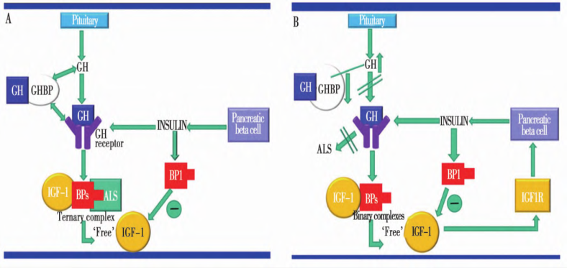

Figure 1 Pathogenesis of infant growth rates regulated by IGF-1 and IGFBP-3

A: full-term infants, B: preterm infants, GH: growth hormone, GHBP: growth hormone binding protein, IGF-1: insulin-like growth factor-1, BPs: binding proteins, ALS: acid labile subunit, IGFIR: type I insulin-like growth factor receptor.

Recent Publications (minimum 5)
- Zhonggui Xiong, Ping Zhang, Jian Ke, Feimin Sun, Zeyuan Xia. The growth rates and influence factors of preterm and full-term infants in urban areas of Hubei province: a birth cohort study. Medicine, 2022, 101: 34(e30262).
- Zhonggui Xiong, Jiong Yan, Shuhua Shi. Epidemiological distributions and critical contributions to the growth rate for infants and young children in Hubei province of China during 2017 to 2018: a review. International Journal of Pediatrics, 2020, 8(2): 10837-10844.

Biography (150 word limit)
Paste your Logo here
Zhonggui Xiong has his expertise in diagnosis and intervention of child developmental disorders, for example the growth rates and influencing factors of preterm and full-term infants. I participated in establishing the reference standard of infant growth rates which was supported by the special fund for basic work, Ministry of Science and Technology of China (Project No.: 2006FY230200) in 2006. Furthermore, I took charge of clarifying the pathogenesis of infant growth rates which was supported by the Maternal-Infant Nutrition and Health Research Project, the National Center for Women and Children’s Health of the Chinese Center for Disease Control and Prevention (Project No.: 2020FYH009).

Email: xiongzhonggui@hbfy.com

Notes/Comments: I thank you for your help.

Presenting author details
Full name: Zhonggui XIONG
Contact number: +86 13871002921
Mail id: xiongzhonggui@hbfy.com
Category: (Oral presentation)

