Biosynthesis of Silver Nanoparticles Using Tridax procumbens Aqueous Leaf Extract and Their Antiproliferative Activity Against Cancer Cell Lines
Nilesh R Makwana¹, Rohini Pungle², Arun S Kharat ¹*

Abstract:
Natural products have been considered more sustainable over chemical drugs, those have failed either due to severe side effects or drug resistance. Green synthesis of metal-nanoparticles using medicinal plants extract is gaining attention due to profound applications for secondary metabolite, those are natural products. Present study describes antiproliferative activity of silver nanoparticles synthesized using the aqueous leaf extract of Tridax procumbens. Aqueous leaf extract of T. procumbens served as a reducing and capping agent in biosynthesis of silver nanoparticles. The biosynthesized T. procumbens silver nanoparticles (TNPs) were characterized using UV-visible spectroscopy, dynamic light scattering (DLS), Fourier transform infrared (FTIR) spectroscopy, X-ray diffraction (XRD), scanning electron microscopy (SEM), transmission electron microscopy (TEM), and energy-dispersive X-ray analysis (EDAX). The phytochemicals responsible for the reduction and capping of biosynthesized TNPs were deciphered through separation and mass spectrometry principles. Antiproliferative activity of TNP was evaluated using 3-(4,5-dimethylthiazol-2-yl)-2,5- diphenyltetrazolium bromide (MTT) assay on a few selected cell lines; A549, and B16 F10 immortal, while HEK293 being the finite cell line. Cellular cytotoxicity assay demonstrated that TNPs exhibits antiproliferative activity against both, A549 and B16F10 with IC50 values 42.70ug/ml and 2.64ug/ml, respectively. Molecular characterization of TNPs synthesized using T. procumbens crude extract and HPLC fraction-11 showed presence of differential phytomolecules. The HPLC fraction originated TNPs showed presence of fosinopril and reducing agents such as peptides (Gln-Gly-Ala, Ser-Pro-Asn, and Leu-Met), terpenoids (lupanyl acid, tiamulin), polyphenol (peucenin), and alkaloids (8′,10′-dihydroxydihydroergotamine, carteolol) phytomolecules, suggesting potential role to the dipeptides/tripeptides in cancer therapy. To decipher antiproliferative mechanism exerted by the TNP in A549 cells was studied with RNA sequencing approach. Monolayer treated with 10 ug along with non-treated monolayers were subjected for RNA sequencing. Primary analysis indicated 15 genes were upregulated while 17 genes were downregulated in the cells treated with 10 ug TNP. Search for potential target genes revealed a series of functional assays and signaling pathway in A549 cell line were differentially regulated when treated with TNP. Understanding nanoparticle-bio interactions in living cells entails an understanding of particles' dynamic behavior

during cellular absorption, intracellular traffic, and mutual interactions with cell organelles. The biosynthesized T. procumbens AgNPs can be further exploited as a potential anticancer candidate agent.

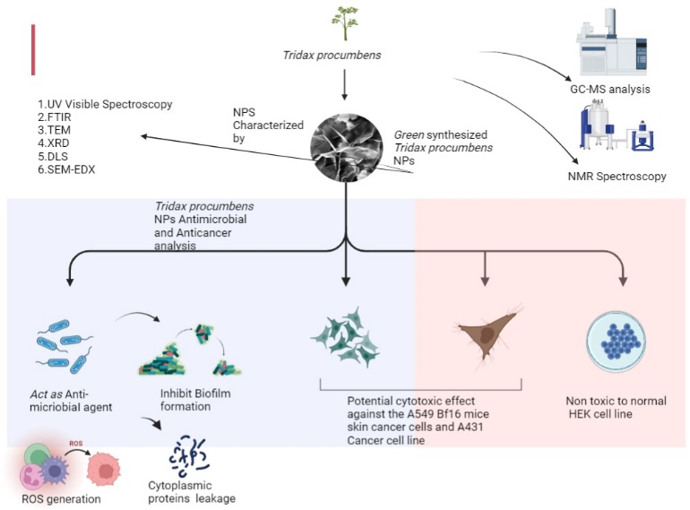

Recent Publications (minimum 5)
- Pungle, R., Nile, S. H., Makwana, N., Singh, R., Singh, R. P., & Kharat, A. S. (2022). Green synthesis of silver nanoparticles using the Tridax Procumbens plant extract and screening of its antimicrobial and anticancer activities. Oxidative Medicine and Cellular Longevity, 2022.
- Kharat, A. A., Makwana, N., Kadam, D. G., Chavan, A. S., Kulkarni, J. A., & Kharat, A. S. (2020). Co-existence of Extended Spectrum β-Lactamase and carbapenemase-producing genes from Diarrheagenic Enteric pathogens isolated in a tertiary care hospital.Acta Biochimica Polonica.

Biography

I am Nilesh Makwana, a Microbiologist and graduate student at School of life Sciences, Jawaharlal Nehru University (JNU), New Delhi. My research work on medicinal plant, its Anti-cancer and Anti-microbial potentiality. Cancer is a leading growing global public health concern. There has been a sufficient scientific advent, which owes to research in last six decades, however, still search of a miraculous anticancer compound is yet to be achieved. My work involves, green synthesis of silver Nanoparticles doped with Tridax procumbens phytochemicals. The nanoparticles exhibited an anticancer potentiality against A549 -a human lung carcinoma cells (Pungle et. al., 2022). An HPLC fraction originated nanoparticles showed presence of di and tri-peptides. High-throughput transcriptional analysis with RNAseq indicated more than 32 genes are differentially regulated, covering processes such as GPCR, ECM, Metallothionine, Apoptosis, Autophagy and collagen.
Email: mnr2808@gmail.com

Notes/Comments:
Presenting author details
Full name: NILESH MAKWANA
Contact number: +91 87587 94399
Mail id: mnr2808@gmail.com
Category: Poster presentati

