TRPV2 plays a critical role in hepoxilin A₃-medited neutrophil transepithelial chemotaxis

Claudia Ferrioti¹, Merran Dunford¹, Rebecca Ferrisi², Francesca Gado², Clementina Manera², Keyi Liu³, Beth McCormick⁴, and Randall Mrsny¹

¹Department of Life Sciences, University of Bath, Claverton Down, Bath BA2 7AY UK
²Dipartimento di Farmacia, Università di Pisa, Via Bonanno 6, 56126 Pisa, Italy
³Applied Molecular Transport, 450 East Jamie Court South San Francisco, CA 94080 USA
⁴Department of Microbiology and Physiological Systems, University of Massachusetts Medical School, Worcester, MA 01605 USA.

Abstract
Purpose: Neutrophil transepithelial migration and accumulation at mucosal surfaces is a hallmark of many inflammatory conditions. Recent studies have demonstrated lipids secreted from the luminal surface of intestinal epithelial cells to regulate this event with N-acyl ethanolamine-type (NAE) endocannabinoids (eCBs) suppressing and the eicosanoid hepoxilin A₃ (HxA₃) activating the chemotaxis of neutrophils across this mucosal barrier. We hypothesized that directional chemotaxis of neutrophils mediated by HxA₃ should involve cell-surface receptor(s). Here, we identify a role for the transient receptor potential cation channel subfamily V member 2 (TRPV2) in HxA₃-mediated chemotaxis that drives neutrophil transepithelial migration.
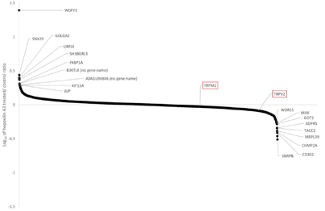
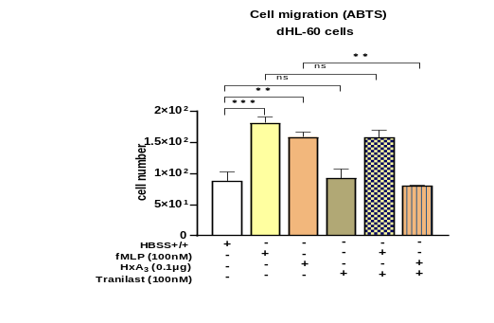
Methods: Human promyelocytic cells (HL-60), differentiated (dHL-60) into a neutrophil-like phenotype, were used in a surface internalization-biased protocol, and proteomic analysis of internalized materials following HxA₃ exposure identified receptor candidates. Cell migration assays were performed in Transwell® polycarbonate membrane plates using dHL-60 cells on the upper chamber, followed by the addition of chemoattractant HxA3 or fMLP or 2-aminoethoxydiphenylborane (2-APB), a non-specific TRP channel activator in the bottom chamber. siRNA-knock-down of CB₂R and TRPV2 genes in dHL-60 cells were performed for their ability to block HxA₃- dHL-60 cell migration.
Results: TRPV2 was identified in the proteomic screen. The CB₂R agonists individually blocked HxA3 and 2-APB-induced migration of dHL-60 cells. Our data suggests TRPV2 interacts with CB2R, linking these two elements in a potentially coordinated chemotactic function that could
Figure 1. Identification of potential cell surface receptors for HxA₃. A) Cartoon of schema describing individual steps of enrichment/capture of cell surface proteins following HxA₃ treatment. B) Intensity plot of proteins identified by proteomic analysis of sample collected using schema outlined in A). C) Impact of pharmacological agents, the TRPV2 inhibitor tranilast (100 nM) and the chemoattractant hepoxilin (HxA3, 0.1μg) on dHL60 cell transmigration across Transwell® polycarbonate membrane plates after 30 min of incubation at 37°C. Values are normalized to HxA3 (1:32 dil. Control) with SEM of studies (N=3) being shown.

be used to position neutrophils in the lamina propria in a state of readiness for transepithelial migration induced by the apical epithelial secretion of HxA_{3.}
Conclusions: We have identified TRPV2 as a promising candidate receptor for HxA₃ to drive the transepithelial migration of neutrophils using the surrogate dHL-60 cell system. Such a system provides a basis for the organization of neutrophils that can rapidly respond to pathogens at the luminal surface of the intestinal epithelium and points to several potential therapeutic opportunities.
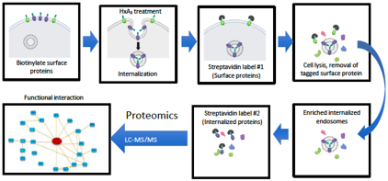
Fig. 1C
Fig. 1A
Fig. 1B

Fig. 2A
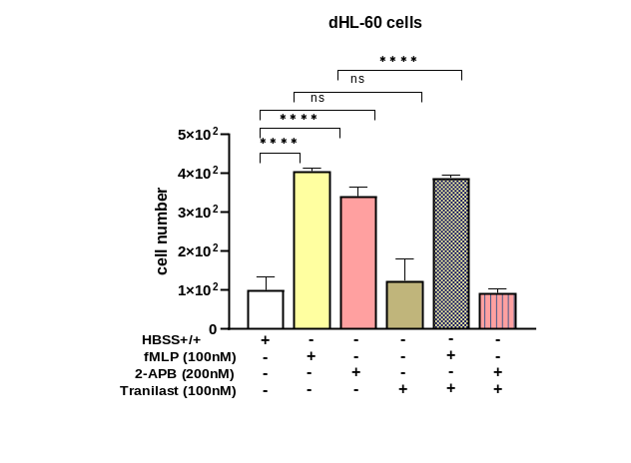

Figure 2. 2-aminoethoydiphenylborane (2-APB), a non-specific TRP channel activator can replace HxA3 to induce cell migration. A) 2-APB-mediated dHL-60 cell migration is blocked by the TRPV2 inhibitor tranilast, dHL-60 cells were incubated with the TRPV2 inhibitor tranilast (100nM) and the non-specific TRPV agonist 2-aminoethoxydiphenyl borate (2-APB 200nM) or N-formylmethionyl-leucyl-phenylalanine (fMLP, 100 nM), as a positive control, to stimulate migration across 96-well Transwell® polycarbonate membrane plates for 30 min at 37°C. B) 2-APB or HXA3- mediated dHL-60 cell migration is blocked by TRPV2 inhibitor tranilast but not by TRPV1 inhibitor AMG9810; dHL-60 cells were incubated with the TRPV1 inhibitor AMG9810 (50nM) or with TRPV2 inhibitor tranilast (100nM) and 2-APB (200nM) or HxA₃ (0.1μg) to stimulate migration across 96-well Transwell® polycarbonate membrane plates for 30 min at 37°C. Values are normalized to HxA₃ (1:32 dil. Control) with SEM of studies (N=3) being shown.

Fig. 3A

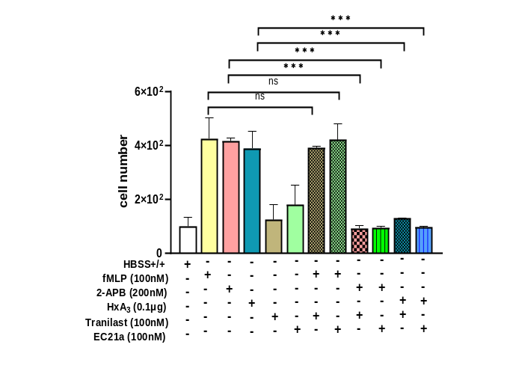
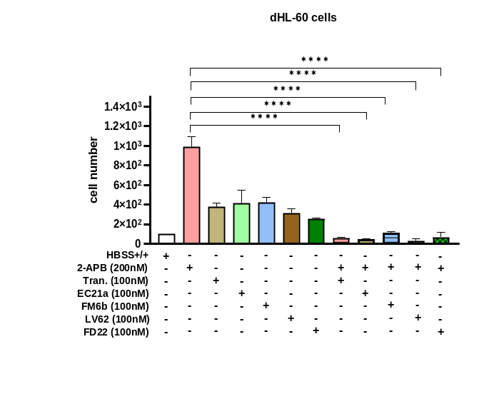

Figure 3. Impact of the anandamide-like eCBs compounds on dHL-60 cell migration. A) The cannabinoid type 2 receptor (CB₂R) acts through anandamide-like eCBs to suppress 2-APB and HxA₃-mediated dHL-60 cell migration, dHL-60 cells were incubated with the CB₂R positive allosteric modulator (EC21a, 100nM) or TRPV2 inhibitor tranilast (100nM) and HxA₃ ( 0.1ug) or 2-aminoethoxydiphenyl borate (2-APB 200nM) or N-formylmethionyl-leucyl-phenylalanine (fMLP, 100 nM) to stimulate migration across Transwell® polycarbonate membrane plates for 30 min. at 37°C. B) CB₂R endocannabinoids agonists (eCBs) block 2-APB induced migration of dHL-60 cells, dHL-60 cells were incubated with the with TRPV2 inhibitor tranilast (100nM) or the CB2R positive allosteric modulator EC21a (100nM) or the orthosteric agonist LV-62 (100nM) or the dual orthosteric agonist FM-6b (100nM) or the dualsteric/bitopic agonist FD22a (100nM) and 2-APB (200nM) stimulate migration across 96-well Transwell® polycarbonate membrane plates for 30 min. at 37°C. Values are normalized to HxA3 (1:32 dil. Control) with SEM of studies (N=3) being shown.

Fig. 2B

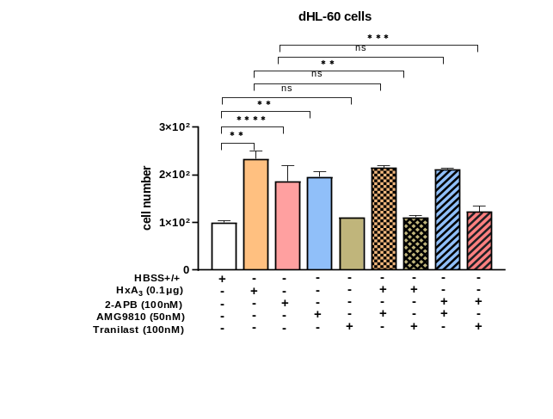

Fig. 3B

Recent Publications

1. McCormick, B.A., et al., Apical secretion of a pathogen-elicited epithelial chemoattractant activity in response to surface colonization of intestinal epithelia by Salmonella typhimurium. J Immunol, 1998. 160(1): p. 455-66.
2. Yamamoto, S., et al., TRPM2-mediated Ca2+influx induces chemokine production in monocytes that aggravates inflammatory neutrophil infiltration. Nat Med, 2008. 14(7): p. 738-47.
3. Neeper, M.P., et al., Activation properties of heterologously expressed mammalian TRPV2: evidence for species dependence. J Biol Chem, 2007. 282(21): p. 15894-902.
4. Szabady, R.L., et al., Intestinal P-glycoprotein exports endocannabinoids to prevent inflammation and maintain homeostasis. J Clin Invest, 2018. 128(9): p. 4044-4056.
5. Gado, F., et al., Identification of the first synthetic allosteric modulator of the CB2
receptors and evidence of its efficacy for neuropathic pain relief. J Med Chem, 2019. 62: p. 276-287.
6. Lucchesi, V., et al., CB2-selective cannabinoid receptor ligands: synthesis, pharmacological evaluation, and molecular modeling investigation of 1,8-Naphthyridin-2(1H)-one-3-carboxamides. J Med Chem, 2014. 57(21): p. 8777-91.
7. Arena, C., et al., The endocannabinoid system dual-target ligand N-cycloheptyl-1,2-
dihydro-5-bromo-1-(4-fluorobenzyl)-6-methyl-2-oxo-pyridine-3-carboxamide improves disease severity in a mouse model of multiple sclerosis. Eur J Med Chem, 2020. 208: p. 112858.
8. Gado, F., et al., Design, synthesis, and biological activity of new CB2 receptor ligands: From orthosteric and allosteric modulators to dualsteric/bitopic ligands. J Med Chem, 2022. 65: p. 9918-9938.

Biography


- Claudia Feriotti has her expertise in host-pathogens interactions and innate immunity, her current work is on the identification of molecules secreted by the intestinal epithelial cells which can control neutrophil transmigration from the intestinal lamina propria to the lumen in homeostatic environment or in the intestinal inflammatory diseases. She examines epithelial transcytosis mechanisms used by bacterial toxins for the delivery of biotherapeutics such as proteins, peptides, and siRNA. Her previous work was on the study of Klebsiella pneumonia-host interactions in human pulmonary infections. She analysed the Type I interferon function in the intracellular signalling pathways driven by Klebsiella infection in macrophages.

Email: cf772@bath.ac.uk

Notes/Comments:

Presenting author details
Full name: Claudia Feriotti
Contact number: +44(0)7878-374406
Twitter account: @FeriottiClaudia
Linked In account: Claudiaferiotti
Session name/ number: Bio pharmaceuticals
Category: (Oral presentation/ Poster presentation

