Redo Cardiac Transplant for coronary allograft vasculopathy of 9 years post-transplant
Sweta Ramani.S, Madhusankar N., Rajaram Anantharaman, Kotturathu Mammen Cherian.
India

Abstract:
In patients with advanced Coronary allograft vasculopathy (CAV) not amenable to revascularization, particularly if associated with allograft dysfunction, retransplant is the only definitive therapy. The overall reported survival after retransplant is lower than the primary transplant. However, the retransplantation specifically for CAV, has been associated with equally good outcome. This report describes a case of CAV with hemodynamic compromise on mechanical circulatory support underwent retransplant.
Ms. R was diagnosed with dilated cardiomyopathy, severe mitral Regurgitation and Severe biventricular dysfunction at the age of 27years. She underwent Orthotopic heart transplant on 19.11.2009 and has been on follow-up since then. She had a near normal life until 9 years later, she was found to be in moderate biventricular dysfunction although her TMT test was inconclusive. Coronary angiogram with Endomyocardial biopsy revealed Cardiac allograft vasculopathy. Despite her antifailure and pulse therapy medications, her cardiac function worsened in 4 months duration landing into cardiogenic shock (global hypokinesia; LVEF 18%) on 20.09.2017. Her clinical condition warranted for a high ionotropic supports and intra-aortic balloon pump. Subsequently she was placed on veno-arterial ECMO. She underwent balloon septostomy on 21-09-2017. With the availability of donor heart, on 22-09-2017, she underwent Redo cardiac transplant. Her post operative period was uneventful and was discharged home on 14th post operative day. A screening endomyocardial biopsy was done at discharge, that confirmed no evidence of rejection.

Till 2015, 3142 redo heart transplants were reported by ISHLT and it forms 2-3.7% of the overall number of transplants. Incidentally, this is the first retransplantation for CAV reported in India, and the second overall, where the first one being, done in a case of early primary graft dysfunction.

Image
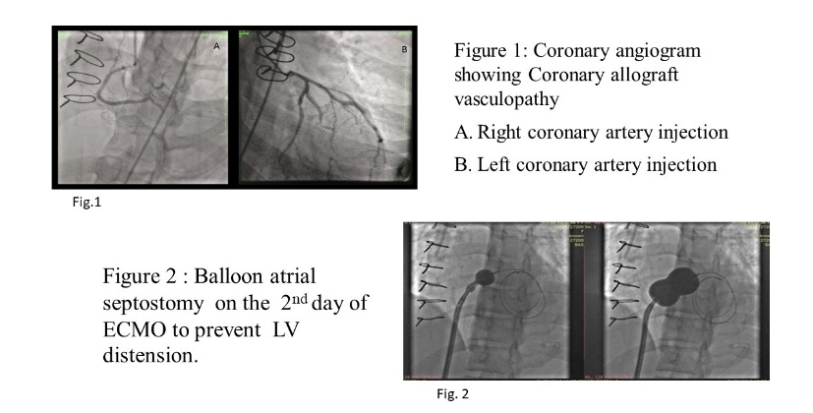
References:
- Goldraich LA¹, Stehlik J², Kucheryavaya AY, Edwards LB, Ross HJ. Retransplant and Medical Therapy for Cardiac Allograft Vasculopathy: International Society for Heart and Lung Transplantation Registry Analysis. Am J Transplant. 2016 Jan;16(1):301-9.
- Zalawadiya S, Fudim M, Bhat G, Cotts W, Lindenfeld J. Extracorporeal membrane oxygenation support and post-heart transplant outcomes among United States adults. J Heart Lung Transplant 2017;36:77–81.
- Shuhaibar JH Kim JB, Hur K, et al: Comparison of survival in primary and repeat heart transplantation from 1987 through 2004 in the united states. Ann Thorac surg 2007; 83(6); 2135-2141.
- Tjang YS, Tenderich G, Hornik L, et al: Cardiac retransplantation in adults: an evidence based systematic review. Thorac Cardiovasc Surg 2004; 56(6): 323.327.
- John R Chen JM, Weinberg A, et al: Long –term survival after cardiac retransplantation: a twenty year single-center experience. J Thorac Cardiovasc Surg 1999, 117 (3): 543-555.

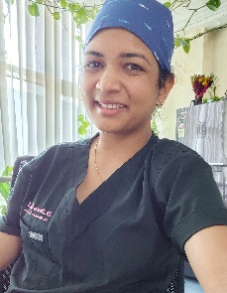 Biography
Paste your Logo here

Dr. Sweta Ramani is a Cardiothoracic Surgeon from India. She was born in the family of doctors and have imbibed great passion for medical profession since then. She started her career in cardiothoracic surgery in 2012, the first few batches of integrated 6-year training program in India. She graduated from Dr.K.M.Cherian heart foundation, which is an apex tertiary care exclusive cardiac centre in India, under Dr. K.M.Cherian himself, who happens to be the ‘pioneer’ in Cardiac Surgery in India. Being one of the larger transplant centres in India, she has been a part of nearly 45 successful heart/ lung / heart-lung transplants in India. Currently, working as Assistant Professor & Superspecialist – Cardiothoracic & Vascular Surgery at ESIC Superspeciality hospitals, Hyderabad (India), parallelly honing her skills in the field of heart failure procedures.
Email: dr.swetaramani@gmail.com

Notes/Comments:

Presenting author details
Full name: Dr. Sweta Ramani. S
Contact number: +91 9444890444
Twitter account:
Linked In account: Sweta Ramani
Session name/ number:
Category: (Oral presentation/ Poster presentation

