Low-molecular weight NGF mimetic attenuates insulin resistance in a high-carbohydrate diet/streptozotocin-induced rat model of type 2 diabetes
Sergei V. Ivanov, PhD, V.V. Zakusov Research Institute of Pharmacology, Moscow, Russia
Rita U. Ostrovskaya, PhD, DSc, V.V. Zakusov Research Institute of Pharmacology, Moscow, Russia
Anastasiya D. Savina, I.M. Sechenov First Moscow State Medical University, Moscow, Russia
Dmitry S. Sukhoruchenkov, I.M. Sechenov First Moscow State Medical University, Moscow, Russia

Abstract

Statement of the Problem: Type 2 diabetes mellitus (DM2) remains one of the most important medical and social problems. The search for new effective antidiabetic drugs is an urgent task of pharmacology. Taking into account the deficiency of the neutrophic factor NGF in DM 2 [1] and the importance of NGF for the pancreatic β-cells functioning [2], the low-molecular weight NGF mimetic “GK-2” (hexamethylenediamine bis-(N-monosuccinyl-L-glutamyl-L-lysine)) created in V.V. Zakusov Research Institute of Pharmacology [3] was studied in the steptozotocin (STZ) DM2 model [4,5]. The purpose of this work is to investigate the effect of GK-2 on insulin resistance in Wistar rats with DM2 induced by a high-carbohydrate diet combined with low doses of STZ.

Methodology & Theoretical Orientation: Rats were fed a high-carbohydrate diet based on replacing of tap water with a 10% fructose solution for 6 weeks. On the 15th day, STZ 35 mg/kg was administered. Then, the rats were divided into two groups: one group (n=10) was treated with GK-2 orally (5 mg/kg), the other (n=10) was treated with saline. The control group (n=10) received water. Blood glucose level was measured weekly. After 28 days of treatment, an oral glucose tolerance test (3 g/kg) was performed. The results of blood glucose measurement were analyzed by ANOVA.

Findings: The usage of high-carbohydrate diet in combination with STZ leads to the development of hyperglycemia up to 22.5 mmol/l and impaired glucose tolerance (AUC 2159,1±224,1 min⁽⁰⁻¹²⁰⁾·mmol/l in untreated dibetic rats vs 1012,0±29,5 min⁽⁰⁻¹²⁰⁾·mmol/l in healthy rats, p<0.01). GK-2 therapy was shown to reduce not only basal glycemia to 12.2±1.7 mmol/l (p<0.05), but also decrease insulin resistance by 29% (AUC 1543,2 ±197,4 min⁽⁰⁻¹²⁰⁾·mmol/l, p<0.05).

Conclusion & Significance: Low-molecular weight NGF mimetic GK-2 demonstrated antidiabetic activity and the ability to reduce the severity of insulin resistance in rats kept on a high-carbohydrate diet combined with low doses of STZ.

Image
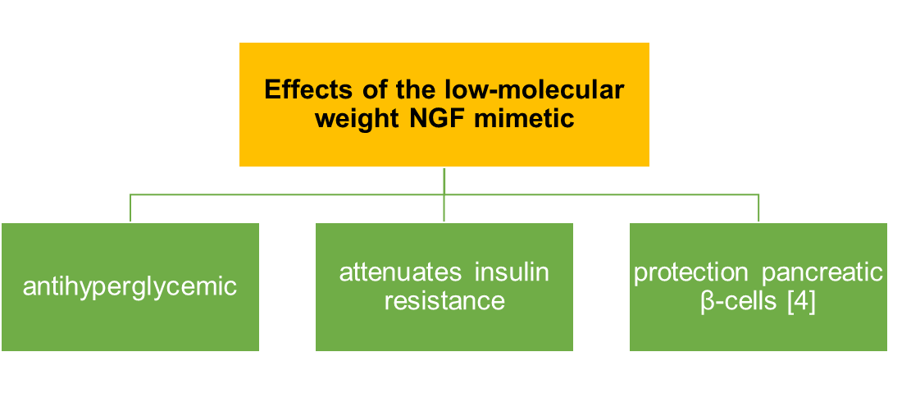
Figure 1. Main effects of the low-molecular weight NGF mimetic “GK-2”
Recent Publications (minimum 5)
- Verge VMK, Andreassen CS, Arnason TG et al. (2014) Mechanisms of disease: role of neurotrophins in diabetes and diabetic neuropathy. Handb Clin Neurol 126:443-460.
- Pierucci D, Cicconi S, Bonini P et al. (2001) NGF-withdrawal induces apoptosis in pancreatic beta cells in vitro. Diabetologia 44(10):1281-95.
- Seredenin SB, Gudasheva TA (2017) Dipeptide mimetics of NGF and BDNF neurotrophins. United States patent US 9683014B2.
- Ostrovskaya RU, Ivanov SV, Gudasheva TA, Seredenin SB (2019) A novel dipeptide NGF mimetic GK-2 selectively activating the PI3K/AKT signaling pathway promotes the survival of pancreatic β-cells in a rat model of diabetes. Acta Naturae 11(40):4-13.
- Ivanov SV, Ostrovskaya RU, Gudasheva TA, Seredenin SB (2021) Dose-dependent effect of nerve growth factor mimetic GK-2 in a Wistar rat diabetes model. Pharm Chem J 55(4):323-327.

 Biography

Sergei Ivanov, PhD, senior researcher of the V.V. Zakusov Research Institute of Pharmacology, 29 years old. Research interests include the study of the anti-diabetic activity of the original cytoprotective compounds on the type 2 diabetes experimental model at the functional and morphological levels.
Email: ivanov-sv-tver@mail.ru

Presenting author details
Full name: Sergei Ivanov
Contact number: +79253029430
Session name/ number: Advanced treatment and prevention of diabetes
Category: E-Poster presentation

