WITHAFERIN A INDUCES METABOLIC CRISIS IN BREAST CANCER CELL LINES VIA DECREASING C-MYC EXPRESSION: POTENTIAL THERAPEUTIC IMPLICATION
Asifa Khan, PhD scholar, Jamia Millia Islamia,
New Delhi, India-110025

Abstract (300 word limit)
Reprogrammed glucose metabolism is considered as the hallmark of the cancer with immense therapeutic relevance. Witahferin A (WA), a withanolide isolated from Withania somnifera has been shown to exhibit anticancer activity. But the role of WA in cancer metabolism still remain elusive. In line with this, we assessed the effect of WA on breast cancer metabolism and its underlying regulatory pathway. Herein, we showed that WA decreases the glucose uptake, lactate production and ATP generation in different breast cancer cell lines via suppression of key glycolytic enzymes i.e. GLUT1, HK2 and PKM2. We identified, WA induced suppression of glycolytic enzymes was through c-myc signaling - one of the major regulator of glycolysis.
Moreover, WA treatment significantly resulted in reduced cell viability, biomass and colony forming ability of breast cancer cells. Silencing of c-myc resulted in reduced glucose uptake, lactate production and ATP generation validating that regulation of Warburg effect is mediated through c-myc. Highlighting the importance of c-myc in glycolysis. To further validate our in vitro findings we used METABRIC dataset of ~2000 breast tumors and employed Pathifier algorithm to determine the pathway deregulation of glycolysis in each patient and normal sample Notably, highest deregulation of glycolysis was observed in breast tumor compared to normal tissues and found to be associated with poor prognosis. Taken together, our results highlight the anti- carcinogenic effect of Withaferin A in modulating breast cancer metabolism and the clinical significance of glycolysis in general.

Image
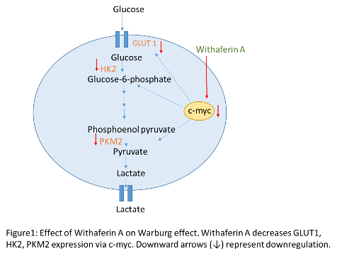
Recent Publications (minimum 5)
- Khan, A., Mohammad, T., Shamsi, A., Hussain, A., Alajmi, M. F., Husain, S. A., ... & Hassan, M. I. (2021). Identification of plant-based hexokinase 2 inhibitors: Combined molecular docking and dynamics simulation studies. Journal of Biomolecular Structure and Dynamics, 1-13. Khan, A., Siddiqui, S., Husain, S. A., Mazurek, S., & Iqbal, M. A. (2021). Phytocompounds Targeting Metabolic Reprogramming in Cancer: An Assessment of Role, Mechanisms, Pathways, and Therapeutic Relevance. Journal of Agricultural and Food Chemistry, 69(25).
- Khan, A., Siddiqui, S., Husain, S. A., Mazurek, S., & Iqbal, M. A. (2021). Phytocompounds Targeting Metabolic Reprogramming in Cancer: An Assessment of Role, Mechanisms, Pathways, and Therapeutic Relevance. Journal of Agricultural and Food Chemistry, 69(25), 6897-6928.
- Iqbal, M. A., Chattopadhyay, S., Siddiqui, F. A., Ur Rehman, A., Siddiqui, S., Prakasam, G., ... & Bamezai, R. N. (2021). Silibinin induces metabolic crisis in triple‐negative breast cancer cells by modulating EGFR‐MYC‐TXNIP axis: potential therapeutic implications. The FEBS Journal, 288(2), 471-485.
- Malik, Z., Parveen, R., Parveen, B., Zahiruddin, S., Khan, M. A., Khan, A., ... & Husain, S. A. (2021). Anticancer potential of andrographolide from Andrographis paniculata (Burm. f.) Nees and its mechanisms of action. Journal of Ethnopharmacology, 272, 113936.

Biography (150 word limit)

Asifa Khan has her expertise in finding the natural compounds and their role in targeting cancer metabolism. She worked on the natural compounds and their effect on upstream and downstream metabolic pathways. She has experience in in silico studies as well. Through in silico studies she finds novel phytocopounds that could be the direct inhibitor of upregulated key glycolytic enzymes. She has the strong academic background as she secured gold medal in securing highest marks in her master’s (This is a certificate of excellence, most prestigious medal awarded to the only one student for securing highest marks in their relevant subject in the university). She also qualified NET (Life science) from Council of Scientific & Industrial Research (CSIR), securing 48th and 40th all over India rank, in 2017 and 2019 respectively. The National Eligibility Test (NET), is the examination for determining the eligibility for the post of assistant professor and in Indian universities. She has experience in research and in teaching graduate students. She is self-motivated, enthusiastic and eager to learn more.
Email: asifakhan0001@gmail.com

Notes/Comments:

Presenting author details
Full name: Asifa Khan
Contact number: +91 9911299455
Mail id: asifakhan0001@gmail.com
Category: (Poster presentation)

