BRCA1/A2 genes mutation profile of breast cancer in the young patients in Mauritania
Selma MOHAMED BRAHIM^{1, 2,} EkhtElbenina ZEIN², Crystel BONNET³,Cheikh Tijani HAMED⁴, Malak SALAME¹, Mohamed Vall ZEIN², Meriem KHYATTI⁵, Ahmedou TOLBA ² and Ahmed HOUMEIDA ¹§
1. Unité de Recherche sur les Biomarqueurs dans la Population Mauritanienne. UNA-FST. Nouakchott-Mauritanie. 2. Centre National d’Oncologie (CNO). Unité de Recherche et d’Enseignement. Nouakchott-Mauritanie. 3. Institut de l’Audition, Institut Pasteur, Inserm, Paris, France.4. Centre d’Hépato virologie. Nouakchott-Mauritanie. 5. Institut Pasteur du Maroc. Laboratoire Oncologie et Thérapie Cellulaire. Casablanca-Maroc

Abstract
Worldwide, about 20 % of all breast cancer cases were caused by mutations passed on from parent genes. Inheriting a pathogenic BRCA1/A2 variant greatly increases women’s risk of developing breast cancer at younger age depending of the mutation.
This study was aimed to provide the first data on breast cancer related gene mutations in Mauritania.
Study population this search for BRCA1/A2 mutations included Mauritanian breast cancer in the young patients to the Centre National Oncologie (CNO) during the period from January 2009 to December 2020.
BRCA1and BRACA2 molecular screening and Using Next Generation Sequencing, underlying BRCA1/A2 genetic mutations were searched in DNA samples from breast cancer patients.
Out of the16 pathogenic or likely pathogenic variations, we identified two predominant BRCA1 variants: rs387905563 (c.815_824dup) and rs80358086 (c.4986+6T>C). Two novel BRCA DNA variants were detected of which three predicted as pathogenic.

Image
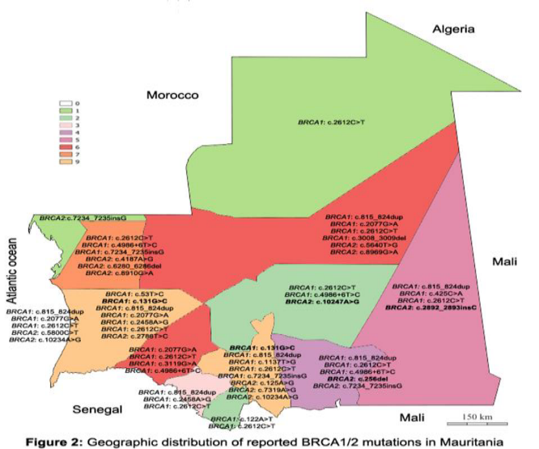
Figure1 geographic distribution of reported BRCA1/2 mutation in Mauritania
Recent Publications
- Selma MOHAMED BRAHIM, Ekht Elbenina ZEIN,Ahmed HOUMEIDA and Ahmedou TOLBA. General Oncology Care in Mauritania. In: Al-Shamsi HO, Abu-Gheida IH, Iqbal F, Al-Awadhi A, eds. Cancer in the Arab World. Springer; 2022:149-161. Doi: 10.1007/978-981-16-7945-2_10
- Imane EL Alami, Amina Gihbid, Hicham Charoute, Wafaa Khaali, Selma Mohamed Brahim, Nezha Tawfiq, Rachida Cadi, Khalid Belghmi, Mohammed El Mzibri, Meriem Khyatti. Prognostic value of Epstein-Barr virus DNA load in nasopharyngeal carcinoma: a meta-analysis. https://www.panafrican-med journal.com//content/article/41/6/full.
- Selma MOHAMED BRAHIM, Ekht Elbenina ZEIN, Crystel BONNET, CheikhTijani HAMED, Malak SALAME, Mohamed Vall ZEIN, Meriem KHYATTI, Ahmedou TOLBA and Ahmed HOUMEIDA. Screening of BRCA1/2 mutations in Mauritanian Breast Cancer patients. (Submitted for consideraition for publication in BMC cancer

Biography

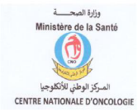


Selma Mohamed Brahim has obtained her baccalaureate in Natural Sciences and her BSc. In Molecular Biology and Physiology from Alasriya University/Mauritania in 2016. After a master’s in biology and Health Sciences at HASSEN II University/Morocco, she is now carrying out a PhD in molecular biology on breast cancer mutation profile in Mauritania as part of a collaboration project between the research unit on biomarkers in the Mauritanian population / AlasriyaUniversity and the onco-virology laboratory of Pasteur institute/ Morocco. She works at the Center National oncology, and she coordinate at unit Research. Thanks to numerous training programs home and abroad, she developed a strong skill set in biomedical, molecular bioinformatics sciences.
Email: Selma.mohamedbrahim@gmail.com

Notes/Comments:
Presenting author details
Full name: Selma MOHAMED BRAHIM
Contact number: 0022220484884
Linked In account: Selma Mohamed Brahim - mr.linkedin.com
Session name/ number:
Category: (Oral presentation/ Poster presentation)

