URINALYSIS AND PREVALENCE OF UROPATHOGENS AMONGST THE AGED IN GHANA


Emmanuel Armah1,2, Bright K. Idun1, Freda Kwarteng Boampong1, Lawrencia Kwarteng1, Isaac Agyapong1, Mawutor Kwame Ahiabu1 , Mercy Oppong1, Prof. Mike Yaw Osei Atweneboana1
- Biomedical and Public Health Research Unit, Water Research Institute-Council for Scientific and Industrial Research
- Department of Medical Microbiology, University of Ghana Medical School (emmanuelarmah44@yahoo.com. 233547492603)

INTRODUCTION
- The Urinary tract infections (UTIs) are among the most common bacterial infections and affect about 150 million people worldwide each year, with high social cost

- Although, the occurrence of UTIs is rampant among the elderly, especially those residing in nursing homes, not enough research has been done on these individuals.


STUDY OBJECTIVES
  - The determine the prevalence of uro- pathogens associated with UTIs in NH

  - Diagnose Urinary Tract Infections via urinalysis

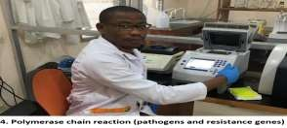
  - Screen for the presence of Uropathogens and the resistance genes responsible for they harbored

  - Determine the risk factors associated with the occurrence of UTIs among the elderly

METHODOLOGY RESULTS

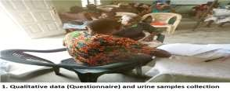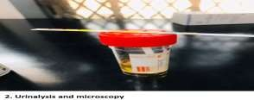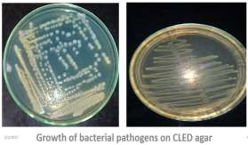
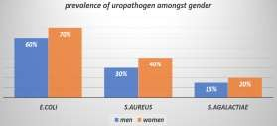
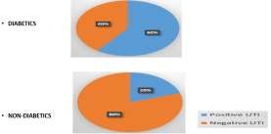

CONCLUSION
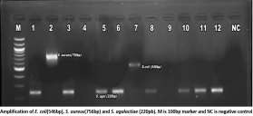
- Females and diabetic patients are
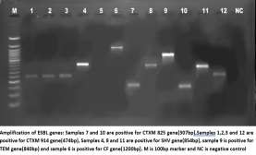
more at risk of developing UTI

- Bacterial pathogens like E.coli, S. agalactiae and S.aureus as well as ESBL genes like CTXM, TEM and SHV are very prevalent among the elderly

- Antibiotic resistance is apparent amongst nursing home patients

