Evaluation of the recovery rate and prevention of hospitalization among covid-19 outpatients: a randomized clinical trial comparing N-acetylcysteine with Bromhexin
Anahita Eslami-Ghayour, MD, Hamadan, Iran

Abstract
Objectives: Due to the referral of COVID-19 patients to outpatient centers in the early stages, the aim of the present study is to compare the effect of N-acetylcysteine and Bromhexine on the recovery rate and prevention of hospitalization in outpatients with COVID-19
Methodology: This study was conducted from April 2022 to September 2022. First, PCR-confirmed COVID-19 patients were divided into two groups, one of these groups received N-acetylcysteine while the other received bromhexine. The patients were followed up on the seventh and fourteenth days of the disease in terms of the duration of changes in oxygen saturation and recovery. The hospitalization and death of the patients were also evaluated after one month.
Results: Out of 150 studied patients, oxygen saturation was increased by 1.33% in the third visit of the patients who received N-acetylcysteine compared to their first visit. This percentage was 1.19% in the patients who received bromhexine.11.33% of the patients were admitted to the hospital and 88.6% of them had no history of hospitalization within 14 day and their mortality rate was zero.
Conclusions: The results of this study showed that early initiation of Bromhexine can effectively reduce the hospitalization rate and shorten the duration of hospitalization.
Clinical trial code: IRCT20220302054167N1 and ethics code: IR.UMSHA.REC.1400.957
Keywords: COVID-19, N-acetylcysteine, Bromhexine, Infection diseases

Image
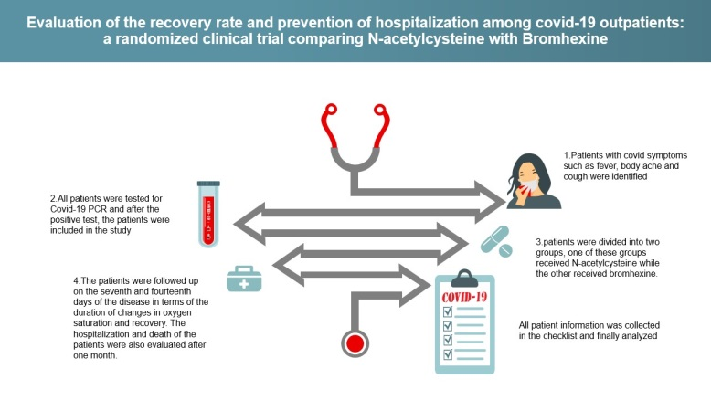
Recent Publication
- Ansarin K, Tolouian R, Ardalan M, et al. Effect of bromhexine on clinical outcomes and mortality in COVID-19 patients: A randomized clinical trial. Bioimpacts. 2020;10(4):209-215. doi:10.34172/bi.2020.27.
- JohnsHopkins Coronavirus Resource Center (CRC) (2022) Https://coronavirus.jhu.edu/data/mortality
- Taher A, Lashgari M, Sedighi L, Rahimi-Bashar F, Poorolajal J, Mehrpooya M. A pilot study on intravenous N-Acetylcysteine treatment in patients with mild-to-moderate COVID19-associated acute respiratory distress syndrome. Pharmacol Rep. 2021 Dec;73(6):1650-1659. doi: 10.1007/s43440-021-00296-2. Epub 2021 Jun 10. PMID: 34114174; PMCID: PMC8191712.
- Hesni, E., Sayad, B., Khosravi Shadmani, F. et al. Demographics, clinical characteristics, and outcomes of 27,256 hospitalized COVID-19 patients in Kermanshah Province, Iran: a retrospective one-year cohort study. BMC Infect Dis 22, 319 (2022). doi.org/10.1186/s12879-022-07312-7

Biography
I am Dr. Anahita EslamI-Ghayour. I studied at Hamedan University of Medical Sciences in Iran. I worked for 1 year in the center of covid hospital, and then for 9 months, I worked in the Covid-19 outpatient clinic in Hamadan as the main doctor of the clinic, and after that, I have several articles being published about covid-19
Email: anahitaeslami1995@gmail.com

Notes/Comments:

Presenting author details
Full name: Anahita Eslami-Ghayour
Contact number:00989188078171
Linked In account: Dr. Anahita Eslami-Ghayour
Category: Oral presentation

