Optimization of Pheromone Dose and Trap Density for Mating Disruption of Chilo suppressalis (Lepidoptera; Pyriladae)
Jan Muhammad Mari PhD (Pakistan), Postdoc (UK)
Sajjad Ali Khuhro PhD (Nanjing, China)

Abstract  Chilo suppressalis is an oligophagous pest that mainly feeds on rice and currently is largely controlled through the chemicals, leading to several ecol ogical problems and oftern low control efficiency due to the larvae’s obscure feeding habits. The alternative techniques are ergently needed to be developped, among whichthe use of sex pheromones is perspective, via means of large scale of trap and kill or mating disrution. The main purpose of the present research was aimed to optimize the pheromone dose and trap density for mating disruption of C. suppressalis. In first year of trials, we tested blend mixture of two pheromones (Z11-16:Ald, Z9-16:Ald) with equal ratio (50:50) applied at different doses i.e, 50, 100, 200, 300 and 500µg/20µl with various trap heights of; 3, 4.5 and 6 feet. Results revealed that, 200 and 300µg/20µl caught significantly more numbers of C. suppressalis and resulted in lowest damage percentage (white ear and dead hearts) as compared to other doses and a insecticides treatment of Fipronal G 2 %. The second year´s trial was targeting to optimizing the trap denisity in which 8, 12, 18 and 25 traps/ha were tested with a median dosage 250µg/20µl, based on first year’s results. It exhibited that 18 traps/ha captured maximum number of moths and reduced the significant damage symptoms followed by other 25, 12 and 8 traps/ha and Fipronal G 2% (P <0.001). Therefore, 18 traps/ha with a dose of 250µg/20µl, could achieve better results for control the C. suppressalis in rice-growing areas and consequently minimum costs of applications as compared to the synthetic insecticide. |  | Graphical Abstract  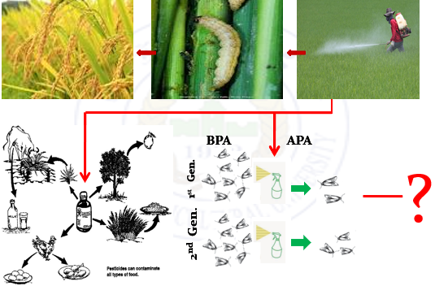  Recent Publications  - Hyder, M., Li, Y., Wang, M., Mao, J., Mari, J. M., Bukero, A., ... & Zhang, L. (2022). Insecticidal activity, Chemical Constituents of Trachyspermum ammi, Withania coagulans and Murraya koenigii ethanloic extracts against Bemisia tabaci. Brazilian Journal of Biology, 84.  - Khuhro, S.A., Mari, J.M, Jatoi, G.H., Soomro, N., Leghari, U.A., & Mengal, A.N. (2001). Resistant Cultivars of Safflower Carthamus tinctorius based on Yield Performance and Infestation against Acanthiophilus helianthi (Diptera: Tephritidae). International Journal on Emerging Technologies 12(1): 175-180.  - Soomro, M. H., Mari, J. M., Nizamani, I. A., & Gilal, A. A. (2020). Impact of trapping density on the performance of aggregation pheromone against Rhynchorphorus ferrugineus (Coleoptera: Dryophthoridae). Int J Entomol Res., 5(3), 129-132.  - Soomro, M. H., Mari, J. M., Nizamani, I. A., & Gilal, A. A. (2022). Performance of Ferrolure+ pheromone in the red palm weevil, Rhynchophorus ferrugineus (Coleoptera: Dryophthoridae) management in date palm growing areas of Sindh, Pakistan. Journal of the Saudi Society of Agricultural Sciences, 21(2), 114-124.  - Mari, J. M., Mari, S., Kumar, S., & Sultana, R. (2019). Utilization of bio-control agent in management of okra pest. Plant Protection, 3(1), 1-7.
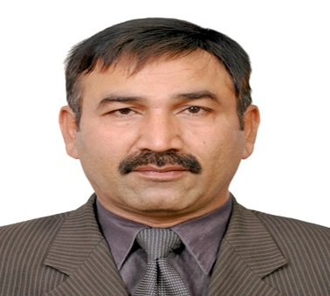 |  |  |  | 

Biography
Prof. Jan Mohammed Mari is currently working as First Pro-Vice Chancellor, Sindh Agriculture University Sub campus, Umerkot. His expertise is in Integrated Pest Management (IPM), biological control and ecology. During the services he taught various courses of Plant Protection and Entomology including Integrated Pest Management, Basic Ecology, Economic Entomology and IPM informatics. He also supervised a number of postgraduate students (Doctoral as well as Masters). As a Principal Investigator, he has successfully completed research projects “Documentation of Insect Pest and their Natural Enemies on Cotton crop” and “Evaluation of different hosts for the rearing of Chrysperla carnea (Stephan)”. He has also performed duty as Principal Scientist in research project “Major Insect pests of chilli in Sindh” funded by Pakistan Science Foundation (PSF), Islamabad, Pakistan. He also worked as Co-Principal Scientist in research projects “Application of Beaureria bassiania for control of pest species of gross hoppers” and “Biology and management of Chilo suppressalis by using eco-friendly tactics based on biogenic volatile organic compounds (BVOCs)” funded by Higher Education Islamabad, Pakistan.
janmarree@gmail.com

Presenting author details
Full name: Professor Dr. Jan Muhammad Mari
Contact number: +923000269158
Twitter account:
Linked In account:
Session name/ number:
Category: (Oral presentation)

