Closed or unclosed mesentery? -A meta-analysis of internal herniation (IH) after laparoscopic Roux-en-Y gastric bypass (LRYGB)
Qian-Long Wu¹, Quan-Zhen Liu¹, Ying-Yun Xi¹, Xiao-Qing Deng¹, Tong-Shan Xu¹, Zi-Chun Xie¹
¹ Guangzhou Medical University, Guangzhou, 510180, China.

Abstract (300 word limit)
Aims: During laparoscopic Roux-en-Y gastric bypass procedure, closing mesentery or not was still controversial according to preexisted studies. So, the current meta-analysis aimed to compare the outcome of closure versus non-closure of mesenteric defects in laparoscopic Roux-en-Y gastric bypass.
Methods: A literature search was conducted in PubMed, EMBASE, Scopus, and Cochrane Library databases using the keywords Mesentery, Internal hernia, and Laparoscopy up to August 2, 2022. After searching, the process of selecting the literature that we got and extracting data was performed independently by two reviewers. Besides, we used the Cochrane risk of bias tool to assess the literature we included.
Results: Fifteen studies were included, enrolling 53,488 patients. Based on the outcome of subgroup analysis, the closure of the mesenteric defects showed a low incidence of IH in patients with >41 years (OR 2.62 [95% CI 1.89,3.63]; p <0.00001) and for Mean age≤41 years (OR 1.52 [95% CI 1.06,2.18]; p =0.02). Moreover, the closure of the mesenteric defects excels non-closure in terms of Jejunal mesenteric site where IH occurred (OR 3.01 [95% CI 1.91,4.75]; p <0.00001), hospital days (MD 0.49 [95% CI 0.35,0.64]; p <0.00001), reoperation (OR 2.18 [95% CI −2.04,2.33]; p <0.00001), while the non-closure of the mesenteric defects was superior to closure in regard to operative time using absorbable sutures purely (MD -15.00 [95% CI -17.31, -12.69]; p <0.00001). No difference was found between the two groups regarding Petersen’s and Jejunal mesenteric’s IH, small bowel obstruction, anastomosis ulcer, stenosis, leakage, bleeding, gastrointestinal perforation, and postoperative BMI of patients.
Conclusions: Regarding Internal Hernia, Jejunal mesenteric site, hospital days, and reoperation, closure of the mesentery was better than non-closure. In terms of operative time, the time of non-closure of the mesentery was shorter than closure. Besides, Petersen’s and Jejunal mesenteric’s IH, small bowel obstruction, anastomosis ulcer, stenosis, leakage, bleeding, gastrointestinal perforation, and postoperative BMI of patients show no difference between non-closure and closure.

Image
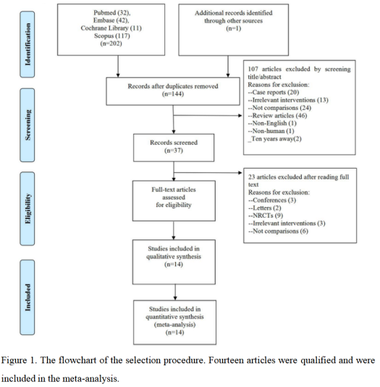
Recent Publications (minimum 5)
- Wu QL, Zeng SX, Peng JY, et al. Advances in metformin for the treatment of non-alcoholic fatty liver disease in children [published online ahead of print, 2022 Sep 8]. Expert Rev Gastroenterol Hepatol. 2022;1-15. doi:10.1080/17474124.2022.2118112.
- Wu QL, Zheng T, Li SZ, et al. Effects of dapagliflozin in the progression of atherosclerosis in patients with type 2 diabetes: a meta-analysis of randomized controlled trials. Diabetol Metab Syndr. 2022;14(1):41. Published 2022 Mar 10. doi:10.1186/s13098-022-00810-3.
- Long T, Lin JT, Lin MH, et al. Comparative efficiency and safety of insulin degludec/aspart with insulin glargine in type 2 diabetes: a meta-analysis of randomized controlled trials. Endocr J. 2022;69(8):959-969. doi:10.1507/endocrj.EJ21-0692.
- Guan Y, Wu Q, Li M, et al. Epigallocatechin-3-gallate induced HepG2 cells apoptosis through ROS-Mediated AKT /JNK and p53 signaling pathway. [published online ahead of print, 2022 Jul 5]. Curr Cancer Drug Targets. 2022;10.2174/1568009622666220705101642. doi:10.2174/1568009622666220705101642.
5. Liang JZ, Li YH, Zhang Y, Wu QN, Wu QL. Expression of ETV6/TEL is associated with prognosis in non-small cell lung cancer. Int J Clin Exp Pathol. 2015;8(3):2937-2945. Published 2015 Mar 1.

Biography (150 word limit)
Paste your Logo here
Not applicable.
Email: drXXXXXXX@xxxmail.com

Notes/Comments:

Presenting author details
Full name:
Contact number:
Twitter account:
Linked In account:
Session name/ number:
Category: (Oral presentation/ Poster presentation)

