Abstract

Black box concept during laparoscopic bariatric surgery our experiences
Lars-Goran Larsson MD Surgical department Mora County Hospital Sweden

Surgical complications during laparoscopic bariatric surgery are still a problem and we are constantly trying to minimize the frequency by improving education, use checklists and share our experiences and surgical shortcomings during congresses like this. Surgery is a high-risk activity and one of the most dangerous acitivity in legal society (Prof PO Nyström) One effective way to improve patient safety during surgery is to copy the routines which airline industriy has been used since 50 years ,the black box koncept. Airline industry is not only safe it´s a ultrasafe activity and we have to strive to reach the same excellent results that this high-risk activity has achieved. In Mora a county hospital in Sweden where we perform o lot of bariatric, gallbladder and hernia surgery we have used audiovideorecording routinely during our operations since a couple of years. During this presentation I will explain how this system is arranged and how it has been introduced in the daily practice in our surgical department i Mora and some pro and cons. I will also show some examples where, thanks to the recording routine, we were able to carry out adequate postoperative analysis which in the end result in improved patient safety. Only recording the surgery is not enough and a guarantee for successful safety work, the most important thing is to share the experiences with other surgeons and this we do via an internet-based surgical videoarchive that is something I have worked with since the early 90s Videoarkivet USÖ • Vårdgivare Region Örebro län (regionorebrolan.se)

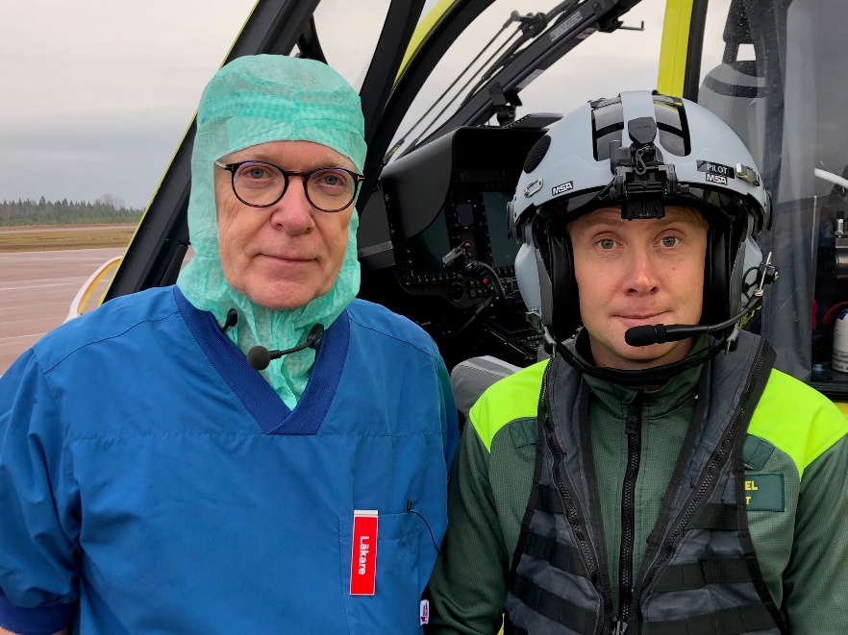

Biography
I work as a minimal invasive surgeon in Mora County Hospital and has spend my career to surgical education , arranged o lot of surgical technical courses and developed a internetbased surgical videoarchive which is used frequently by my surgical colleagues in Sweden.

