Determination of the Accuracy of Linear Height Bone for Implant Placement in Panoramic Radiography Relative to CBCT in the Posterior Areas of the Jaws

Dr Majid Zolfagharikhorshaneh School of Dentistry, Lorestan University of Medical Science, Khorramabad, Iran
DOI: 10.9734/JPRI/2021/v33i59B34421

Abstract

Purpose: In the levels of implant treatment in the posterior region, determining the height of the bone has particular importance. The aim of the study was to compare the accuracy of linear bone height measurement for implant placement on panoramic view compared to CBCT in posterior jaw area.

Materials and Methods: The study was performed on 20 patients. In each of the posterior edentulous areas, a surgical guide for each patient was marked with gutta-percha (a total of 70 points). Panoramic radiographs and CBCTs were obtained from the patients and then the distance between the marked points in the maxilla to the maxillary sinus and in the mandible to the upper border of the alveolar canal was measured by Romaxis software and analyzed by Statistical software Stata 14. The obtained measurements of panoramic view were compared to CBCTs using t-test. P≤0.05 was considered significant.

Results: The mean difference between the sizes obtained from panoramic radiography and CBCT radiography in the maxilla was 0.34 mm (P = 0.57) and the mean difference between the sizes obtained from panoramic radiography and CBCT radiography in the mandible was 0.86 mm (P = 0.004).

Conclusion: According to the results of study, it is logical panoramic radiography just used to preassessment of implant procedures in posterior area of mandible were as it could be more reliable in maxilla.
Image
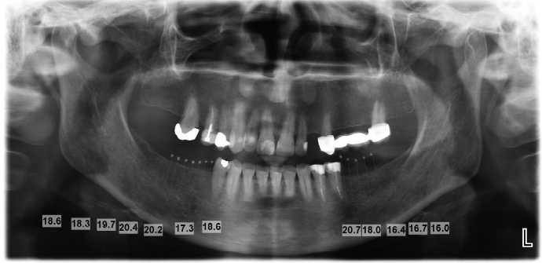

Recent Publications

1 . Different Methods of Jaw Reconstruction and
Implants Asian Journal of Research in Surgery
1(2): 1-6, 2018; Article no.AJRS.46173

2. Determination of the Accuracy of Linear Height Bone for Implant Placement in Panoramic Radiography Relative to CBCT in the Posterior Areas of the Jaws
Journal of Pharmaceutical Research International
33(59B): 604-611, 2021; Article no.JPRI.79017
ISSN: 2456-9119
(Past name: British Journal of Pharmaceutical Research, Past ISSN: 2231-2919,
NLM ID: 101631759)


Biography
Majid zolfagharikhorshaneh has his passion and wishes for improving clinical and diagnosis tools in purposes of better treathment plan in order to continues research on different paper work . his creativity on selecting the unbound titles for discover the newly method help him to make a clear horize on different treathment procedure to gain the better prognosis
Email: m10266z@yahoo.com

