Physicochemical Effects of Magnesium Chloride on the solvation Behavior of an Anti-epileptic Drug, Sodium Valproate: Volumetric, Acoustic and Spectroscopic Approach
Amandeep Kaur, Department of Chemistry, DAV College, Jalandhar-144008, Punjab, India
Tarlok Singh Banipal, Department of Chemistry, Guru Nanak Dev University, Amritsar – 143005, Punjab, India

Abstract
Study of the physicochemical properties of anti-epileptic drugs in the presence of co-solutes in aqueous solutions has been a subject of interest of researchers because of their interaction with biological membranes to employ their effect. Such properties provide complete information regarding solute-solute and solute-solvent type interactions. As the electrolytes are the essential component of biological system, therefore the study of drug-electrolyte chemistry is important to understand the mechanism of drug action at molecular level and hence useful in drug discovery and development process. Therefore, in the current report, the density and sound velocity of an anti-epileptic drug sodium valproate (SV) in aqueous and in aqueous solutions of an electrolyte viz. MgCl₂ (m_{B} = 0.024, 0.047, 0.070 mol kg⁻¹) at different temperatures (288.15, 298.15, 308.15, and 318.15 K) have been measured along with ¹H-NMR spectroscopy. Various volumetric and acoustical parameters like apparent molar volume (V) and isentropic compressibility (K_{s}) of solutes, apparent molar volume (V°) and isentropic compressibility (K_{s}°) of solutes at infinite dilution, apparent molar expansibility (E°) and their double derivatives (∂²V°/∂T²)_{P}, transfer volumes (∆_{tr}V°), acoustic impedance (Z) and intermolecular free length (L_{f}) have been calculated from density and sound velocity data. The variation in all these parameters with co-solute concentration indicate the existence of hydrophilic/ionic-ionic interactions at lower but hydrophobic-ionic interactions at higher concentrations of MgCl₂. The ¹H-NMR spectroscopic results also support the existence of hydrophobic-ionic interactions at higher concentrations of MgCl₂. The decrease in electrostriction but increase in hydrophobic hydration of solute molecules has also been seen with rise in temperature.

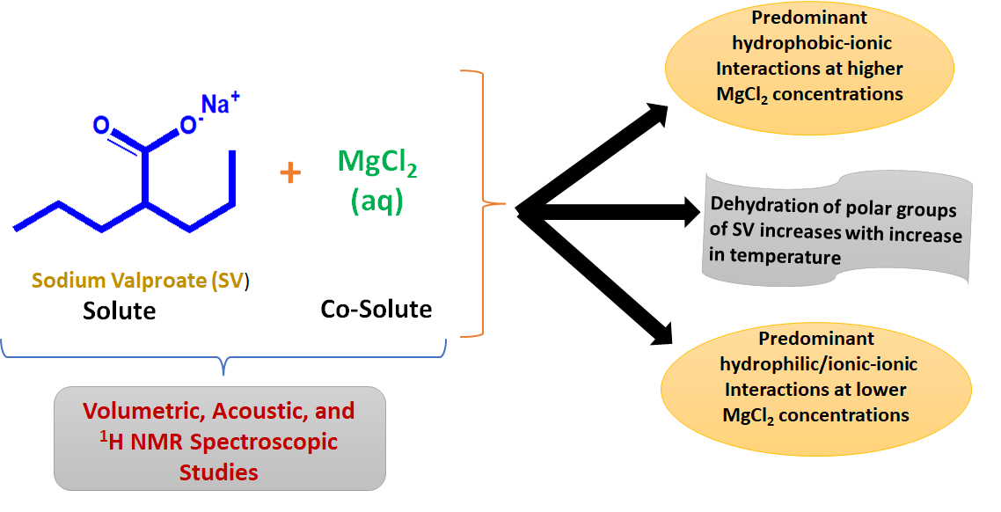
Graphical Abstract

Recent Publications (minimum 5)
- A. Kaur, Mehak, P. K. Banipal, T. S. Banipal (2022) Molecular Interactions of Local Anesthetics in Aqueous MgCl₂ Solutions: A Volumetric, Acoustic and Spectroscopic Analysis. J. Mol. Liq. 367: 120505.
- A. Kaur, K. Kaur, P. K. Banipal, T. S. Banipal (2021) Investigations on the pH-dependent binding of sodium valproate with bovine serum albumin: A calorimetric, spectroscopic and volumetric approach. J. Chem. Thermodyn. 152: 106269.
- A. Kaur, S. Sharma, P. K. Banipal, T. S. Banipal (2018) Probing the binding ability of vitamin B₁ with bovine serum albumin: calorimetric, light scattering, spectroscopic and volumetric studies. J. Chem. Thermodyn. 127: 59-70.
- A. Kaur, I. A. Khan, P. K. Banipal, T. S. Banipal (2018) Deciphering the complexation process of a fluoroquinolone antibiotic, levofloxacin, with bovine serum albumin in the presence of additives. Spectrochim. Acta Part A 191: 259-270.
- A. Kaur, P. K. Banipal, T. S. Banipal (2017) Local anesthetic-bovine serum albumin interactional behaviour: Characterization by volumetric, calorimetric, and spectroscopic methods. J. Mol. Liq. 243: 91-101.

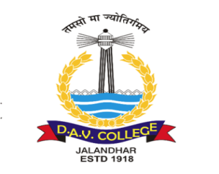



Biography (150 word limit)
Dr. Amandeep Kaur is currently working as Assistant Professor at Department of Chemistry DAV College Jalandhar. She received her M.Sc. degree in Chemistry from Department of Chemistry, GNDU, Amritsar. She completed her Ph.D. in Biophysical Chemistry in 2018 under the guidance of Dr. Tarlok Singh Banipal at GNDU, Amritsar. Her research work includes the study of various physicochemical properties of protein-ligand (drugs/ pollutants/ metal ions) interactions as well as the solution chemistry of drug-electrolyte systems using various spectroscopic, calorimetric, microscopic, volumetric and acoustical methods.
Email: amanchem27@gmail.com

Notes/Comments:

Presenting author details
Full name: Dr. Amandeep Kaur
Contact number: 9501626896
Twitter account:
Linked In account:
Session name/ number: Solution and Thermodynamics/ Track 3
Category: (Oral presentation/ Poster presentation) ………….Poster Presentation

