The Chemistry of Memory
Gerard Marx, MX Biotech Ltd., Jerusalem, Israel
Chaim Gilon, Institute of Chemistry, Hebrew University, Jerusalem, Israel

Abstract (300 word limit)

The ambition of modern neuroscientists is to analyze natural phenomena with testable/observable descriptions. However, mental states are inherently untestable, unobserved. Psychoanalysis does little to clarify the molecular processes that occur in our brains. Physics is encumbered by its focus on observables related to mass, light, kinetics and primary forces: gravity, electro-magnetism, weak and strong nuclear forces. Computer/Information scientists are hemmed in by binary algorithms that have no code for emotive states.

It falls to the physiologic-biochemist to cut this “Gordian knot “ of mentality. We provide a short review of the evolution of chemical notations (chemography) that helped clarify the composition and structure of matter, from simple chemicals to complex, chiral molecules.

Focusing on neural memory, we present a chemographic shorthand for the biochemical encoding of emotive experience with molecules and processes available to brain cells.

Three brain compartments are critical to the emergence of memory, namely:

• Brain cells - neurons & glial (astrocytes) cells organized as specialized circuits.

• nECM/PNN - extracellular matrix/perineural glycose-aminoglycan net that surround the brain cells and performs as a “memory material”.

• Dopants - metal cations & transmitter molecules (neuro- and glio-transmitters (NTs & GTs). which elicit physiologic reactions as well as affective mental states and encode these in the nECM.

The tripartite mechanism with chemographic notation describes the combined interactions of neural cells with their immediate glycose-aminoglycan surroundings that permit the encoding of feelings and decodes these as emotive memory.
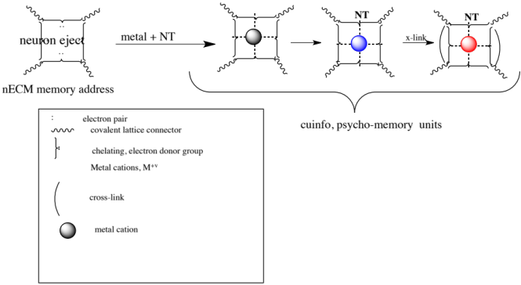
Figure 1. Chemographic representations of the reaction of a nECM
electron rich site (“address”) with a metal cation. The subsequent
binding of a neurotransmitter (NT) to the metal-centered
cognitive unit of information (cuinfo) confers emotive context, later rendered more stable by cross-linking.
Recent Publications (minimum 5)
- Marx G., Gilon C. (2012).The molecular basis of memory.
ACS Chemical Neurosci. 3:633-642.
- Marx G., Gilon C. (2013). The molecular basis of memory.
MBM Pt 2: The chemistry of the tripartite mechanism.
ACS Chem. Neurosci. 4, 983–993.
- Marx, G., Gilon C. (2016).The molecular basis of neural memory. MBM Pt 6: Chemical coding of logical and emotive modes. Int. J. Neurology Res. 2: 259-268.
- Marx G, Gilon C. 2020.
The Molecular Basis of Neural Memory. Part 11.
Chem-electric Write /Read Processes.
J. Neurosurg. Imaging Techniques 6: 283-301.
- Marx G, Gilon C. 2022.
History of chemical notations from alchemy to psycho-chemistry.
Israel J. Chem. e202100088

Gerard Marx is a biochemist with a background in blood coagulation and tissue engineering with blood-derived proteins, notably fibrinogen and albumin. He invented Fibrin Sealants for surgical applications and variants thereof for tissue engineering.
Dr. Marx graduated with a BSc degree in Chemistry from City College, New York, and a PhD in Organic/Polymer Chemistry from Brooklyn Polytechnic Institute. He worked in Columbia University P&S, Mt Sinai (NY), New York Blood Center, Magen David Adom (MDA) Blood Bank, Beilinson Hospital (Petah Tikva) and Hadassah Medical Center (Jerusalem). He has guided the research activities of commercial start-up companies (Vitex Inc., Hapto Biotech Inc, MX Biotech Ltd).
Currently, in collaboration with Professor Chaim Gilon (Hebrew University), he is working on the molecular basis of mental processes, notably neural memory and emotions.

Email: gerardmarx@gmail.com

Notes/Comments:

Presenting author details
Full name: Gerard Marx
Contact number: +972 52 5214660
Twitter account:
Linked In account:
Session name/ number:
Category: (Oral presentation/)

