Life Cycle Assessment between Reusable Packaging of Vacuum Insulated Panels Using Recycled PET and Expanded Polystyrene Boxes

Sooyeon Kim, Dept. of Biotechnology, Korea University, Seoul, Republic of Korea
Charoensri Korakot, PhD, Dept. of Biotechnology, Korea University, Seoul, Republic of Korea
Yangjae Shin, PhD, Dept. of Biotechnology, Korea University, Seoul, Republic of Korea
Hyunjin Park, PhD, Dept. of Biotechnology, Korea University, Seoul, Republic of Korea
Dongho Kang, PhD,Korea Institute of Industrial Technology,Bucheon, Republic of Korea

Abstract (300 word limit)
In many countries, including Korea, disposable expanded styrene (EPS) boxes are widely used as packaging materials for vaccines and fresh food. This was due to the relatively low price, but there was a problem of generating enormous waste according to single-use. In the case of disposal, landfill and incineration of EPS boxes are high in Europe, whereas Korea has a relatively high recycling rate. As a result of the LCA analysis, based on the survey data in 2020, Korea showed about 6.6 times higher environmental advantage in CO2 reduction than Europe. In addition, conventional vacuum insulation materials (VIP) made of glass fiber, such as fumed glass, are expensive and have to use thick packaging materials due to thermal bridge problems on curved surfaces when applied to packaging. The issue of recycling was also raised. Therefore, by developing a VIP packaging material made by recycling PET bottles, which are discarded in large quantities, we tried to improve the problems of the existing EPS and glass fiber VIP packaging. In addition, the number of reuses was designed and tested beyond the existing EPE-based reusable packaging materials, but it was set based on the average number of uses of the existing packaging, 85 times. As a result of the life cycle environmental impact assessment, CO2 reduction was 16.3% compared to Korea's EPS box and 83.0% lower than Europe. Therefore, VIP reusable packaging that recycles discarded PET bottles is expected to contribute to the realization of a circular economy by reducing CO2 eq compared to existing disposable EPS boxes.
Image
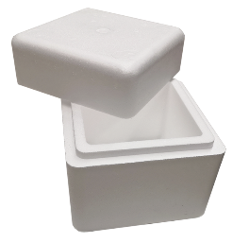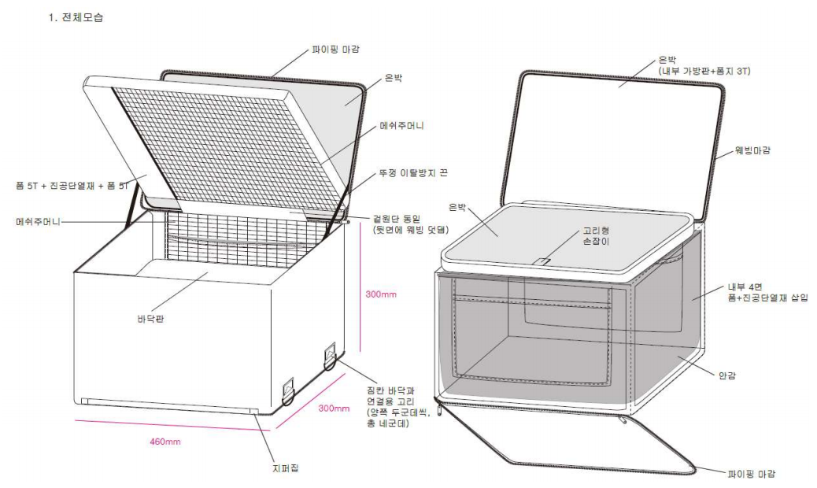
Recent Publications (minimum 5)
- SY Kim, CHAROENSRI KORAKOT, YJ Shin, and HJ Park (2022) Environmental Impact Assessment of EPS Box for Fresh Food in Korea and Europe. KOREAN JOURNAL OF PACKAGING SCIENCE & TECHNOLOGY Vol. 28, No. 3 201~210
- HJ Kim, K Charoensri, JA Ko, HJ Park (2022) Effects of layered double hydroxides on poly (vinyl alcohol)/poly (acrylic acid) films for green food packaging applications, Progress in Organic Coatings 163, 106634
- C KORAKOT, SY Kim, YJ Shin, HM Jung, JM Park (2022) Measurement of Delivery Service Environment for Cold Chain EPS Packaging System of Fresh Food, KOREAN JOURNAL OF PACKAGING SCIENCE & TECHNOLOGY 28 (1), 67-73
- K Charoensri, YJ Shin, KC Kim, HJ Park (2022) Active Packaging Material Based on Immobilized Diatomaceous Earth/Zinc Oxide/High-Density Polyethylene Composite for Sea Food and Products, Polymers 14 (23), 5228
- B Cho, K Charoensri, H Doh, H Park (2023) Preparation of Colorimetric Sensor Array System to Evaluate the Effects of Alginate Edible Coating on Boiled-Dried Anchovy, Foods 12 (3), 638


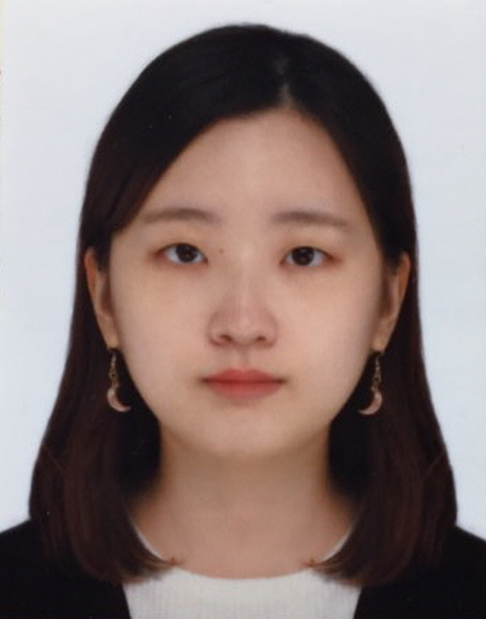 Biography (150 word limit)

Master Course Sooyeon, Kim
Systems Food Biotechnology
145 Anam-Ro, Seongbuk-Gu, Seoul 02841, Korea
Email: sykim22@korea.ac.kr

Notes/Comments:

Presenting author details
Full name: Sooyeon, Kim
Contact number: +82-10-3023-3292
Twitter account:
Linked In account:
Session name/ number: Track 6:Plastic Waste Recycling
Category: Poster presentation
(태국학회 제출 원문)

In many countries, including Korea, single-use expanded styrene (EPS) is most widely used as a packaging material for distribution of vaccines and fresh food. Especially after COVID-19, online delivery service has increased quantity rapidly, but it is causing many environmental problems when discarded. In addition, existing vacuum insulation panel (VIP) made of fumed glass or glass fiber material has higher insulation than EPS, but inside of packaging material is thicker due to heat bridge problem that cannot be applied to curved surface of the packaging material. It had to be reinforced, so content volume was reduced and unit price was high. To improve this, RECYCLED-PET VIP, which recycled discarded PET bottles, and eco-friendly packaging materials that can be reused were developed. The packaging was then compared to EPS packaging to evaluate LCA. Environmental impact assessment started with production of raw materials, and analyzed environmental impact according to the amount of materials and energy generated at each stage, such as packaging production, transportation, cleaning, and disposal. In addition, the number of reuses was set based on the average number of times of use of existing reusable packaging materials, 85 times, and environmental impact caused by fine dust was evaluated by additionally installing a dust collection facility to increase cleanliness of packaging manufacturing process. As a result of life cycle environmental impact assessment, despite fact that 0.339 kg CO2 eq increased in GWP category due to the addition of a dust collector, overall environmental impact was reduced by 16.3% compared to EPS packaging. Also, fine dust (PM 2.5) was reduced by 6.5 times. In addition, through ISTA 7D test and thermal conductivity test, insulation performance of the container increased by about 2.3 times compared to EPS packaging material, and it was expected that it would be possible to maintain freshness for a longer time or to distribute more contents by reducing thickness of the packaging material. As a result, it is expected that reusable packaging using VIP that recycled discarded PET bottles can contribute to realization of a circular economy, such as reducing CO2 eq compared to existing disposable EPS packaging.

(수정1)

In many countries, including Korea, single-use expanded styrene (EPS) is most widely used as a packaging material for distribution of vaccines and fresh food.
Compared to Europe, Korea has a relatively higher rate of recycling than landfill and incineration of EPS boxes, and recyclables manufactured from waste EPS boxes are used for various purposes other than building insulation. LCA results showed environmental benefits of recycling EPS boxes in Korea are about 6.6 times higher than those of European EPS boxes as of 2020.

In addition, existing vacuum insulation panel (VIP) made of fumed glass or glass fiber material has higher insulation than EPS, but inside of packaging material is thicker due to heat bridge problem that cannot be applied to curved surface of the packaging material. It had to be reinforced, so content volume was reduced and unit price was high. In addition, the recycling rate of PET bottles, which are currently being discarded, is reduced, so to improve the recycling rate of PET bottles and reduce carbon dioxide, RECYCLED-PET VIP, which recycled discarded PET bottles, and eco-friendly packaging materials that can be reused were developed and compared to EPS packaging to evaluate LCA. In addition, the number of reuses was set based on the average number of times of use of existing reusable packaging materials, 85 times.

As a result of life cycle environmental impact assessment, overall environmental impact was reduced by 16.3% compared to EPS packaging in Korea and 83% compared to EPS packaging in Europe. As a result, it is expected that reusable packaging using VIP that recycled discarded PET bottles can contribute to realization of a circular economy, such as reducing CO2 eq compared to existing disposable EPS packaging.

