Covid-19 Vaccination and Myocarditis – Who is the culprit?
Dr. Jasim Jalal
Olive Health Care
India

Abstract (300 word limit)
Covid-19 is the greatest epidemic of this century. Covid-19 vaccination was indeed a great breakthrough in tacking the SARS-CoV 2 virus. Myocarditis is one of the dangerous complication post covid-19 mRNA vaccination. What could be the cause?
Let’s analyse the causes.
1. Antibody responses – qualitative and quantitative
2. T-cell response
3. Cytokine release
4. Viral antigens

Who among these is the actual culprit?
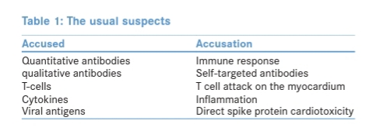

Recent Publications (minimum 5)
- Li G, Fan Y, Lai Y, Han T, Li Z, Zhou P, et al. Coronavirus infections and immune responses. J Med Virol 2020;92:424-32.
- Seneff S, Nigh G, Kyriakopoulos AM, McCullough PA. Innate immune suppression by SARS-CoV-2 mRNA vaccinations: The role of G-quadruplexes, exosomes, and microRNAs. Food Chem Toxicol 2022;164:113008.
- Hurme A, Jalkanen P, Heroum J, Liedes O, Vara S, Melin M, et al. Long-lasting T cell responses in BNT162b2 COVID-19 mRNA vaccinees and COVID-19 convalescent patients. Front Immunol 2022;13:869990.
- Ouldali N, Bagheri H, Salvo F, Antona D, Pariente A, Leblanc C, et al. Hyper inflammatory syndrome following COVID-19 mRNA vaccine in children: A national post-authorization pharmacovigilance study. Lancet Reg Health Eur 2022;17:100393.
- Rijkers GT, Weterings N, Obregon-Henao A, Lepolder M, Dutt TS, van Overveld FJ, et al. Antigen presentation of mRNA based and virus-vectored SARS-CoV-2 vaccines. Vaccines (Basel) 2021;9:848.

Biography (150 word limit)

Dr Jasim Jalal is a Consultant Physician and specialises in rheumatology and clinical neurology.

Jasim graduated from Government Medical College, Trivandrum, India in 2010. Following his Physician training (DNB – Family medicine) and a three-year tenure as Consultant Physician, he completed rheumatology advanced training (EULAR certification in Rheumatology) and a rigorous diabetes and clinical neurology training at Lakeshore Hospital and Research Center, Kochi, India.

He has an ongoing appointment as Consultant Rheumatologist at the Olive Health Care. He is actively involved in teaching medical students and advanced trainees at the Olive Health Care. He also practices privately widely across the coastal regions of Thrissur, Kerala, India.

His interest in Rheumatology is wide-ranged and include Rheumatoid Arthritis, Systemic Lupus Erythematosus and Mixed Connective Tissue Diseases. He has multiple publications in peer-reviewed journals in Medicine, Rheumatology and Neurology.

He is a compassionate and experienced physician and rheumatologist who believes in holistic care of the patients and focuses on evidence-based practices to achieve excellent outcomes.

Email:
jasimabduljalal@yahoo.com

Presenting author details
Full name: Jasim Jalal
Contact number: 9778252781
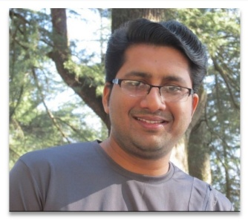
Category: (Poster presentati

