Design of a Reversible Full Adder Using Quantum Cellular Automata

Rashmi Seethur, PES University, Karnataka, India

Abstract

Contemporary times holds a substantial hurdle in the designing of chips and ICs due to the roadblocks in the nanotech scaling of transistors, which is an obvious reason for Moore's Law to be working at a slower pace. The CMOS, VLSI technology imposes serious challenges when it enters the nano-domain, leading to the need of an innovation in nanotech scale. Quantum Dot Cellular Automata (QDCA or QCA) is a novel emerging transistor-less revolution for computation in the nanotech order. Besides this, irreversibility is a major concern in digital computation due to the loss of information. Therefore, here a reversible methodology is followed to address the problem of power dissipation. The purpose of this paper is to present a novel reversible full adder (RFA) of complexity 123 cells, 1.5 delay and area of 0.11um2 is introduced using single layer cross over coplanar scheme, employing the demonstrated adder universal basic gates are implemented. On the basis of this adder we construct a 3-bit Comparator with a delay of 4.25 factors and cell count of 581.

Image

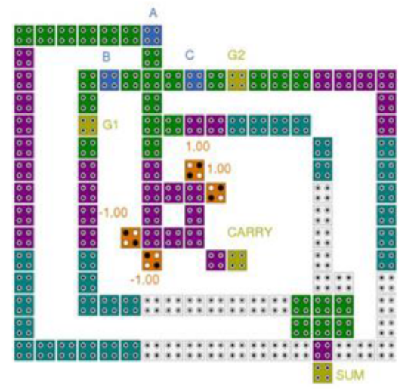

Fig1. Proposed Reversible Full Adder
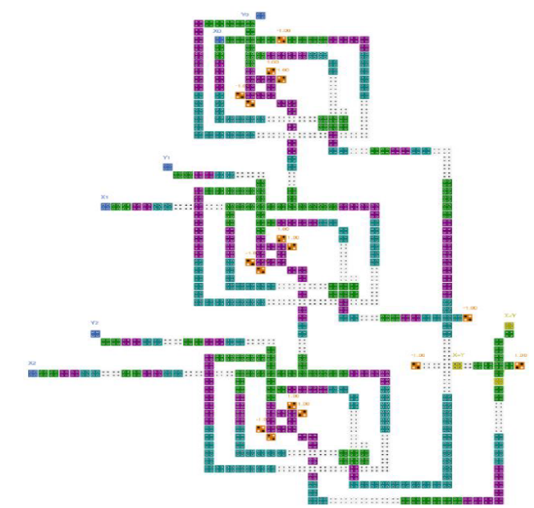

Fig2. 3-bit Comparator

Recent Publications
- T, S., Sanyal, W. & Seethur, R. (2022). Design of a Reversible Full Adder Using Quantum Cellular Automata. The Eurasia Proceedings of Science Technology Engineering and Mathematics, 21, 500-505. DOI: 10.55549/epstem.1227552
- S. T and R. Seethur, "Design of a Dual Band Low Noise Amplifier at 1.1GHz and 2.4GHz," 2022 IEEE International RF and Microwave Conference (RFM), Kuala Lumpur, Malaysia, 2022, pp. 1-4, doi: 10.1109/RFM56185.2022.10065193.
- Rashmi, S.B., Yellampalli, S.S. & Shreedhar, H.K. 60 GHz Common-Gate Single-Stage Current Reuse Cascode LNA Topology for High-Data-Rate Applications. J. Electron. Mater. 50, 1655–1667 (2021). https://doi.org/10.1007/s11664-020-08494-z
- Rajdev, N. C. , V, L. & Seethur, R. (2022). Design of Dual-Stage Ku- Band Low Noise Amplifier for Satellite Downlink Application . The Eurasia Proceedings of Science Technology Engineering and Mathematics , 21 , 196-201 . DOI: 10.55549/epstem.1225081
- Seethur, R., Yellampalli, S., & Shreedhar H. K. (2022). Design of Common Gate Current-Reuse Noise Cancellation UWB Low Noise Amplifier in 90nm CMOS. International Journal of Electronics, Communications, and Measurement Engineering (IJECME), 11(1), 1-14. http://doi.org/10.4018/IJECME.312257


Biography


Dr. Rashmi Seethur Completed BE in Electronics and Communication from Visveswaraya Technological University in 2004. Completed Master of Technology in VLSI and Embedded systems, 2012 with CGPA of 8.09 at UTL Technologies Limited VTU Extension Centre Bangalore. Completed Ph.D. in CMOS RF circuit design in 2019 from Visveswaraya Technological University. Her research interests are Analog circuit design, CMOS Amplifier design, RF circuit design and reversible logic. She has a teaching experience of about 15 years. She is a life member for IACSIT.
Email: rashmiseethur@pes.edu

