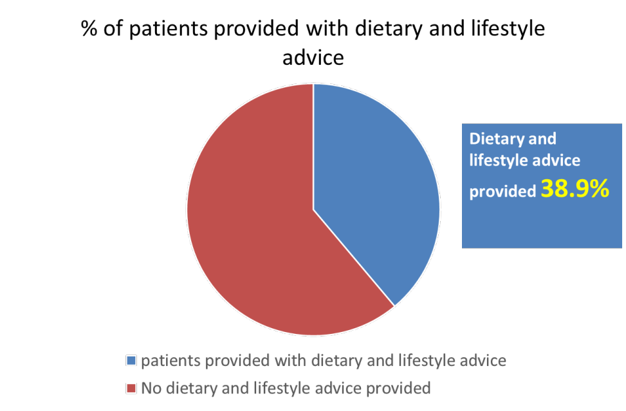

Abstract: Background: Diet and environment play an important role in stone disease, presumably by modulating urine composition. Dietary modification to decrease lithogenic risk factors and prevent stone recurrence has potential to be safer and more economical than drug treatment. NICE Guidance recommends that all patients with renal and ureteric stones should undergo dietary and lifestyle advice;
1. 2.5-3L water/ day
2. Avoiding carbonated drinks
3. Salt intake no more than 6g
4. Maintain normal dietary calcium intake, not to restrict
Above information is provided in a British Association of Urological Surgeons (BAUS) information leaflet. Aims/ Objectives: To assess whether target compliance of 100% has been achieved. To improve departmental compliance with NICE guidelines of providing dietary and lifestyle advice to patients admitted under urology presenting with renal and ureteric stones. To improve patient understanding leading to improved patient care and experience. Method: Male and female patients, aged >=18, all ethnicities were included. We performed a retrospective data collection from patient discharge lists during the period from October -November 2022. Results: 59 patients were included. 38.9% of patients were provided with dietary and lifestyle advice. 17 patients received complete advice in the form of a BAUS leaflet. 36 patients received no dietary and lifestyle advice. Of the 23 patients who were given dietary advice, 73.9% were provided with a BAUS leaflet and 26.1% of patients were provided with verbal advice on fluid intake. Discussion/ conclusion: Urology department is non-compliant with standards for provision of lifestyle and dietary advice for patients presenting with renal and/ or ureteric stones. Recommendations are made to increase the availability of BAUS stone leaflets. Posters have been placed to remind junior doctors to provide leaflets. A QR code link to the diet leaflet has been generated to enable patients to access the advice from their phones.
Presenting author details:
Full Name: Lauren Shipperbottom
Contact number: 07712506904
Email: lauren.shipperbottom1@nhs.net
Recent Publications:
- Shipperbottom, L., & Scally, R. (2021). A service evaluation of the healthy lifestyle groups in a female medium secure unit- what do our patients know about nutrition? BJPsych Open, 7(S1), S350-S350. doi:10.1192/bjo.2021.917

