4th Annual Congress on Plant Biology & Agricultural Sciences May 15-16, 2023 at Madrid, Spain

Title: Genomics of the ERF family in Crop Running Title: ERF family in Crop

Shouhartha Choudhury^{1,} ^{2,} ³ *
1H K School of Life Sciences, Assam University, Silchar-788011
2Department of Biotechnology, Assam University, Silchar-788011
3Department of Life Science and Bioinformatics, Assam University, Silchar-788011

Keywords: AP2/ERF superfamily; ERF/DREB family; Abiotic Stress; and Development

Highlights:
several plant-specific genes observe in crops. Those species-specific genes regulate growth and abiotic stress in plants. Therefore, the above findings provided expensive knowledge in agronomic, economic and ecological traits and possibly other avails in crops.

- Repeated AP2 domain originated during the growing embryo, leaf, and flower.
Organisms | Arabidopsis thaliana | Oryza sativa | Brassica juncea
AP2 domain | 178 | 189 | 544
RRTF1 | 1 | 2 | 6

- The sole AP2 domain initiated abiotic stress such as freezing, drought, salt, low oxygen, oxidative, osmotic, heat, heavy metals, and soil salinity.
- AP2 domain with the B3 domain implicated the solution of brassinosteroid.

Abstract:
The AP2 (apetala2)/ERF (ethylene-responsive factor) superfamily has diverse functions that prevail during growth and stress abidance in the crop. In contrast, the ERF family of transcription factor (TF) genes is widespread in the plant genome. Known studies exhibit the ERF family classify into the DREB (dehydration-responsive element- binding) subfamily. Therefore, the AP2/ERF family demonstrated the repeated AP2 domain originated during growth. The sole AP2 domain initiated abiotic stress. Finally, the AP2 with B3 domain implicated the solution of brassinosteroid. So, observation of the large AP2/ERF family is fundamental to pursuing the subject of the major ERF family and their sub-family involved during stress fluctuation in crops. Therefore, perform bioinformatics and computational techniques to the present wisdom of the mighty

Reference:

Table

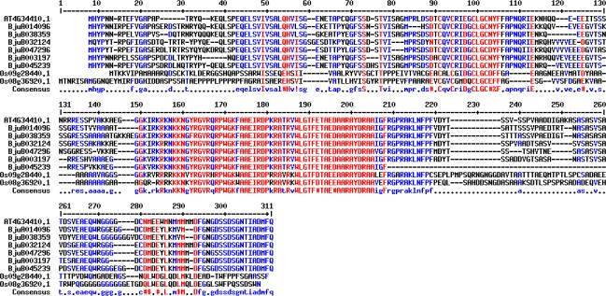
Figure

AP2/ERF family and their subfamilies in crops. This method may be significant for future analysis of particular gene families in the plant. So, the present observation explored the stress-responsive ERF family and DREB subfamily in three species. The findings provided evidence of the ERF family and their subfamily existence in all species. Also, remark on earlier reported genes and presented overall genes between the ERF and DREB family in three different plant species. The specific bioinformatics and computational analysis documented the conserved domain, motifs, phylogeny, gene network, and gene expression. These results will be valuable for future examination of substantial AP2/ERF superfamily. In this study,
  - Sakuma, Y., Liu, Q., Dubouzet, J. G., Abe, H., Shinozaki, K.and Yamaguchi-Shinozaki, K.2002. DNA-binding specificity of the ERF/AP2 domain of Arabidopsis DREBs, transcription factors involved in dehydration-and cold-inducible gene expression. Bioch. Biophysical Res. Communi., 290(3): 998-1009.
  - Nakano, T., Suzuki, K., Fujimura, T. and Shinshi, H. 2006. Genome-wide analysis of the ERF gene family in Arabidopsis and rice. Plant Physio., 140(2): 411-432

  - Shouhartha Choudhury, In-silico analysis of ERF family in Arabidopsis, Oryza, and Solanum crop plants, Journal of Genetics, Genomics & Plant Breeding, Vol. 3(3) 34-44 (July 2019)

Biography:
The author did B.Tech in Bioinformatics from Bharath University, Chennai (2011). The Bharath University is Deemed University under the UGC Act located in Tamil Nadu, Chennai, India.

Then he obtained an M.Tech in Bioinformatics from West Bengal University of Technology, Kolkata (2014). The West Bengal University is a State University situated in West Bengal, Kolkata, India

Afterwards, he joined Assam University, Silchar, as an IPP(Integrated Pre-PhD) Program in 2016. Then he did coursework in the Department of Life Science and Bioinformatics, Assam University, Silchar, India

After course work, the author enrolled for M.Phil in Life Science and Bioinformatics in the Department of Life Science and Bioinformatics, Assam University, Silchar. During M. Phil research, he proposed bioinformatics and a computational pipeline for genome- wide analysis of transcription factor genes. Also, he published a research article in M.Phil research.

Also, the author continued PhD research in Biotechnology in the Department of Biotechnology, Assam University, Silchar. He published research articles in Cancer Science and Development and one article on Diabetes during PhD research. He even communicated various peer-review pre-printed research papers for evaluation and consideration in Journals. Also, he presented abstracts and participated in National and International Conferences. Furthermore, The author is a reviewer of the Journal of Cancer Gene Therapy, the Journal of Cancer Reports, and the Journal of Diabetes and Metabolism.

Author details*



*Corresponding author
Full Name: Shouhartha Choudhury Email: shouharthac@gmail.com bioinfo11shouhartha@gmail.com
Contact number: +91-9365860541 (WhatsAPP)
+91-9707912559
Linked In account: Shouhartha Choudhury Category: Oral presentation
Passport Number: Z6304193

