Effect of Soil Mineral Elements on Their Distribution in the Different Parts of the Plant and on the Yield of Chickpea-Rhizobium Symbioses
Ahmed Khadraji, Ahmed Qadourry, Cherki Ghoulam
Center of Agrobiotechnology and Bioengineering, (Centre AgroBiotech-URL-CNRST-05), Laboratory of Biotechnology and Agrophysiology of Symbiosis, Cadi Ayyad University, Marrakesh, Morocco

Abstract
Statement of the Problem: Chickpea is a legume with high nutritional value. It is mainly grown in arid and semi-arid areas soils, which are characterized by a deficiency in mineral elements, a severe water deficit and a poor soil quality. Chickpea is an important crop that provides the main components of the human diet to a growing global population. Chickpea is an important source of protein, fiber, and micronutrients and plays an essential role in sustainable agriculture. The chickpea crop in terms of production ranks third after beans with an annual production of over 11.5 million tons. Our work aims to evaluate the effect of different mineral elements in the soil on nodular biomass, growth and yield of chickpea. Methodology & Theoretical Orientation: The physico-chemical analyzes of the soil and the agronomic, physiological parameters showed us that the level of phosphorus available in the soil positively affected the growth parameters in the chickpea plants studied. Our results also confirmed the positive effect of adequate plant P nutrition on plant yield. Indeed, agricultural soil 7 presented the highest potassium content and yield (12.87 mg/g DM and 62 seeds per plant, respectively). In parallel, soil 7 recorded the highest value of phosphorus 23.52 ppm. On the contrary, soil 5 was the least rich in this element (6.73 ppm). A positive correlation was recorded between the sodium concentration in the soil and in the aerial parts (r =0.73). The results also showed that the aerial part was richer in calcium than the root part and the nodules. Moreover, other positive correlations were recorded between the calcium concentration in the soil and in the aerial part and in the root part (r =0.76 and r =0.54; respectively).
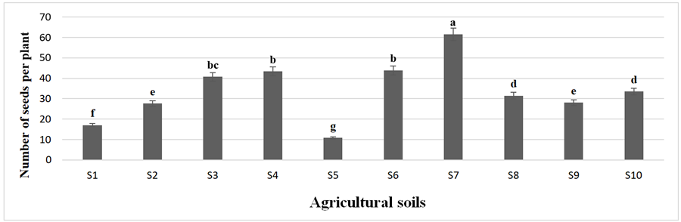
Figure 4. Yield of chickpea plants in the different agricultural soils.
Recent Publications (minimum 5)
- Khadraji A, Bouhadi M, Ghoulam C (2020) Effect of Soil Available Phosphorus Levels on Chickpea (Cicer arietinum L.)—Rhizobia Symbiotic Association. Legum. Res. 43: 878–883.
- Gaj R, Szulc P, Siatkowski I, Waligóra H (2020) Assessment of the effect of the mineral fertilization system on the nutritional status of maize plants and grain yield prediction. Agriculture 10: 404.
- Wang Y, Chen Y. F and W. H. Wu. (2020c) Potassium and phosphorus transport and signaling in plants. J. Integr. Plant Biol. 63: 34–52. doi: 10.1111/jipb.13053
- Gilliham M., Dayod M, Hocking BJ, Xu B, Conn SJ, Kaiser BN, Leigh RA, Tyerman SD. (2011) Calcium delivery and storage in plant leaves: exploring the link with water flow. Journal of Experimental Botany.62: 2233– 2250.
- Dayod M, Tyerman SD, Leigh RA, Gilliham M. (2010) Calcium storage in plants and the implications for calcium biofortification, Protoplasma. 247: 215-231.

Biography


Ahmed Khadraji has an experience of more than twenty years of work in teaching and research in biology and plant physiology. Several artciles are to his credit which mainly concern legumes and in particular the growth of chickpea under water deficit. From the early stage of development to the production stage, agronomic and physiological analyses are implemented to improve the yield of chickpea plants under water deficit.
Email: khadraji,fstg@gmail.com

Notes/Comments:

Presenting author details
Full name: ahmed KHADRAJI
Contact number:212642672012
Linked In account: ahmed-khadraji-bba84447/
Category: Oral presentation

