Herbal tea mixtures: The synergy in the background
Elena Kurin, PharmDr Mgr PhD, Faculty of Pharmacy, Comenius University, Bratislava, Slovakia
Silvia Bittner Fialova, Assoc Prof PharmDr PhD, Faculty of Pharmacy, Comenius University, Bratislava,Slovakia
Eva Trajcikova, PharmDr PhD, Faculty of Pharmacy, Comenius University, Bratislava,Slovakia
Pavel Mucaji, Prof PharmDr PhD, Faculty of Pharmacy, Comenius University, Bratislava,Slovakia
Milan Nagy, Prof Ing CSc, Faculty of Pharmacy, Comenius University, Bratislava,Slovakia

Abstract
Camellia sinensis Kuntze and Mentha × piperita L. are plants from different taxonomic orders. However, both enjoy great worldwide popularity for the well-known drinks prepared as a water infusion from their leaves: green tea and peppermint tea. Both plants are a rich source of polyphenols, known antioxidants that are the subject of research in medicinal plants and food stabilization as well. Most of the studies focus on investigating the effects of individual plants. But in combinations a hidden synergy can occur, mainly when the chemical composition of individual plants is different. Therefore, we explored the antioxidant activity of peppermint and green tea leaves lyophilizates, respectively. In addition, using different mixing method and different extract ratios we prepared lyophilized mixtures, which antioxidant activity was subsequently evaluated. Interaction analysis revealed the hidden synergy in several mixtures to quench the DPPH radical and in the DCF cell-based antioxidant assay. We also performed an interaction analysis of the combination of polyphenols present in the green tea (epigallocatechin gallate and quercetin) and peppermint tea (rosmarinic acid), respectively. We discovered synergy among polyphenols in the DPPH assay, which can partially enlighten the interaction of the lyophilizates on molecular level. Our work supports the old practice of combining the herbal substances into herbal tea mixtures, where the achieved effects are higher, than expected.
Acknowledgements: this work was supported by VEGA grants 1/0226/22 and VEGA 1/0284/20.

Image

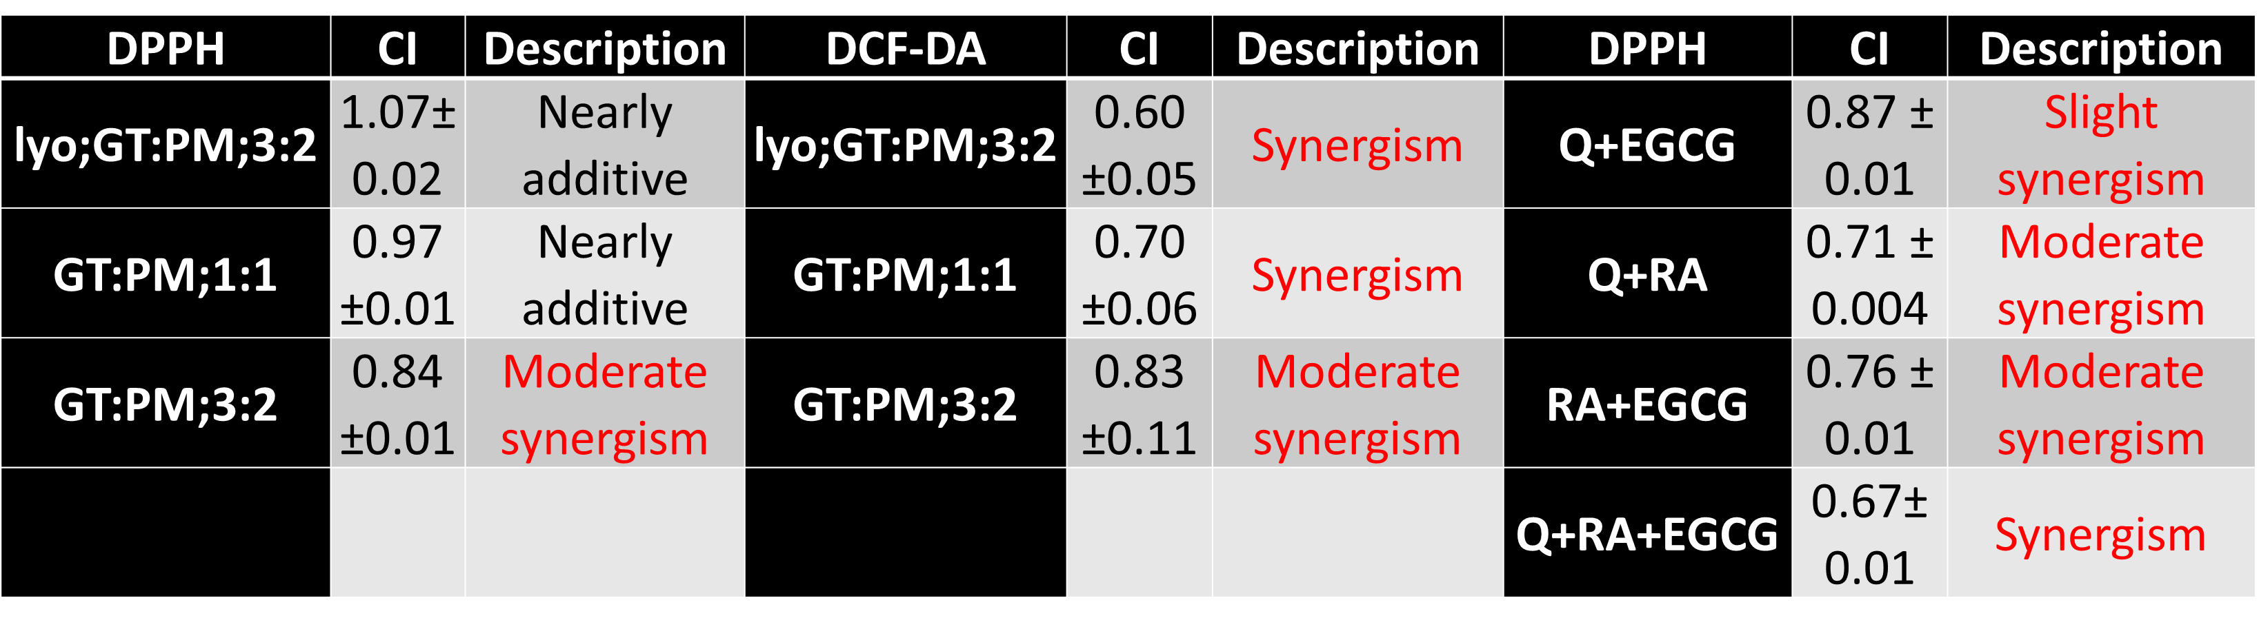

Table 1. Interaction analysis of CI value indicates synergy, additivity or antagonism, when it is <, = or > than 1. Each value error bars are expressed as ± SDA. Measured mixtures are abbreviated as common green tea and peppermint tea lyophilizate in 3:2 ratio (lyo;GT:PM;3:2), mixture of single green tea and peppermint lyophilizate in 1:1 or 3:2 ratio (GT:PM;1:1 or GT:PM;3:2). Polyphenols are abbreviated as epigallocatechin gallate (EGCG), quercetin (Q) and rosmarinic acid (RA). Antioxidant assays are abbreviated as 2,2-diphenyl-1-picrylhydrazyl scavenging (DPPH), dichlorodihydrofluorescein diacetate (DCF-DA).

Recent Publications
- Gancar M, Kurin E et al (2020) Amyloid Aggregation of Insulin: An Interaction Study of Green Tea Constituents. Scientific Reports 10:244-255.
- Novotny B, Nagy M, Kurin E (2021) Synergy evaluation of non-normalizable dose-response data: Generalization of combination index for the linear effect of drugs. Pharmaceutical Statistics 20:982-989.
- Bittner Fialova S, Kurin E et al (2020) Mentha Rhizomes as an Alternative Source of Natural Antioxidants. Molecules 25(1):1-14.
- Trajcikova E, Kurin E et al (2020) Antimicrobial and antioxidant properties of four Lycopus taxa and an interaction study of their major compounds. Molecules 25(6):1-18.
5. Kurin E, Mucaji P, Nagy M. (2012) In Vitro Antioxidant Activities of Three Red Wine Polyphenols and Their Mixtures: An Interaction Study. Molecules 17(12):14336-14348.

 Biography

Elena Kurin is a scientist and a teacher with strong, evidence based believe in plant medicine. She is an expert in the study of synergy, which appears to be responsible for the biological effects of many plant substances, present in nature in complex systems. She enriched the synergy evaluation about new way of evaluation in linear data space (Novotny B, Nagy M, Kurin E, 2021). This can be used in many mainly chemically based assay, where linear correlation is present, as interaction analysis method. However, among natural substances, it can help to understand the mutual interactions of the plant extracts.
Email: elena.kurin@uniba.sk

Presenting author details
Full name: Elena Kurin, Mgr PharmDr PhD
Contact number: +421 2 501 17 206
Linked In account: /www.linkedin.com/in/elena-kurin
Session name/ number: Plant Physiology and Biochemistry / 4
Category: Poster presentation

