The wound healing potential of agrimony
Pavel Mucaji, Prof PharmDr Ph.D, Faculty of Pharmacy, Comenius University, Bratislava, Slovakia
Martina Papadakos, PharmDr., Ph.D, Faculty of Pharmacy, Comenius University, Bratislava, Slovakia
Elena Kurin, PharmDr Mgr Ph.D, Faculty of Pharmacy, Comenius University, Bratislava Slovakia
Silvia Bittner Fialova, PharmDr Ph.D, Faculty of Pharmacy, Comenius University, Bratislava, Slovakia
Milan Nagy, Prof Ing CSc, Faculty of Pharmacy, Comenius University, Bratislava, Slovakia

Abstract
Statement of the Problem: Agrimonia eupatoria L. (Rosaceae) is an herb widely used in traditional medicine for its beneficial effects. Agrimony belongs to one of the most famous middle-European medicinal plants. The aerial part of agrimony is a rich source of tannins, organic acids, and flavonoids. This herbal remedy is recommended for the symptomatic relief of mild inflammation of the mouth and throat, symptomatic treatment of mild diarrhea, and for relief of minor skin inflammation and small, superficial wounds. [1]. Antimicrobial, anti-glucosidase, anti-glycation, and anti-hyperglycemic activities were previously described for agrimony [2,3]. Moreover, experiments on isolated aortas showed improved vasodilatation in diabetic rats. In vivo study [4] revealed wound healing-promoting effects, which led us to extend the evaluation to fibroblasts and keratinocytes and open and sutured wounds in rats [5]. The purpose of this study was to prepare different extracts of agrimony and, after HPLC characterization and identification of phenolic compounds, prepare different topical preparations (gels) for wound treatment. Methodology & Theoretical Orientation: water and 50% methanol extracts of agrimony were prepared and lyophilized, followed by HPLC characterization and phenolic compounds identification. Determination of phenolic compounds and flavonoids was carried out, and topical pharmaceutical preparations for wound treatment were prepared. Findings: different phenolics were identified by HPLC. The Content of total polyphenols, tannins, and flavonoids was determined according to European Pharmacopoeia. Gels with agrimony extracts for topical application were prepared. Animal experiments with gel applications are planned. Conclusion & Significance: The reported and obtained data showed that extract could help improve the healing of acute skin wounds.
This work was supported by the Grant Agency of The Ministry of Education, Science, Research, and Sport of Slovakia (grants no. VEGA 1/0284/20 and VEGA 1/0226/22).

Image

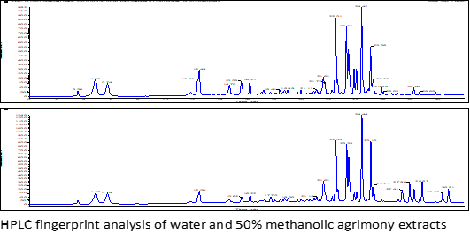

Recent Publications
- EMA, Assessment report on Agrimonia eupatoria L., herba (https://www.ema.europa.eu/en/medicines/herbal/agrimoniae-herba).
- Mucaji P, Slobodníkova L et al (2022) Antimikróbna aktivita a obsah sekundárnych metabolitov repíka lekárskeho. XII. Podlahovy chirurgické dny a XIII. Interaktivní symposium hojení ran
ISBN 978-80-01-07053-6.
- Kuczmannová A, Gál P, et al (2015) Agrimonia eupatoria L. and Cynara cardunculus L. water infusions: phenolic profile and comparison of antioxidant activities. Molecules 20 (11): 20538-20550.
- Kuczmannová A, Balažová A et al (2016) Agrimonia eupatoria L. and Cynara cardunculus L. water infusions: comparison of anti-diabetic activities. Molecules 21(5): 564.
- Vasilenko T, Kováč I, et al (2022) Agrimonia eupatoria L. Aqueous Extract Improves Skin Wound Healing: An In Vitro Study in Fibroblasts and Keratinocytes and In Vivo Study in Rats. In Vivo.

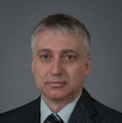 Biography

Dr. Mucaji graduated in Pharmacy at Comenius University in Bratislava, Slovakia, where he also received a Ph.D. degree in Pharmacognosy. Since 2013 is an ordinary professor at the Department of Pharmacognosy and Botany, Faculty of Pharmacy, CU. He has published over 90 research articles with more than 1100 citations. His field of interest is pharmacognosy, the separation, and identification of natural compounds, extracts standardization, and evaluation of natural compounds' biological activity
Email: mucaji@fpharm.uniba.sk

Presenting author details
Full name: Pavel Mucaji
Contact number: +421 908 976 480
Session name/ number: Plant Physiology and Biochemistry / 4
Category: Poster presentation

