Which are the most efficient to drought and salinity constraints: heritage or recent cereal varieties?
Amor Slama, 1: University of Tunis El Manar, Faculty of Sciences of Tunis, LR18ES03, Laboratory of Neurophysiology, Cellular Physiopathology and Biomolecules Valorisation, 2092 Tunis, Tunisia; 2: University of Carthage, Faculty of Sciences of Bizerte, 7021 Jarzouna - Bizerte, Tunisia

Abstract

Cereal species are primordial sources of human and animal nutrition worldwide. Our challenge in the coming years is to develop more productive cultivars in order to satisfy food requirements. Due to the climatic change and the global warming, the temperature and the water scarcity are increasing and the production of this sector has decreased rapidly. Optimizing fertilization, irrigation and plant growth regulators and the research of tolerant varieties to abiotic stresses are currently a challenge. Mechanisms of tolerance implemented by the plant to fight against the abiotic constraints depend on the species, the cultivar and even the ecotype. In the recent years many countries are oriented to their local and autochthonous varieties. In this context, the objective of this review was to compare recent and heritage cereal varieties (durum wheat, bread wheat and barley) cultivated under drought and salinity constraints. This review represents, particularly, a synthesis of our works interested in this subject. Different morpho-physiological, biochemical and agronomic parameters were investigated. According to these parameters, our investigation showed that old cultivars are the best-adapted to local conditions and showed characteristics of drought and salinity tolerance, while recent varieties showed more water and salt stresses susceptibility. Therefore, local varieties of each country should be kept by farmers and plant breeders to preserve their genetic heritage.
Image
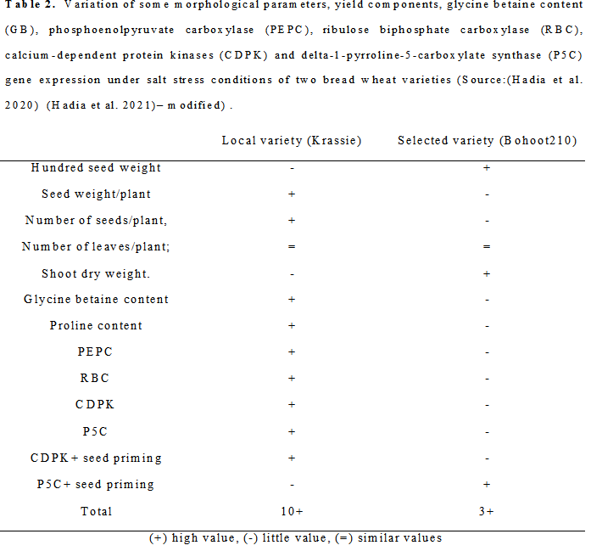
Recent Publications
1. Elhadi Hadia1, • Amor Slama* • Leila Romdhane • Hatem Cheikh M’Hamed • Mohamed Ali Saed Fahej•Leila Radhouane (2022). Seed Priming of Bread Wheat Varieties with Growth Regulators and Nutrients Improves Salt Stress Tolerance Particularly for the Local Genotype. Journal of Plant Growth Regulation
2. Elhadi Hadia, Amor Slama*, Aziza Zoghlami1 , Leila Romdhane , Ahmed Houssein Abodoma, Mohamed Ali Saed Fahej , Leila Radhouane (2021). Response of morphological and biochemical traits and transcriptomic of CDPKs and P5CS Genes to phytohormones and nutrients in two bread wheat germplasms under salinity conditions. Rom Biotechnol Lett. 2021; 26(6): 3054-3061
3. Romdhane L, Dal Ferro N, Slama A*, Radhouane L, (2020). Optimizing irrigation and determining the most sensitive development stage to drought in barley (Hordeum vulgare L.) in a semi-arid environment. Acta Bot. Croat.
4. El Hadi Hadia, Amor Slama*, Leila Romdhane, Hatem Cheikh M’hamed, Ahmed Houssein Abodoma, Mohamed Ali Saed Fahej, Leila Radhouane (2020). Morpho-physiological and molecular responses of two Libyan bread wheat cultivars to plant growth regulators under salt stress. Italian Journal of Agronomy; volume 15:1633
5. Slama A*, Mallek-Maalej E, Ben Mohamed H, Rhim T, Radhouane L, (2018). A return to the genetic heritage of durum wheat to cope with drought heightened by climate change. PLoS One13:e0196873

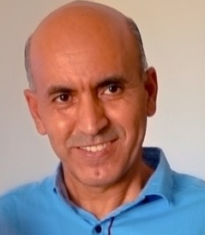Biography
Paste your Logo here
Dr Amor SLAMA specialized in the plant eco-physiology. His field research is the adaptive biology particularly the study of the strategies that allow plants to adapt to their environment under drought, salinity and high temperature conditions (abiotic stress). He worked as a researcher assistant between 1998 and 2002 in the National Tunisian agricultural research Institute (INRAT). In 2002, He joined the Science Faculty of Gabes in Tunisia as an assistant professor until 2006; since this year He joined the Science Faculty of Bizerte in Tunisia as an Associate professor and He continued his research work in INRAT.
Email: slamaamor@yahoo.fr

Notes/Comments:
Presenting author details
Full name: Amor SLAMA
Contact number: 0021697622401
Twitter account:.......
Linked In account: www.linkedin.com/in/slama-amor-ba026564/
Session name/ number: track 13
Category: (Oral presentation/ Poster presentation): Oral presentation

