Framework method for retrieving heavy metal nickel concentration in agricultural soil based on VNIR spaceborne hyperspectral imagery
Yishan Sun, Guangzhou Institute of Geography, PhD, Guangdong Academy of Sciences, China
Shuisen Chen*, Guangzhou Institute of Geography, Prof. PhD, Guangdong Academy of Sciences, China
Xuemei Dai, Guangzhou Institute of Geography, M.D, Guangdong Academy of Sciences, China
Dan Li, Guangzhou Institute of Geography, Prof. PhD, Guangdong Academy of Sciences, China
Hao Jiang, Guangzhou Institute of Geography, Prof. PhD, Guangdong Academy of Sciences, China
Jia Kai, Guangzhou Institute of Geography, PhD, Guangdong Academy of Sciences, China

Abstract (300 word limit)
Widespread soil contamination endangers public health and undermines global attempts to achieve the United Nations Sustainable Development Goals. Spaceborne spectroscopy allows continuous monitoring of soil heavy metals with minimal secondary environmental effects and the coverage of broad areas at low cost. However, due to few relevant studies and low precision, estimating soil heavy metals concentrations using satellite image remains a great challenge. In this study, a feature extraction-machine learning calibration framework was proposed to evaluate the potential of spaceborne VNIR hyperspectral imagery for predicting and mapping soil heavy metal nickel (Ni) concentration in Leizhou peninsula of China. Specifically, spectral features were extracted by discrete wavelet transform (DWT) and dimension reduction (DR) algorithm that includes principal component analysis (PCA) and t-distributed stochastic neighbor embedding (tSNE). In conjunction with spectral indices derived from the full spectrum as predictors, random forest (RF), extreme gradient boosting (XGBoost), back propagation neural network (BPNN), support vector machine regression (SVMR), and gaussian process regression (GPR) models were developed to predict Ni concentration using Zhuhai-1 OHS imagery and the established prediction process. The feature extraction results show that multi-scale DWT of the first derivative reflectance (FDR) combined with tSNE algorithm for DR provides the most effective method of extracting Ni spectral features. The feature bands of Ni were closely related to iron oxides and were distributed around 500, 560, 660-760, 800, 860, and 940nm. The prediction results of machine learning models show that XGBoost and BPNN exhibit excellent predictability and stability (both RPD(>2) and SSR/SST(>0.5) were satisfied). The FDR-tSNE-XGBoost framework method provided the most accurate prediction, with RPD of 2.08, SSR/SST of 0.80, and slope of 0.80 on the validation dataset. This work offers a reliable and accurate framework for estimating and mapping soil Ni concentration.

Image
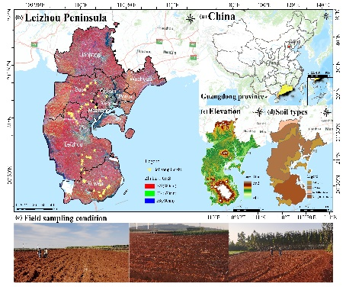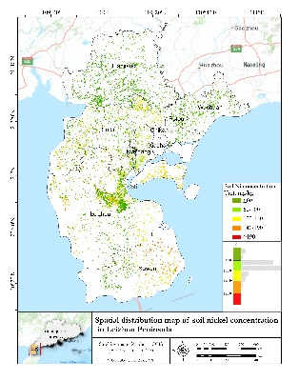

Recent Publications (minimum 5)
- Kai Jia, Shuisen Chen*, Weiguo Jiang (2022) Continuous long time series monitoring of mangrove forests in the Guangdong-Hong Kong-Macao Greater Bay Area using remote sensing. Journal of Remote Sensing 1-17.
- Maimaiti Bumairiyemu, Chen Shuisen*, Alimujiang Kasimu, Zibibula Simayi, Nuermaimaiti Aierken (2021) Urban spatial expansion and its impacts on ecosystem service value of typical oasis cities around Tarim Basin, northwest China. International Journal of Applied Earth Observation and Geoinformation 104: 102554.
- Li Wang, Shuisen Chen*, Zhiping Peng, Jichuan Huang, Chongyang Wang, Hao Jiang, Qiong Zheng, Dan Li (2021) Phenology Effects on Physically Based Estimation of Paddy Rice Canopy Traits from UAV Hyperspectral Imagery. Remote sensing 13(9): 1792
- Dan Li, Chongyang Wang, Hao Jiang, Ji yang, Zhiping Peng, Shuisen Chen* (2018) Monitoring litchi canopy foliar phosphorus content using hyperspectral data. Computers and electronics in agriculture, 154:176-186.

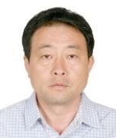Biography (150 word limit)

Corresponding author Pro.Ph.D Shuisen Chen is the Deputy Director of Guangdong Public Laboratory of Geospatial Information Technology and Application, Director of Guangdong Engineering Technology Research Center of Remote Sensing Big Data Application. He is mainly engaged in environmental (quantitative) remote sensing and GIS application, agricultural remote sensing and precision agriculture research. He is the chief expert of Guangdong Province modern agricultural industrial Technology System Innovation team (research and development of common key technologies in precision agriculture). Associate Editor of Modern Agriculture and Biotechnology, SunKrist Geology and Research Journal, Editorial board of Earth Sciences, Satellite Oceanography Meteorology, etc. He has published more than 150 peer-reviewed papers. He has presided over more than 30 projects, such as National Natural Science Foundation, Guangdong Provincial Natural Science Key Fund and science and technology plan projects.
Email: css@gdas.ac.cn

Notes/Comments:

Presenting author details
Full name: Shuisen Chen
Contact number: +86 13539919673
Twitter account: \
Linked In account: \
Session name/ number:
Category: Oral presentation

