Investigate the Role of Thioredoxin Domain-containing Protein 5 (TXNDC5) in Peritoneal Dialysis-induced Peritoneal Fibrosis
Chun-Jung Chien, DVM, SVM, NTU, Taiwan
Kai-Chien Yang, MD, PhD, CM, NTU, Taiwan
Pei-Shiue Jason Tsai, DVM, PhD, SVM, NTU, Taiwan

Abstract (300 word limit)
Statement of the Problem: Peritoneal dialysis (PD) is one of the kidney replacement therapies that maintain the lives of patients with kidney failure. Long-term PD will lead to peritoneal fibrosis (PF), which would cause functional and morphologic changes in the peritoneum and eventually result in ultrafiltration failure. Despite efforts being made, there is still no effective treatment that has been developed to alleviate PF. Recently, an endoplasmic reticulum protein, thioredoxin domain-containing protein 5 (TXNDC5), was identified as a novel mediator in the process of organ fibrosis in multiple organs. The purpose of this study is to explore a potential target to treat ultrafiltration failure by investigating the role of TXNDC5 in PF. Methodology & Theoretical Orientation: A 5-week methylglyoxal (MGO)-induced peritoneal fibrosis mouse model was established, and the peritoneal tissue was harvested to validate the expression of fibrosis-related proteins and protein expression of TXNDC5 via western blot and immunofluorescence staining. Findings: Histological and Masson’s trichrome staining showed MGO-induced significant peritoneum thickening when compared with PD fluid control group, indicating that the PF was successfully established (Fig. 1). Immunofluorescent staining confirmed that an increased TXNDC5 signal was present at the thickened parietal peritoneum. In addition, western blot results showed that both TXNDC5 and fibrogenesis-related signaling were upregulated in MGO-induced peritoneum (Fig. 2). Using Col-GFP transgenic mice (Col1a1-GFP^{Tg}), we showed mesothelial cells became Col-GFP positive on the peritoneal surface, indicated that mesothelial cells expressed collagen I secreting ability after MGO-induction, and likely play a role in the progression of MGO-induced peritoneal fibrosis (Fig. 3). Conclusion & Significance: TXNDC5 protein expression is increased after MGO induction and is positively correlated with fibrogenesis-related signaling. Therefore, targeting TXNDC5 could be a potential therapeutic approach against the development of PD-induced PF, which may prolong the service life of PD patients.
Image
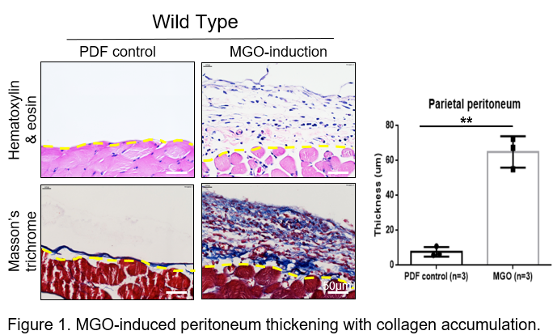

Image
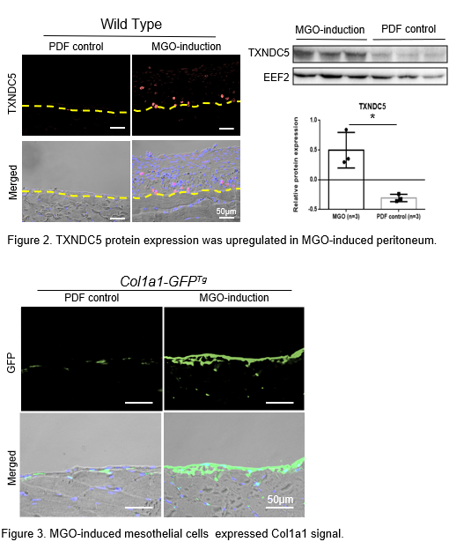
Recent Publications (minimum 5)
- Shih, Y. C., Chen, C. L., Zhang, Y. et al. (2018). Endoplasmic Reticulum Protein TXNDC5 Augments Myocardial Fibrosis by Facilitating Extracellular Matrix Protein Folding and Redox-Sensitive Cardiac Fibroblast Activation. Circulation research, 122(8), 1052–1068.
- Hsu, YT., Wu, CH., Chao, CY. et al. (2020) Hypochlorite-induced porcine model of peritoneal fibrosis through the activation of IL1β-CX3CL1-TGFβ1 signal axis. Sci Rep 10, 11496.
- Hung, CT., Tsai, YW., Wu, YS. et al. (2022) The novel role of ER protein TXNDC5 in the pathogenesis of organ fibrosis: mechanistic insights and therapeutic implications. J Biomed Sci 29, 63.
- Balzer M. S. (2020). Molecular pathways in peritoneal fibrosis. Cellular signalling, 75, 109778.
- Mittelmaier, S., Niwa, T., & Pischetsrieder, M. (2012). Chemical and physiological relevance of glucose degradation products in peritoneal dialysis. Journal of renal nutrition : the official journal of the Council on Renal Nutrition of the National Kidney Foundation, 22(1), 181–185.

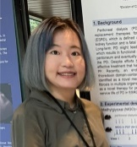Biography (150 word limit)
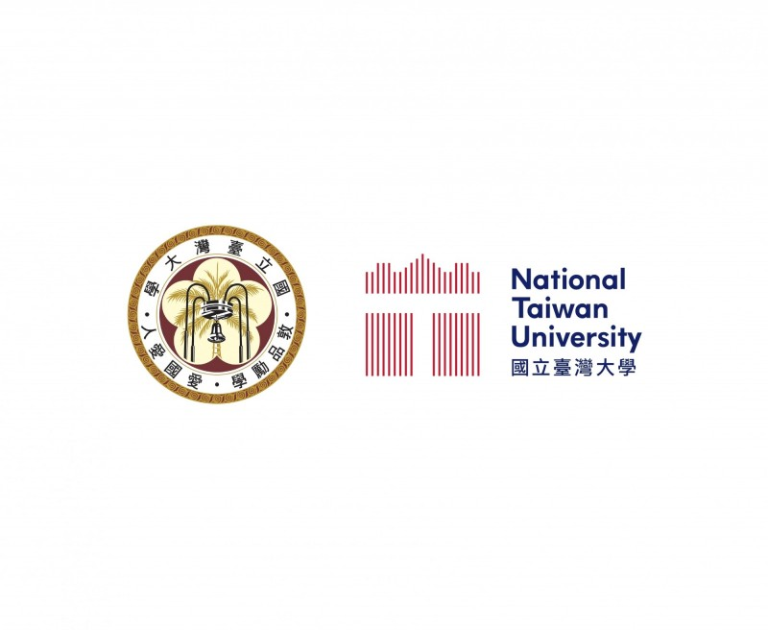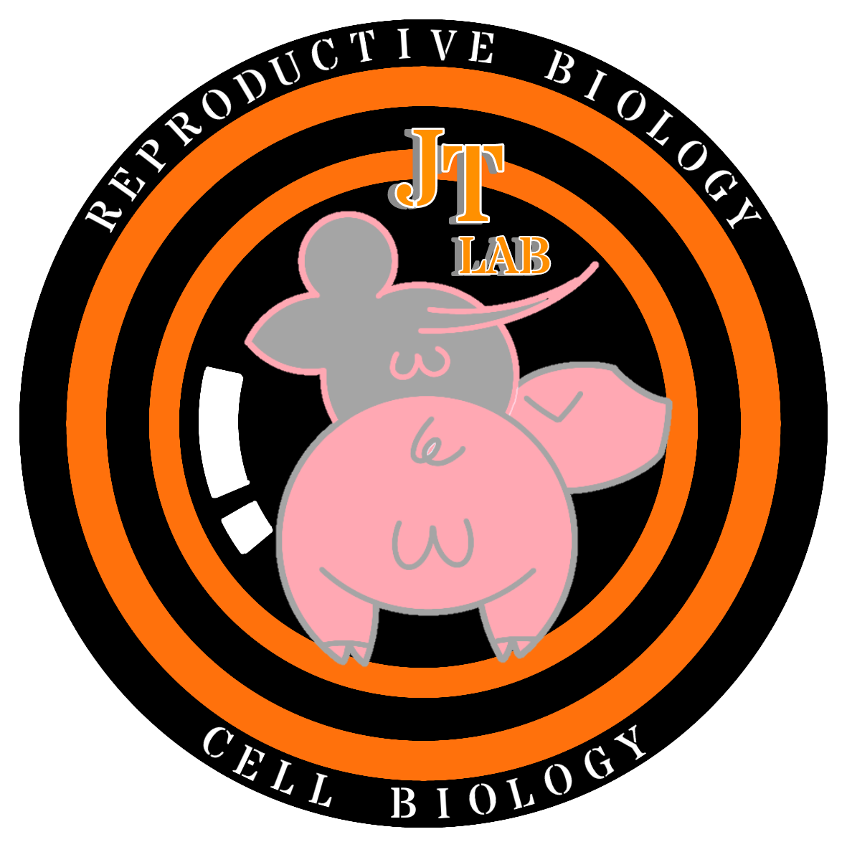Paste your Logo here
Chun-Jung Chien majors in veterinary medicine at NPUST, after obtaining her DVM license, she continues her study for a master degree in the conservation reproductive biology and regenerative medicine lab at the graduate institute of Veterinary Medicine at National Taiwan University. Her research focuses on investigating the mechanism of peritoneal dialysis-induced fibrosis and exploring novel therapeutic approaches for peritoneal fibrosis.
Email: r10629007@ntu.edu.tw

Notes/Comments:

Presenting author details
Full name: Chun-Jung Chien
Contact number: +886-0905559670
Twitter account:
Linked In account:
Session name/ number:
Category: (Oral presentation/ Poster presentation)

