Cardioprotective effect of c-kit^{ve} amniotic fluid mesenchymal stem cells in an in-vitro model of myocardial ischemia reperfusion injury
Manali Jain, PhD Scholar
Sanjay Gandhi Post-Graduate of Medical Sciences, India

Abstract

Myocardial ischemia-reperfusion injury (MIRI) is the main pathological manifestation of heart failure. Recently, c-kit^{ve} amniotic fluid mesenchymal stem cells (c-Kit^{+ve} AF-MSC) have been shown to have cardiomyogenic potential under in vitro conditions. While the c-Kit^{+ve} AF-MSC demonstrated limited homing and differentiation within cardiac tissue, there was still enhanced vascularization of ischemic cardiac tissue. Thus, it has proposed that beneficial effects of these cells are attributable to their modulatory paracrine factors rather than directly from transplanted cells. However, no direct comparison between c-Kit^{+ve} AF-MSC cell based and cell-free therapy has been reported till date. Therefore, in this study, we have evaluated the cardioprotective effect of the c-Kit^{+ve} AF-MSC and their derived secretome and extracellular vesicles (EVs) in an in vitro model of MIRI. To establish an in vitro model of MIRI injury, primary human cardiomyocytes were subjected to oxygen (1% oxygen, 94% nitrogen, and 5% CO₂), glucose (1%) deprivation (OGD), followed by reoxygenation (12 h). Cell viability was assessed by MTT assay, and cell apoptosis TUNEL assay on days 1, 3, and 5 of co-culture with c-Kit^{+ve} AF-MSC, Secretome, and EVs. The findings revealed that I/R injury resulted in a significant decrease in cell survival rate in cardiomyocytes. When injured cardiomyocytes are co-cultured with c-Kit^{+ve} AF-MSC and their derived secretome and EVs, there is an increase in cell survival after 1, 3, and 5 days. However, co-culture with c-Kit^{+ve} AF-MSC secretome significantly rescued the cells after MIRI compared with c-Kit^{+ve} AF-MSCs. Moreover, apoptosis was low in healthy cardiomyocytes but increased after I/R injury (Fig.1). Following co-culture with c-Kit^{+ve} AF-MSC, secretome, and EVs, there was a significant reduction of these TUNEL-positive cells on days 1, 3, and 5. Overall, our study highlights that secretome-derived c-Kit^{+ve} AF-MSC is a better source to rescue the I/R induced injury of cardiomyocytes than c-Kit^{+ve} AF-MSC or EVs, suggesting that the paracrine factors released by c-Kit^{+ve} AF-MSC may be sufficient to ameliorate the in-vitro MIRI.
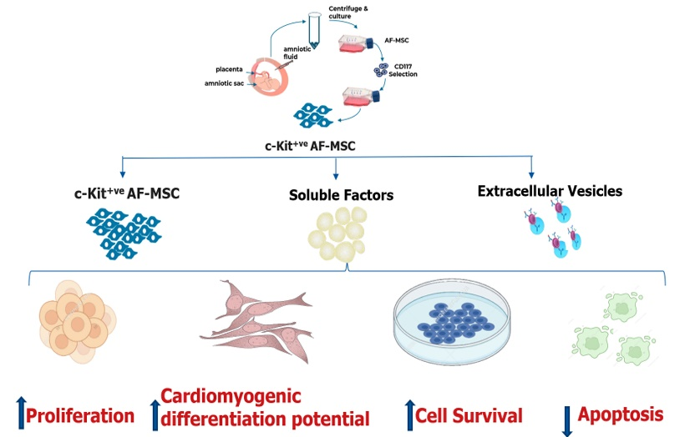
Fig.1 c-Kit^{+ve} AF-MSC possesses significantly high in-vitro differentiation potential and secretome derived c-Kit+ve AF-MSC derived is a better source to rescue the hypoxia induced injury of cardiomyocytes than c-Kit+ve AF-MSC or EVs, suggesting that the paracrine factors released by c-Kit+ve AF-MSC may be sufficient to ameliorate the cardiac injury in-vitro

Recent Publications
- Jain, Manali, et al. "Comparison of the cardiomyogenic potency of human amniotic fluid and bone marrow mesenchymal stem cells." International Journal of Stem Cells 12.3 (2019): 449-456
- Bai, Ming, et al. "Insights into research on myocardial ischemia/reperfusion injury from 2012 to 2021: a bibliometric analysis." European Journal of Medical Research 28.1 (2023): 1-16.
- De Coppi P, Bartsch G Jr, Siddiqui MM, Xu T, Santos CC, Perin L, Mostoslavsky G, Serre AC, Snyder EY, Yoo JJ, Furth ME, Soker S, Atala A (2007) Isolation of amniotic stem cell lines with potential for therapy. Nat Biotechnol 25:100–106.
- Casciaro, Francesca, et al. "Effect of the Enrichment in c-Kit Stem Cell Potential of Foetal Human Amniotic Fluid Cells: Characterization from Single Cell Analysis to the SecretomeContent." Biomedicines 11.2 (2023): 430.
- Kizilay Mancini Ö, Lora M, Shum-Tim D, Nadeau S, Rodier F, Colmegna I. A proinflammatory secretome mediates the impaired immunopotency of human mesenchymal stromal cells in elderly patients with atherosclerosis. Stem Cells Transl Med. 2017;6(4):1132–40
Biography
Manali Jain is a PhD Scholar in the department of Haematology, Sanjay Gandhi Post-Graduate Institute of Medical Sciences, Lucknow, India. She is presently working in the field of cardiac regenerative potential of amniotic fluid stem cell.

