Minifabs - a new microfabrication model for biosensors
Mitch Hsing, CEO InchFab, USA
Doug Sparks VP InchFab, USA

Abstract (300 word limit)
Using traditional microfabrication techniques to fabricate biosensors has become increasingly prohibitive due to high cost. Microfabrication historically has been used to fabricate microchips in tremendously high volumes - billions of devices per month. As a result, many biosensors can not justify the economies of scale to economically use microfabrication. This talk presents a new microfabrication paradigm that allows biosensors to be economically manufactured using traditional microfabrication techniques. t.

Recent Publications (minimum 5)
- D.Sparks, “Integrating 3D Micro-Printing into Traditional MEMS Fabrication Processes,” 3D Micro Printing 2023, Microtech Ventures, May (2023)
- D.Sparks, “Retrospective on MEMS packaging - challenges to be considered / challenges to be solved,” MEPTEC, Apr (2023).
- D.Sparks, “Regional Semiconductor Supply Chains,” 7th JiWei Semiconductor Summit - Analyst Conference, Macau, Apr (2023).
- D.Sparks, “MEMS Global Landscape: Overview and Challenges,” International Semiconductor Executive Summit: Middle East 2023, Feb (2023).
- D.Sparks, “Biosensor Commercialization Strategies,” 6th International Conference on Biosensors and Bioelectronics, London, May 20-21, (2022).

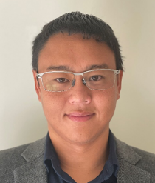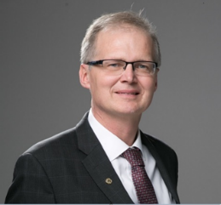

Biography (150 word limit)
Mitchell Hsing, is the Co-Founder and CEO of InchFab, a low-cost, fast-cycle-time foundry solution for sensors and actuators. InchFab was born out of frustration from Mitchell and his co-founder’s struggles with the lack of access and high barrier of entry needed to make microdevices. Innovators at heart, Mitchell’s aim is to lower the barrier of entry and enable more people to innovate on the microscale. Mitchell holds, S.M. and Ph.D. degrees in Electrical Engineering from MIT and B.S.
degrees in Physics and Electrical Engineering from the University of California, Irvine

Dr Douglas Sparks is the Vice President of Business Development at InchFab. Dr. Sparks has international business experience in these fields in the US, China, Japan and Europe in medical, industrial, aerospace, semiconductors, consumer and automotive applications. He has worked at large MEMS IDMs, start-ups and MEMS foundries. Doug was the CTO of Hanking Electronics which built the first 200mm pure MEMS wafer fab in China. He founded a microsensor vacuum packaging company called NanoGetters, which was acquired by Materion. He was the EVP at Integrated Sensing Systems where he launched multiple microfluidic sensor products, including an FDA approved MEMS drug infusion device and industrial products acquired by Endress + Hauser. Doug worked in automotive sensors and semiconductor fabs with Delphi. Dr. Sparks holds a PhD in materials engineering from Purdue University and has published more than 170 technical papers and has 70 issued patents.
Email: mhsing@inchfab.com dsparks@inchfab.com

Notes/Comments:

Presenting author details
Full name: Mitch Hsing
Contact number: 408-621-0927
Twitter account:
Linked In account:
Session name/ number: Euro Biosensor 2023
Category: (Oral presentation/ Poster presentation)

