Title: Design Thinking and Sustainable Tourism: Creating Positive Impact Through Systems and Future Thinking.
Tatiana Velez, Ms., Aldea Travel, London, UK

Abstract
In this keynote session, I will discuss the importance of sustainable tourism and how design and systems thinking principles can be used to create innovative solutions that benefit both people and the planet. Drawing from the works of authors like Tim Brown, Jeanne Liedtka, and David Kelley, I will explain how design thinking can be used to develop sustainable business models that prioritize social and environmental impact.
To illustrate this concept, I will share the case of my company Aldea Travel for Good. Using empathy, experimentation, and iteration, I developed a business model that connects travelers with local communities in Latin America in a way that supports social and environmental initiatives. By engaging travelers in meaningful experiences that benefit local communities and conservation efforts, Aldea Travel for Good demonstrates the potential of design, systems and future thinking to create positive social and environmental impacts through tourism.
During this keynote, I will provide practical tips and actionable insights for industry professionals, leaders, and the general public on how to incorporate design and system thinking principles into sustainable tourism practices. By embracing the values of sustainability and using design thinking to create innovative solutions, we can ensure a sustainable future for tourism while also promoting positive social and environmental impacts.

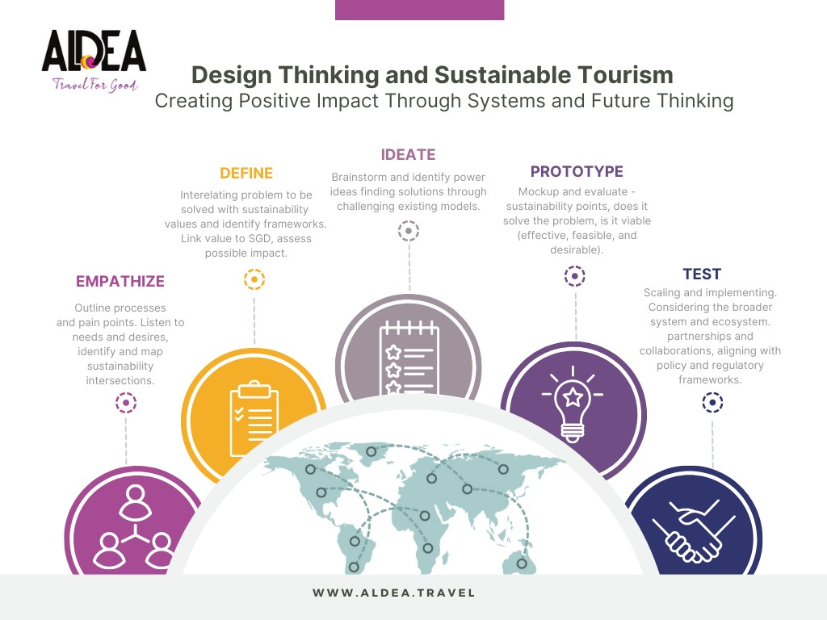
- www.aldea.travel
- https://www.linkedin.com/in/tatianavelez/
- Building Sustainable Tourism: A Case Study of the Archipelago of San Andrés and Old Providence
- Tourism and Climate Change, Tourism as a Tool to Building Resilience in the Colombian Caribbean



Biography
Tatiana Velez is a Female+Latina impact entrepreneur and keynote speaker, specializing in sustainable tourism development, climate change, and hospitality management. She is the founder of Aldea Travel for Good, a sustainable travel marketplace based in London. Velez has a background in international hospitality management and international tourism management, and holds a Master's degree in Sustainable Development in Climate Change from the Salle University Institute of Climate and Environmental Studies INIECO.

Through her expertise in systems, and design thinking, Velez provides actionable insights on how to create positive impact in the industry. She emphasizes the importance of values such as empathy, innovation, and sustainability, and highlights case studies such as Aldea Travel for Good to demonstrate how sustainable tourism experiences can benefit local communities, travelers, and the environment. As a conscious business and sustainability speaker, Velez encourages audiences to think creatively and collaboratively about how they can contribute to a more sustainable and equitable world. With her engaging and inspiring presentations, Velez empowers industry professionals, leaders, and the general public to drive positive change through sustainable development and tourism.

Email: tatiana@aldea.travel

Notes/Comments:
Presenting author details

Full name:
Contact number:

Mail id:
Category: (Oral presentation/ Poster presentation)

