Increasing drug availability while implementing cost containment policies: 13 years’ experience of Maccabi Health Services (MHS) - a large health maintenance organization in Israel
Yossef Lomnicky, Head- Department of Pharmacy, Maccabi Health Services (MHS) Israel

Background
Drug expenditure has been growing at an accelerated rate in developed countries at an annual increase of 2-10%. The Maccabi Health Services (MHS), the second largest health maintenance organization in Israel has implemented a “smart policy” that includes a wide range of steps aimed to reduce non-essential drug costs while maintaining maximum quality of health services.
Methods
We evaluated the contribution of the implemented methods on the annual drug expenditure values from 2007 to 2019. The expenditures were evaluated and standardized to the "Israeli Health value index" of 2019 and calculated per insured per MHS member. The main steps were implemented in three levels, physicians, drugs companies, and the patients.
The policy was implemented using "preferred drugs" which The physicians were Directed to prescribe in most therapeutic groups (example: Statins, Ace I, ARBs, Steroids for inhalation etc.). Start to use generics as soon as they are marketed. Renewing drug purchasing contracts. Restricting the use of expensive drug via preauthorization, setting higher co-payments for "non-preferred drugs" and revising contracts with pharmacies that provide service for the MHS members in order to achieve better terms for the MHS.

Results
Figure 1 displays the MHS’s drug expenditures from 2007 through 2019.
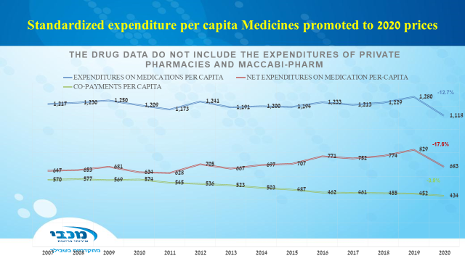
Fig 1. Expenditure for medications for each of the years.
It can be seen that drug expenditures were elevated by a total of 5% that presents an average of 0.4% per year.
The overall outcomes of Implementing the drugs cost containment steps, demonstrated an average increase rate of 0.4% in annual drugs expenditures (in the period 2007 to 2020) per standardized MHS member
This increase rate is relatively low compared to most developed countries, despite the fact that Israel is among the early adapter of new pharmaceutical technologies.

Conclusions
A “smart comprehensive cost-containing policy” successfully controlled the increase rate of drugs expenditures in healthcare services/ organizations that operate in limited budget.
Dr. Lomnicky – lomnicky@zahav.net.il
Biography:
Yossef Lomnicky is the head of the Pharmacy Department at Maccabi Health Services (MHS) which is a large health maintenance organization in Israel. He has attended several conferences around the globe.

