Biogas production from OFMSW is enhanced by nickel addition in a two stages system compared with a conventional digester
Karina J. Salazar-Batres¹, Audrey-Anne Durand², Philippe Constant², Iván Moreno-Andrade¹*
E-mail address: imorenoa@ii.unam.mx (I. Moreno-Andrade).
Tels. (55) 5623 4271, (442) 192 6171; Fax (55) 5623 4685, (442) 192 6185
¹Laboratory for Research on Advanced Processes for Water Treatment, Instituto de Ingeniería, Universidad Nacional Autónoma de México, Blvd. Juriquilla 3001, Querétaro 76230, Mexico.
²Centre Armand-Frappier Santé-Biotechnologie, Institut national de la recherche scientifique, 531 boulevard des Prairies, Laval (Québec), H7V 1B7, Canada

Abstract
Biogas production from organic fraction of municipal solid waste (OFMSW) is a promising alternative for producing fuel. Nevertheless, one stage anaerobic digestion (OSAD) has limitations since maintaining the stability of the process is challenging and requires certain strategies that include two-stage (TSAD) and the addition of trace metals such as Ni²⁺. In this sense, the main objective of this research was to determine the effect of the addition of different concentrations of Ni²⁺ on the production of H₂-rich biogas through dark fermentation process followed by CH₄-rich biogas production in a second stage. The impact of TSAD and OSAD as well as the addition of Ni²⁺ on microbial communities were also examined. OSAD and TSAD were performed in sequencing batch reactors. The Ni²⁺ effect was analyzed in the acidogenic reactor with 0, 0.1 and, 0.5 mg Ni²⁺/gVS_{inoculum}. The acidogenic effluents were fed in the second stage to produce CH₄-rich biogas. The results showed that it was possible to increase the CH₄-productivity and the SMY by 72% and 98%, respectively, by operating in TSAD compared with OSAD. Regarding the Ni effect, the CH₄-productivity and the SMY increased 127% and 380% when the reactor was fed with the effluent enriched with Ni (from cycles 15-32), compared with OSAD. Regarding the microbial communities, important differences in community structure from each stage were found. Cloacimonadia and JS1 were the most significant class in the first stage, and Methanobacteria and Actinobacteria were the predominant class in the second stage.

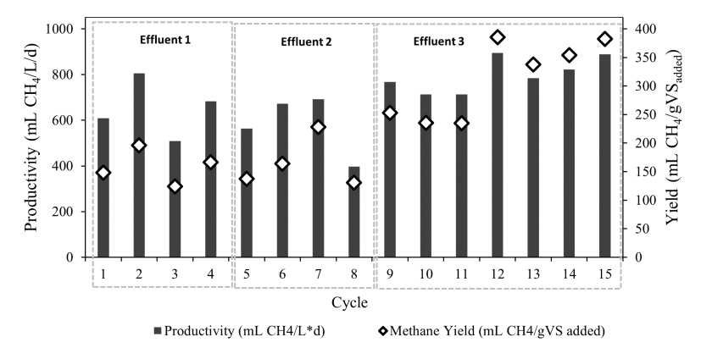
Fig. 1. Methane yields and productivities.
Recent Publications
- Chen Y, Yin Y, Wang J (2021) Effect of Ni2+ concentration on fermentative hydrogen production using waste activated sludge as substrate. Int. J. Hydrog. Energy 46(42):21844–21852.
- Chowdhury B, Magsi SB, Ting HNJ, Dhar BR (2020) High-Solids Anaerobic Digestion Followed by Ultrasonication of Digestate and Wet-Type Anaerobic Digestion for Enhancing Methane Yield from OFMSW. Processes 8(5):555.
- Jiménez-Ocampo UE, Vargas A, Moreno-Andrade I (2021) Methane production from food waste using a feedback control strategy in a sequencing batch reactor. Water Sci. Technol. 84(8):1969–1980.
- Strazzera G, Battista F, Andreolli M, Menini M, Bolzonella D, Lampis S (2021) Influence of different household Food Wastes Fractions on Volatile Fatty Acids production by anaerobic fermentation. Bioresour. Technol. 335:125289.
- Zamri MFMA, Hasmady S, Akhiar A, Ideris F, Shamsuddin AH, Mofijur M, Fattah IMR, Mahlia TMI (2021) A comprehensive review on anaerobic digestion of organic fraction of municipal solid waste. Renew. Sustain. Energy Rev. 137:110637.


Biography (150 word limit)
Karina Salazar PhD. Student. My research is focused on the production of biogas rich in hydrogen and methane in anaerobic digesters from organic solid waste. The effect of trace metals on biogas production and microbial communities is also part of my research.
Email: ksalazarb@iingen.unam.mx

Notes/Comments:
Presenting author details
Full name: Karina Janette Salazar Batres
Contact number: +52 618260 72 54
Twitter account: @Kary_Salazar_B
Linked In account:
Session name/ number:
Category: Oral presentation

