Pelletizing of agricultural residues in Senegal: study of influencing phenomena & chemical elements
Cheikh Ahmadou MBODJI, Gaston Berger University, Saint-Louis, Senegal
Djicknoum DIOUF, Prof., Gaston Berger University, Saint-Louis, Senegal
Bruno PIRIOU, PhD, CIRAD, Montpellier, France
Amadou Seidou MAIGA, Prof., Gaston Berger University, Saint-Louis, Senegal

Abstract
Biomass fuels, more specifically, pellets from agricultural residues have attract interest rapidly in recent years. Pellets from agricultural residues often represent a better alternative to domestic fossil fuels (charcoal, firewood, conventional biomass), due to their accessibility but also their better density and higher calorific value. In the present work, we produce from residues of groundnut shell, corn cob, palm nutshell and typha, simple pellets (a single residue) and mixed pellets (mixture of two residues in variable proportions). The characterizations of these pellets show that the pelleting of biomass residues makes it possible to significantly increase the calorific value (LCV) of simple pellets. The mixture of different agricultural residues makes it possible to have a much higher calorific value, with pellets with LCV greater than 19 MJ/kg. We also demonstrate the importance of pelleting in reducing the ash content for mixed pellets; the opposite phenomenon being observed for simple pellets. Our work also shows the importance of pelleting and blending of agricultural residues in reducing the formation of bottom ash and corrosion.

Image
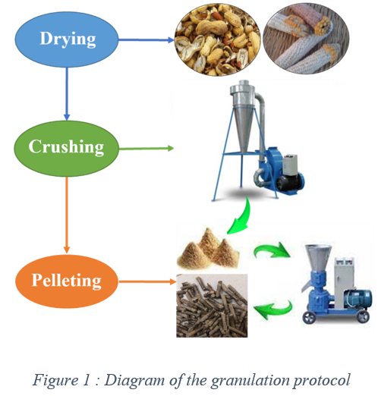

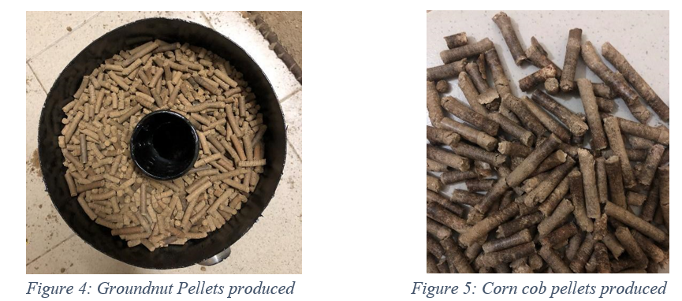

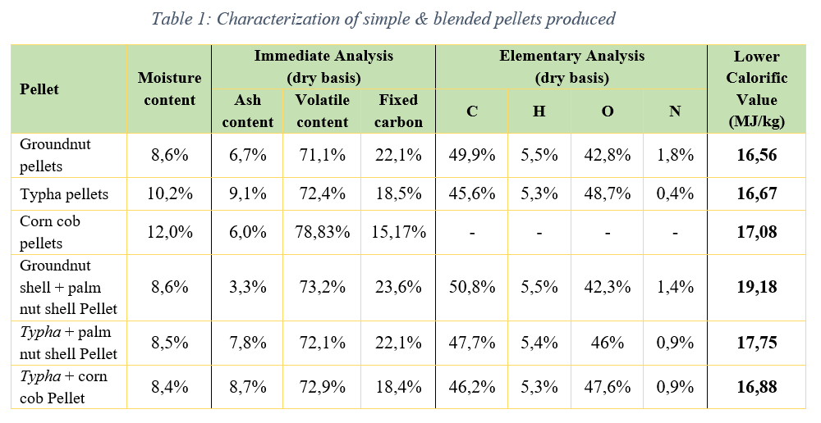
Recent Publications (minimum 5)
- C. Mbodji, A. Fall, D. Diouf, A. Seck: Energy potential of crop residues in Senegal: Pathways for valorisation, SEA4cities/Springer Nature Book, 2021.
- A. Stam, W. Livingston, M. Cremers, G. Brem: Review of models and tools for slagging and fouling prediction for biomass co-combustion. Rev Artic IEA, 2010.
- L. Baxter, T. Miles, B. Jenkins, T. Milne, D. Dayton, R. Bryers: The behavior of inorganic material in biomass-fired power boilers: field and laboratory experiences, 1998.
- S. Lokare, J. Dunaway, D. Moulton, D. Rogers, D. Tree, L. Baxter: Investigation of Ash Deposition Rates for a Suite of Biomass Fuels and Fuel Blends, 2006.
- H. Nielsen, F. Frandsen, K. Dam-Johansen, L. Baxter: The implications of chlorine-associated corrosion on the operation of biomass-fired boilers, 2000
- S. Vassilev, D. Baxter, C. Vassileva: An overview of the behaviour of biomass during combustion: Part I. Phase-mineral transformations of organic and inorganic matter, 2013
- B. Piednoir, J-M. Commandré, A. Benoist, S. El Fassi, G. Vaitilingom: Biomass blending as a way to reduce NOx emissions during the combustion of biomass residues, 1st International Conference on Bioenergy & Climate Change
- Phyllis database for biomass, https://phyllis.nl/ (last access on 15/11/2022)

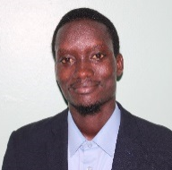Biography

Graduated from Gaston Berger University of Saint-Louis (Senegal), Cheikh holds a master’s degree in Renewable Energies. He is also finishing his PhD on the valorisation of crop residues in Senegal through gasification. Cheikh has expertise on feasibility study of energy projects, PV systems sizing, energetic audits and energy recovery from solid waste. Besides, he is also very interested in working for renewable energies integration into national grids, have worked previously in micro-grid (solar power plants) design for rural electrification. Cheikh was part of one research project from Austria Cooperation named “Sustainable Energy Access for Cities”, led by TU Vienna & Technical University of Thies (Senegal), where they produced a database of knowledge on how distributed renewable generation and energy efficiency can be integrated in residential and commercial buildings as a contribution to the necessary energy transition, alongside with an energy planning tool, Energy System Map (ESMP).
Email: cheikhahmadou7@gmail.com

Notes/Comments:

Presenting author details
Full name: Cheikh Ahmadou MBODJI
Contact number: 00221 77 717 91 45
Twitter account:
Linked In account: https://www.linkedin.com/in/cheikh-ahmadou-mbodji-827967136/
Session name/ number:
Category: Oral presentation

