Establishment of a PML-RARa Copy Number Estimator for Prototype Xpert® PML-RARa Assay
Mengying(Mona) Liu¹, Yan(Amber) Zhao¹, Yuanyuan Liu¹, Huilin Wei¹, Jessica Saini¹, Dylan Goldman¹, Shawn Kayhan¹, Tran Tran¹, Lin Yuan¹, Gwo-Jen Day¹
¹ Oncology, R&D, Cepheid, Sunnyvale, United States

Abstract

Statement of the Problem: Acute Promyelocytic Leukemia (APL) represents 10-15% of Acute Myeloid Leukemia (AML)¹. The PML-RARa fusion transcript is expressed in more than 95% of APL patients². Three PML-RARa isoforms (bcr1, bcr2, and bcr3) are identified in 90-95% of PML-RARa positive cases³. Prototype Xpert® PML-RARa, an automated cartridge-based assay for measuring PML-RARa fusion transcript levels (bcr1, bcr2, and bcr3), is standardized to quantify the amount of PML-RARA relative to ABL1 control gene based on delta Ct in peripheral blood. Since PML-RARa level is crucial for diagnosis and ongoing therapeutic monitoring in APL^{4,5}, it can be useful to obtain the PML-RARa copy number (CN). The aim of this work is to develop PML-RARa CN estimator and to compare %PML-RARa/ABL1 reporting between delta Ct-based and CN-based methods. Methodology & Theoretical Orientation: Four levels of PML-RARa (bcr1, bcr2, and bcr3) and ABL1 IVT-RNA panels as well as two lots of prototype Xpert® PML-RARa assay were used to generate standard curves for CN and %CN reporting. The samples with spiked-in bcr1 IVT-RNA and APL clinical samples containing PML-RARa fusion transcript were examined to evaluate the CN and %CN between two lots of the prototype Xpert® PML-RARa assay and to compare the delta Ct-based and CN-based methods for reporting %PML-RARa/ABL1. Linearity was demonstrated in Ct vs CN input for PML-RARa (R2>0.98) and ABL1 (R2>0.97). Less than 2-fold difference was exhibited for CN and %CN across two different lots. Less than 2-fold difference was observed in %PML-RARa/ABL1 reporting between delta Ct-based and CN-based approaches. Conclusion & Significance: A PML-RARa copy number estimator for prototype Xpert® PML-RARa assay was established, which will provide helpful information for diagnosis and prognosis of APL. (Product in development. Not for use in diagnostic procedures. Not reviewed by any regulatory body.)
Image

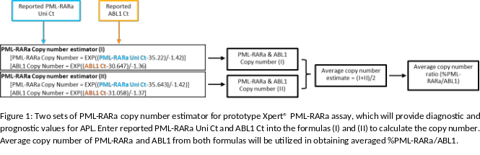
Recent Publications
- Jimenez, Joaquin J et al. “Acute promyelocytic leukemia (APL): a review of the literature.” Oncotarget vol. 11,11 992-1003. 17 Mar. 2020.
- Zhang, X., Sun, J., Yu, W. et al. Current views on the genetic landscape and management of variant acute promyelocytic leukemia. Biomark Res 9, 33 (2021).
- Liquori, Alessandro et al. “Acute Promyelocytic Leukemia: A Constellation of Molecular Events around a Single PML-RARA Fusion Gene.” Cancers vol. 12,3 624. 8 Mar. 2020.
- Network NCC. Acute Myeloid Leukemia, Version 2.2023, NCCN Clinical Practice Guidelines in Oncology. Acute Myeloid Leukemia. Online: NCCN; 2023.
- Yilmaz, M., Kantarjian, H. & Ravandi, F. Acute promyelocytic leukemia current treatment algorithms. Blood Cancer J. 11, 123 (2021).



Mengying(Mona) Liu has her expertise in molecular biology, microbiology, cell biology, gene & cell therapy, drug development, and biomarker discovery. She has experience in process and assay development. Current research focuses on assay development to provide accurate and high quality IVD products for cancer diagnostic and monitoring.
Email: Mona.Liu@Cepheid.com

Notes/Comments:

Presenting author details
Full name: Mengying(Mona) Liu
Contact number:
Twitter account:
Linked In account: https://www.linkedin.com/in/mengying-mona-liu-ph-d-615a641a6/
Session name/ number:
Category: (Oral presentation/ Poster presentation

