Use of Proton Pump Inhibitors Medications during the First Years of Life and Late Complications
Kamelia Hamza ¹, Corina Hartman ², David Stepensky ³.
¹ Pharmaceutical Services, Lady Davis Carmel Medical Center, Haifa, Israel.
² Director Of Gastroenterology Unit, Lady Davis Carmel Medical Center And Haifa And Western Galilee District.
³ Director School Of Pharmacy, Clinical Biochemistry And Pharmacology, Ben-Gurion University Of The Negev, Beer- Sheva, Israel.

Abstract
Background: Proton pump inhibitors (PPIs) are the most prescribed drug classes for pediatric gastroesophageal reflux disease (GERD). Many patients are treated with these drugs for atypical manifestations attributed to gastroesophageal reflux (GER), even in the absence of proved causal relationship.
There is an impression of an increase use of PPI's treatment for reflux in "clalit health services" the largest health organization in Israel. In the recent years the medicine is given without restriction, it's not limited to pediatric gastroenterologists only, but pediatricians and family doctors.
The objective of this study is to evaluate the hypothesis that exposure to PPIs during the first year of life is associated with an increased risk of developing late adverse diseases: pneumonia, asthma, AGE, IBD, celiac disease, allergic disorders, obesity, attention deficit hyperactivity disorders (ADHD), autism spectrum disorders (ASD). Methods: The study is a retrospective case-control cohort study based on a computerized database of Clalit Health Services (CHS). It includes 9844 children born between 2002-2018 and reported to complain of at least one of the symptoms (reflux/ spitting up, irritability, feeding difficulties, colics). The study population included the study group (n=4922) of children exposed to PPIs at any time prior to the first year of life and a control group (n=4922) child not exposed to PPIs who were matched to each case of the study group on age, race, socioeconomic status, and year of birth. The prevalence of late complications/diseases in the study group was compared with the prevalence of late complications/diseases diagnosis between 2002-2020 in the control group. Odds ratios and 95% confidence intervals were calculated by using logistic regression models. Results: We found that compared to the control group, children exposed to PPIs in the first year of life had an increased risk of developing several late complications/ disorders: pneumonia, asthma, various allergies (urticaria, allergic rhinitis, or allergic conjunctivitis) OR, inhalant allergies, and food allergies. In addition, they showed an increased risk of being diagnosed with ADHD or ASD, but children exposed to PPIs in the first year of life had decrease the risk of obesity by 17% (OR 0.825, 95%CI 0.697-0.976)

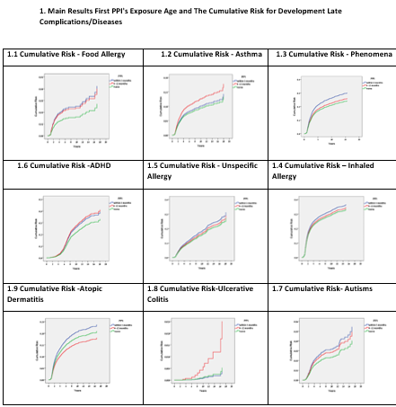

Conclusions: We found significant associations between the use of PPIs during the first year of life and subsequent development of late complications/diseases such as respiratory diseases, allergy diseases, ADHD, and ASD. More studies are needed to prove causality and determine the mechanism behind the effect of PPIs and the development of late complications

Biography
Kamelia hamza, M.Sc community clinical pharmacy and regulatory, MHA health management administration, head of hospital pharmacy services at Carmel Hospital-Haifa, Israel. I had been for several year clinical pharmacist in pediatric department, this is my first research.
.
Email: kamelia.h.h@gmail.com
Notes/Comments: presenting author details
Full name: kamelia hamza
Contact number:0528164771
Mail id: kamelia.h.h@gmail.com
Category: Poster presentation

