Letter of Acceptance

Date: April 15, 2023

To,
Mohammad Asadian,
PharmD
Samira RajiAsadabadi, DDS
Doctor in Dentistry

Dental World 2023 invites Dr. Mohammad Asadian as a speaker to attend the Experts Meeting on Dental World 2023 and to present his oral presentation. This conference is organized with respect to the theme: “Reviewing excellence in the dental world”. The event will be held during August 10-11, 2023 Paris, France

Dental World 2023 is achieving the two-fold objective of bringing together a host of research Professionals from multiple and varied specialties. We would like to inform you that your abstract entitled “Dental implant survival in patients with osteoporosis.” has been accepted under Poster presentation at this conference.

On behalf of the organizing board of trustees and the supporting Journals, I cheerfully welcome you to be a part of this scientific knowledge-sharing event.

Please visit our website for more details: https://worlddental.conferenceseries.com/

We look forward to seeing you at the Conference.

Sincerely,
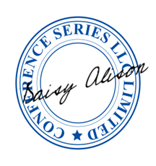

Daisy Alison
Program Manager
DENTAL WORLD 2023
47 Church Field Road,
W3 6A Y, London. UK
Tel: +44 1371 290000

