Inhibitory effect of natural honey on the growth of Rhizopus stolonifer, Mucor spp. and Aspergillus niger
Sarah Saad Alamer^{1*}, Sozan Mohamed Fadl¹ and Reham Mosleh Alahmadi² collage of medicine,
¹Almaarefa University, KSA
²King Saud University, KSA

Abstract
Honey is used in many countries as an antiseptic and therapeutic agent for many infections. The chemical and physical properties of honey have inhibitory effects on a lot of microorganisms including fungi. Rhizopus stolonifer, Mucor and Aspergillus niger are common bread molds. During growth on bread, they produce large numbers of spores that cause different types of infections especially in immunocompromised patients. To evaluate the effect of natural honey on the growth of Rhizopus stolonifer, Mucor spp., and Aspergillus niger fungi. To determine the minimal inhibitory concentration of honey that can suppress the growth of these fungi. This was an experimental study conducted in College of Sciences in King Saud University during the period between August and November 2021 in Riyadh, KSA. Multifloral honey was diluted in sterile distilled water volume to volume (%, v/v) in series concentrations: 5%, 15%, 30%, 45%, 60%. It was then added to potato dextrose agar (PDA). Measured parts of the colonies of Rhizopus stolonifer, Mucor, and Aspergillus niger, were cultured on the prepared plates in duplications and were incubated at room temperature (25±2°C). Fungal growth was monitored daily for three months. The 5%, 15%, 35% concentrations of honey mixed with PDA did not inhibit the fungal growth, the fungi started to grow within the first 24h. On the other hand, the 60 % dilute concentration killed the three fungi and completely inhibited their growth, the fungi were monitored for 3 months and during that time they did not grow (Figure 1). This study confirms that honey has a strong inhibitory effect on the growth of Rhizopus Stolonifer, Mucor spp. and Aspergillus niger when used in concentration of 60% or above. Accordingly based on these findings we determine that the minimal inhibitory concentration (MIC) of multifloral honey on bread fungi is 60%.

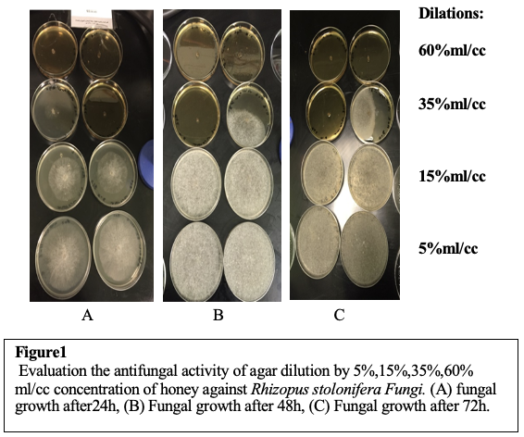
Recent Publications
- Alamer SS, Alanazi AK, Alazzam SM, Almutairi RS, Alasfr RM, Sendy JS, Aleid LS, Fallatah HA, Omar AA, Alfadeel MA. Prevalence of obesity and associated factors among girls' primary school-age in Riyadh: Perspectives of mothers. Medical Science 2022; 26: ms528e2498.
- Abdelkhalig SM, Alazzam SM, Sendy JS, Alamer SS, and Alanazi AK. Awareness of Human Papillomavirus Vaccine among Females in Riyadh in 2021. IJMDC 2023;7(3):400-405.


Biography
Sarah Alamer, Riyadh, Saudi Arabia, Almaarefa University, Medical college, Medical Student, Level 12, Webinar team leader in Almaarefa Medical Student Committee, interested in research and presentations, collage of medicine leader in Almaarefa University student council.

