Use of Anchor Domains to Enable the Use of Biologics to Treat Ocular Surface Disease
Robert M. Q. Shanks^{1,2}, Eric G. Romanowski^{1,2}, John E. Romanowski1,², Katherine Davoli¹, Nancy A. McNamara³, and Jes K. Klarlund¹

- Department of Ophthalmology, University of Pittsburgh School of Medicine, 203 Lothrop Street, Pittsburgh, PA 15213

- Charles T. Campbell Laboratory of Ophthalmic Microbiology, University of Pittsburgh, 203 Lothrop Street, Pittsburgh, PA 15213, USA

- School of Optometry and Vision Science Graduate Program, University of California, 524 Minor Addition, Berkeley, CA 94720-2020, USA

Abstract (300 word limit)
Purpose: Corneal diseases are generally treated by topical drug application because it minimizes off-target exposure and allows more aggressive treatments. However, the ocular surface has very efficient clearance mechanisms including blinking and tear flow that washed out biologics drugs too quickly for them to have significant therapeutic effects. The goal of this study was to test the hypothesis that attaching a module that binds to the ocular surface and that can serve as an “anchor” to increase the residency time of biologics on the ocular surface. The outcome could extend the use of biologics for the treatment of ocular surface diseases.
Methods: A variety of antibodies were conjugated to wheat germ agglutinin which binds GlcNAc and sialic acid that are ubiquitously present in the cornea using EDC (1-Ethyl-3-[3-dimethylaminopropyl] carbodiimide) / sulfo-NHS(N-hydroxysulfosuccinimide) cross-linking. Binding of AlexaFlour 488- labeled ligands was assessed by binding to antibodies immobilized on GlcNAc beads. Antibody to IL- 17A was labeled with AlexaFluor 488 and the retention was followed by fluorescent imaging. To establish dry eye disease phenotypes, the main extraorbital lacrimal glands of C57Black/6 were surgically removed. The effects of application on the integrity of the corneal surface were monitored by fluorescein staining, and histological analysis for limbal CD4+ cells, epithelial thickness and disorganization, and disruption of innervation. Scoring was done by masked observers.

Results: Antibodies conjugation to wheat germ agglutinin did not compromise binding of antibodies to their cognate ligands, increased retention on the ocular surface by 350- fold, and conjugated antibodies to IL-17A, IL-23, and IL-1β conjugated reduced manifestations of dry eye, even when applied just once daily. By contrast unconjugated antibodies and the anchor alone control were ineffective.
Conclusions: Anchors, such as wheat germ agglutinin, appear to be a simple means to overcome washout and allow their therapeutic use of biologics on the ocular surface.

Image
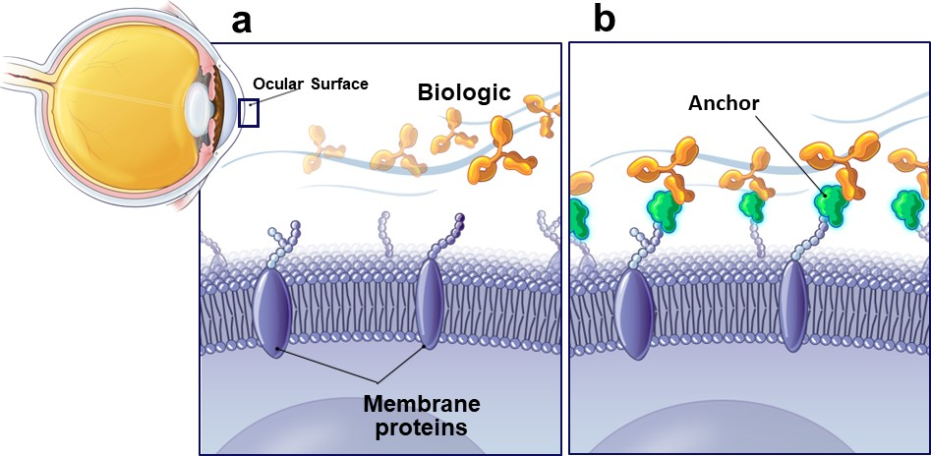
Legend: Anchor domains allow biologics to be maintained at the ocular surface long enough to provide therapeutic effects despite the wash-out problem the generally prevents this class of drug from being used on mucosal surfaces. Image courtesy of AnkyrBio, LLC.

Recent Publications (minimum 5)
- Shanks RM, Romanowski, EG, Romanowski JE, Davoli K, McNamara, NA, Klarlund JK. Overcoming washout of biologics at mucous membranes after topical application. Communications Biology. Accepted 2023
- Klarlund JK, Callaghan JD, Stella NA, Kowalski RP, McNamara NA, Shanks RM. Use of collagen binding domains to deliver molecules to the cornea. J. Ocular Pharmacol Ther 2019 PMID 31593501
- Harshaw NS, Meyer MD, Stella NA, Lehner KM, Kowalski RP, Shanks RM. The short-chain fatty acid propionic acid activates the Rcs stress response system partially through inhibition of d- alanine racemase. mSphere 2023. PMID 36645277
- Stella NA, Romanowski EG, Brothers KM, Calvario RC, Shanks RM. IgaA protein, GumB, has a global impact on the transcriptome and surface proteome of Serratia marcescensw. Infection and Immunity 2022. PMID 36317876
- Brothers KM, Callaghan JD, Stella NA, Bachinsky JM, AlHigaylan M, Lehner KL, Frnaks JM, Lathrop KL, Collins E, Schmitt DM, Horzempa J, Shanks RM. Blowing epithelial cell bubbles with GumB: ShlA-family pore-forming toxins induce blebbing and rapid cellular death in corneal epithelial cells. PLoS Pathogens 2019. PMID 31220184

Biography
Robert Shanks is an associate professor at the University of Pittsburgh School of Medicine with expertise in molecular microbiology and ocular infections.
Email: shanksrm@upmc.edu

Notes/Comments:

Presenting author details

Full name: Robert M. Q. Shanks Contact number: Robert. M. Q. Shanks Mail id: shanksrm@upmc.edu
Category: (Oral presentation/ Poster presentation) Poster

