Establishment of a NPM1 Mutation Copy Number Estimator for Xpert® NPM1 Mutation Test
Yan(Amber) Zhao¹, Mengying(Mona) Liu¹, Yuanyuan Liu¹, Huilin Wei¹, Tran Tran¹, Lin Yuan¹, Gwo-Jen Day¹
¹Oncology, R&D, Cepheid, Sunnyvale, United States

Abstract

Statement of the Problem: The nucleophosmin (NPM1) is the most mutated gene (~30%) in Acute Myeloid Leukemia (AML)¹. Three NPM1 mutations (type A, B, and D) represent ~84% in NPM1-mutated AML cases while other uncommon subtypes occupy ~16%². Xpert® NPM1 mutation, an automated cartridge-based test for measuring NPM1 mutation transcript levels (type A, B and D), is standardized to quantify the amount of mutated NPM1 relative to ABL1 control gene based on delta Ct in peripheral blood³. Since mutated NPM1 level is crucial for risk assessment, medication selection, and ongoing therapeutic monitoring in AML^{4,5}, it is important to obtain the NPM1 mutation copy number (CN). The aim of this work is to develop NPM1 mutation CN estimator and to compare %NPM1 mutation/ABL1 reporting between delta Ct-based and CN-based methods. Methodology & Theoretical Orientation: Five levels of NPM1 mutations (A, B, D) and ABL1 IVT-RNA panels as well as two lots of Xpert® NPM1 mutation tests were used to generate standard curves for CN and %CN reporting. The cell lysates from cell lines carrying either NPM1 mutation A, B, or D and AML clinical samples containing NPM1 mutations were examined to evaluate the CN and %CN between two lots of the Xpert® NPM1 mutation tests and to compare the delta Ct-based and CN-based methods for reporting %NPM1 mutation/ABL. Findings: Linearity was demonstrated in Ct vs CN input for NPM1 mutation and ABL1 with R2 above 0.96 for Lot1 and Lo2. Less than 3-fold difference was exhibited for CN and %CN across two lots of Xpert® NPM1 mutation test. Less than 3-fold difference was observed in %NPM1 mutation/ABL1 reporting between delta Ct-based and CN-based approaches. Conclusion & Significance: An NPM1 mutation copy number estimator for Xpert® NPM1 mutation test was established, which will provide diagnostic and prognostic values for NPM1-mutated AML patients.
Image

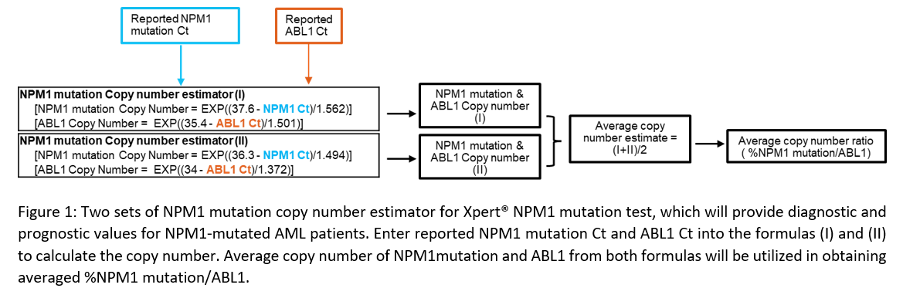
Recent Publications
- Brunangelo Falini, Lorenzo Brunetti, Paolo Sportoletti, Maria Paola Martelli; NPM1-mutated acute myeloid leukemia: from bench to bedside. Blood 2020; 136 (15): 1707–1721.
- Patkar N, Kodgule R, Kakirde C, Raval G, Bhanshe P, Joshi S, Chaudhary S, Badrinath Y, Ghoghale S, Kadechkar S, Khizer SH, Kannan S, Shetty D, Gokarn A, Punatkar S, Jain H, Bagal B, Menon H, Sengar M, Khattry N, Tembhare P, Subramanian P, Gujral S. Clinical impact of measurable residual disease monitoring by ultradeep next generation sequencing in NPM1 mutated acute myeloid leukemia. Oncotarget. 2018 Nov 27;9(93):36613-36624. doi: 10.18632/oncotarget.26400. Erratum in: Oncotarget. 2019 Jan 15;10(5):617. PMID: 30564301; PMCID: PMC6290958.
- Xpert® NPM1 mutation brochure.
- Forghieri, Fabio et al. “Minimal/Measurable Residual Disease Monitoring in NPM1-Mutated Acute Myeloid Leukemia: A Clinical Viewpoint and Perspectives.” International journal of molecular sciences vol. 19,11 3492. 6 Nov. 2018
- Network NCC. Acute Myeloid Leukemia, Version 2.2023, NCCN Clinical Practice Guidelines in Oncology. Acute Myeloid Leukemia. Online: NCCN; 2023



Yan (Amber) Zhao has her expertise in molecular biology, microbiology, and cell biology. She has experience in process and assay development. Current research focuses on assay development to provide accurate and high quality IVD products for cancer diagnostic and monitoring.
Email: yan.zhao@Cepheid.com

Notes/Comments:

Presenting author details
Full name: Yan (Amber) Zhao
Contact number:
Twitter account:
Linked In account: https://www.linkedin.com/in/yan-amber-zhao-2450a314a/
Session name/ number:
Category: (Oral presentation/ Poster presentation)

