Establishment of a BCR-ABL p190 Copy Number Estimator for Xpert® BCR-ABL Ultra p190 Test
Mengying(Mona) Liu¹, Yan(Amber) Zhao¹, Yuanyuan Liu¹, Huilin Wei¹, Tran Tran¹, Lin Yuan¹, Gwo-Jen Day¹
¹ Oncology, R&D, Cepheid, Sunnyvale, United States

Abstract

Statement of the Problem: BCR-ABL p190 (e1a2) is expressed in 20-30% of Acute Lymphoblastic Leukemia (ALL) and 1-2% of Chronic Myeloid Leukemia (CML)^{1,2}. The co-expression of p190 and p210 is rare in both CML and ALL^{1,2}. Xpert® BCR-ABL Ultra p190, an automated cartridge-based test for measuring BCR-ABL p190 transcript level, is standardized to quantify the amount of BCR-ABL p190 relative to ABL1 control gene based on delta Ct in peripheral blood of patients³. Since BCR-ABL p190 level is crucial for risk stratification and treatment decisions in ALL⁴ as well as diagnosis and continuous therapeutic monitoring in CML⁵, it can be useful to obtain the copy number (CN) of BCR-ABL p190. The purpose of this study is to establish a BCR-ABL p190 CN estimator with known CN of e1a2-ABL IVT-RNA as well as to compare %BCR-ABL p190/ABL1 reporting between delta Ct-based and CN-based methods. Methodology & Theoretical Orientation: Nine levels of e1a2-ABL IVT-RNA as well as two lots of Xpert® BCR-ABL Ultra p190 tests were used to generate standard curves for CN and %CN reporting. BCR-ABL p190 contrived samples and ALL clinical samples containing the BCR-ABL p190 transcript were examined to evaluate the CN and %CN between two lots of the Xpert® BCR-ABL Ultra p190 tests and to compare the delta Ct-based and CN-based methods for reporting %BCR-ABL p190/ABL1. Findings: Linearity was demonstrated in Ct vs CN input for BCR-ABL p190 (R²>0.99) and ABL1 (R²>0.98). Less than 1.35-fold difference was exhibited for CN and %CN across two different lots. Less than 2-fold difference was observed in %BCR-ABL p190/ABL1 reporting between delta Ct-based and CN-based approaches. Conclusion & Significance: A BCR-ABL p190 copy number estimator for Xpert® BCR-ABL Ultra p190 test was established, which will provide helpful information for diagnosis and prognosis of diseases relating to BCR-ABL p190.
Image

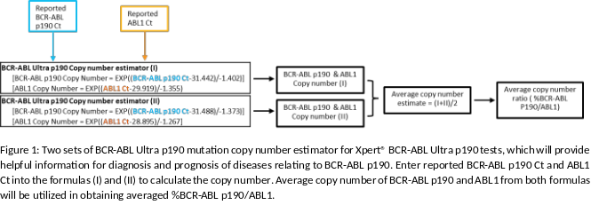
Recent Publications
- Reckel, S et al. “Differential signaling networks of Bcr-Abl p210 and p190 kinases in leukemia cells defined by functional proteomics.” Leukemia vol. 31,7 (2017): 1502-1512.
- Adnan-Awad, S., Kim, D., Hohtari, H. et al. Characterization of p190-Bcr-Abl chronic myeloid leukemia reveals specific signaling pathways and therapeutic targets. Leukemia 35, 1964–1975 (2021).
- Xpert® BCR-ABL Ultra p190 Instructions for Use (part number 302-6673).
- Shi, T., Xie, M., Chen, L. et al. Distinct outcomes, ABL1 mutation profile, and transcriptome features between p190 and p210 transcripts in adult Philadelphia-positive acute lymphoblastic leukemia in the TKI era. Exp Hematol Oncol 11, 13 (2022).
- Narlı Özdemir, Zehra et al. “Guidelines for the treatment of chronic myeloid leukemia from the NCCN and ELN: differences and similarities.” International journal of hematology vol. 117,1 (2023): 3-15.



Mengying(Mona) Liu has her expertise in molecular biology, microbiology, cell biology, gene & cell therapy, drug development, and biomarker discovery. She has experience in process and assay development. Current research focuses on assay development to provide accurate and high quality IVT products for cancer diagnostic and monitoring.
Email: Mona.Liu@Cepheid.com

Notes/Comments:

Presenting author details
Full name: Mengying(Mona) Liu
Contact number:
Twitter account:
Linked In account: https://www.linkedin.com/in/mengying-mona-liu-ph-d-615a641a6/
Session name/ number:
Category: (Oral presentation/ Poster presentation

