Triple threat: Severe COVID-19-strongyloidiasis-taeniasis co-infection: a case report

Helen Jane Polido, MD, Bernard Demot, MD, Samantha Bartolo, MD Baguio General Hospital and Medical Center
Email address: hjanepolido139@gmail.com

ABSTRACT

Strongyloidiasis is caused by a soil-transmitted threadworm that is endemic worldwide and is more prevalent in humid climates. As for Taeniasis, it is an intestinal infection of tapeworms which is usually acquired by ingestion of parasite’s larval cysts found in undercooked or infected meat. These infections are neglected parasitic infections even more so with the current global threat which is COVID-
19. In here, we describe a case of multiple parasitic infections, Taenia and Strongyloides in patient who is co-infected with SARS-CoV-2. The patient was initially managed as severe COVID-19 pneumonia and was given supplemental oxygen, Remdesivir and Dexamethasone. On the 2nd hospital day, the patient passed out proglottids and microscopy revealed Taenia saginata and the rhabditiform larvae of Strongyloides stercolaris. He was given Ivermectin and Praziquantel and surveillance fecalysis post treatment revealed successful eradication of the said parasites. The patient was discharged improved. A study done in Africa showed that immunomodulation caused by helminth infection may help reduce the severity of COVID-19 infection. This case report described a 58-year old male who was infected with SARS-CoV-2 and at the same time, with Taenia saginata and Strongyloides stercolaris. Neglected tropical diseases like strongyloidiasis and taeniasis should also be considered among COVID-19 patients. Education emphasizing hygiene, proper food handling and preparation minimizes the risk acquiring such infections.

Keywords: COVID-19, Taeniasis, Strongyloidiasis, Ivermectin, Praziquantel

Introduction

Coronavirus disease 2019 (COVID-19) caused by the virus SARS-CoV-2 is an ongoing global pandemic which led to loss of human life worldwide and presents an unprecedented challenge not only to public health but also to the food systems and the world of work.¹ In the Philippines, the Department of Health (DOH) recorded 2.6 million of cases, 90 thousand of which are active cases and 39 thousand have died as of October, 10, 2021.² COVID-19 has currently dominated the healthcare system hence other disease entities have been overshadowed

Strongyloides stercolaris and Taenia saginata both belong to the group Helminths, which are the most common parasites infecting humans through food, water and soil and remain as significant challenge in the global health. A high prevalence of several helminthiases in East and Southeast Asia occur primarily in rural areas of developing countries throughout the tropics and subtropics.³ Approximately 300 million people with heavy helminth infections present severe morbidity, resulting in over 150, 000 deaths per year.⁴

To the best of our knowledge, to date, no case of strongyloidiasis, taeniasis and COVID-19 co- infections has been reported. This report aims to present a case of co-infection with the cestode Taenia and Strongyloides in a patient who is a COVID-19 confirmed severe patient.

Case

A 58-year old man presented in our institution with a 2-week history of joint pain (hand and ankle), undocumented febrile episodes, productive cough and decreased in appetite. The patient denied abdominal pain, nausea, vomiting or diarrhea. He sought consult 4 days prior to admission wherein RT- PCR nasopharyngeal and oropharyngeal swab were done revealing positive result.

Past medical history was significant for Hypertension, Gouty arthritis and Pulmonary Tuberculosis (treatment completed last 2017). He is taking Losartan and Allopurinol as his maintenance medications and Diclofenac as needed for pain. He works as a machine operator in a local water district and is fond of ‘kilawen’ (raw fish, meat).

On admission, blood pressure was 140/100 mmHg, pulse 116 beats/minute, respiratory rate 22, temperature 36⁰C, and oxygen saturation of 92% hence hooked on 3L/minute of supplemental oxygen. On physical examination, he had multiple joint swelling prominent on right radiocarpal joint, right scaphotrapeziotrapezoidal and 1st digit carpometacarpal joint (left). Admission blood work was notable for a hemoglobin of 114 g/L, white cell count of 17.75 x 10⁹ (neutrophilic predominance – 76%), Sodium
126.75 mmol/L, Potassium 5.94 mmol/L creatinine 119.19, Aspartate aminotransferase 231.49, Alanine aminotransferase 178.76, lactate dehydrogenase 311.72 U/L, C-reactive protein 314.2 mg/L, procalcitonin 5.2ng/mL hemoglobin A1c 7%. The admission chest X-ray was notable for the presence of hazy and reticular densities in both lungs.

Treatment with Piperacillin-tazobactam and dexamethasone were started along with enoxaparin prophylaxis. Other medications given were Losartan, colchicine, to address hypertension and gouty arthritis respectively. Potassium correction was also done. Remdesivir was not yet started since patient had elevated liver enzymes.

On hospital day 2, there was noted passage of tapeworm segment in his stool which was about 2 feet long, consists of flat ribbon-like bodies consistent with Taenia saginata (Figure 1). Patient denied abdominal pain/upset, nausea, vomiting, diarrhea nor loss of appetite. Fecalysis was also done the same day and direct wet mount with saline revealed also the presence of rhabditiform larvae of Strongyloides stercolaris. Microscopic examination of the sputum was negative for the presence of Strongyloides stercolaris larvae.

Praziquantel 600mg single dose and Ivermectin (200 ug/kg/day) for 2 doses were given for the Taeniasis and Strongyloidiasis respectively. In the ensuing days, stool examination was facilitated but

still, the scolex of Taenia sp. was not found. On hospital day 7, stool examination was already negative for rhabditiform larvae of Strongyloides stercolaris.

On hospital day 9, the patient’s transaminitis has resolved hence a 5 day course of Remdesivir treatment was given. A second sputum sample was again, negative for Strongyloides.

On hospital day 10, another dose of Praziquantel was given since the scolex was still not seen on stool examination. Fecalysis with stool concentration was done for every bowel movement for 3 consecutive days and was negative for the presence of parasites. He completed 1- week course of antibiotic, 5-day course of Remdesivir, 2 doses of Praziquantel and Ivermectin with noted full recovery hence was discharged on hospital day 17.

Discussion

Taeniasis is an intestinal infection wherein humans are infected by eating raw or undercooked pork/beef infected with Taenia solium (pork tapeworm), Taenia saginata (beef tapeworm) and Taenia asiatica.^{5,6} Our patient claimed that he is fond of eating raw meat. Symptoms are usually mild or nonexistent hence people may not know that they are already have Taeniasis and the most visible symptoms of Taeniasis is passing of tapeworm segments (proglottids) just like in the case of our patient.⁵ Approximately 8 weeks after ingestion of meat infected with Taenia, symptoms like abdominal pain, nausea, diarrhea or constipation may arise when tapeworms are fully developed in the intestine and the symptoms may continue until the tapeworm dies following the treatment, otherwise it may live for number of years as in the case of Taenia solium wherein it may persist for 2-3 years if untreated.⁶

Strongyloidiasis on the other hand is a disease caused by a soil-transmitted helminth (nematode/roundworm) in the genus Strongyloides wherein Strongyloides stercolaris is the primary species that accounts for human infection.⁷ Infection is through contact with soil contaminated with free- living larvae (filariform larvae) wherein they come in contact with skin, are able to penetrate it then able to

migrate to through the body eventually reaching small intestine wherein the burrow and lay their eggs then these eggs hatched into larvae.⁷ These larvae are either eliminated through stool or can become filariform larvae which may cause autoinfection by penetrating either the intestinal mucosa or the skin of the perianal area.⁸

Use of steroids may cause exacerbation of Strongyloides infection leading to hyperinfection or dissemination⁸. In case of immunosuppression, strongyloidiasis can cause hyperinfection syndrome or disseminated infection with fatality rates up to 70-100%.⁹

A study of Abdoli (2020) states that helminth co-infection may suppress the efficient immune response against SARS-CoV-2 in the early stage of the infection and thereby may increase morbidity and mortality of COVID-19 and treatment and prevention of helminth infections in endemic regions might decrease the morbidity and mortality of COVID-19.¹⁰ On the other hand, a cohort study done in Africa which determined the association between co-infection with parasites and COVID-19 severity, states that intestinal parasite co-infection is associated with a reduced risk of severe COVID-19 in African patients and parasite-driven immunomodulatory responses may mute hyper-inflammation associated with severe COVID-19.¹¹ However in our patient, he presented with elevated inflammatory markers (CRP, LDH, procalcitonin) and severe COVID-19 infection.

Conclusion

Neglected tropical diseases like strongyloidiasis and taeniasis should also be considered among COVID-19 patients especially in endemic areas like in the Philippines. Education on hygiene, proper food handling and preparation should also be emphasized since it has a significant impact on the transmission of diseases just like the parasitic infections presented in this case.

References

- World Health Organization. Impact of COVID-19 on people’s livelihoods, and their health and our food systems https://www.who.int/news/item/13-10-2020-impact-of-covid-19-on-people's-
livelihoods-their-health-and-our-food-system

- World health Oraganization. COVID-19 in the Philippines Situation Report 87 https://www.who.int/philippines/internal-publications-detail/covid-19-in-the-philippines-situation-
report

- Chuan J, Feng Z, Brindley PJ, McManus DP, Han Z, Jianxin P, Hu W. Our wormy world genomics, proteomics and transcriptomics in East and southeast Asia. Adv Parasitol. 2010;73:327-71. doi: 10.1016/S0065-308X(10)73011-6. PMID: 20627147.

- Hotez PJ, Bundy DAP, Beegle K, et al. Helminth Infections: Soil-transmitted Helminth Infections and Schistosomiasis. In: Jamison DT, Breman JG, Measham AR, et al., editors. Disease Control Priorities in Developing Countries. 2nd edition. Washington (DC): The International Bank for Reconstruction and Development / The World Bank; 2006. Chapter 24. Available from: https://www.ncbi.nlm.nih.gov/books/NBK11748/ Co-published by Oxford University Press, New York.

- Centers for Disease Control and Prevention. Parasites-Taeniasis https://www.cdc.gov/parasites/taeniasis/index.html

- World Health Oranization.Taeniasis/Cysticercosis https://www.who.int/news-room/fact-sheets/detail/taeniasis-cysticercosis

- Centers for Disease Control and Prevention. Parasites-Strongyloides https://www.cdc.gov/parasites/strongyloides/gen_info/faqs.html

- Centers for Disease Control and Prevention. Strongylidiasis https://www.cdc.gov/dpdx/strongyloidiasis/index.html

- Buonfrate D, Requena-Mendez A, Angheben A, Muñoz J, Gobbi F, Van Den Ende J, Bisoffi Z. Severe strongyloidiasis: a systematic review of case reports. BMC Infect Dis. 2013 Feb 8;13:78. doi: 10.1186/1471-2334-13-78. PMID: 23394259; PMCID: PMC3598958.

- Abdoli A. Helminths and COVID-19 Co-Infections: A Neglected Critical Challenge. ACS Pharmacol Transl Sci. 2020 Sep 30;3(5):1039-1041. doi: 10.1021/acsptsci.0c00141. PMID: 33073203; PMCID: PMC7552170.

- Wolday D, Gebrecherkos T, Arefaine ZG, Kiros YK, Gebreegzabher A, Tasew G, Abdulkader M, Abraha HE, Desta AA, Hailu A, Tollera G, Abdella S, Tesema M, Abate E, Endarge KL, Hundie TG, Miteku FK, Urban BC, Schallig HHDF, Harris VC, de Wit TFR. Effect of co-infection with intestinal parasites on COVID-19 severity: A prospective observational cohort study. EClinicalMedicine. 2021 Sep;39:101054. doi: 10.1016/j.eclinm.2021.101054. Epub 2021 Jul 31. PMID: 34368662; PMCID: PMC8324426

Figure 1

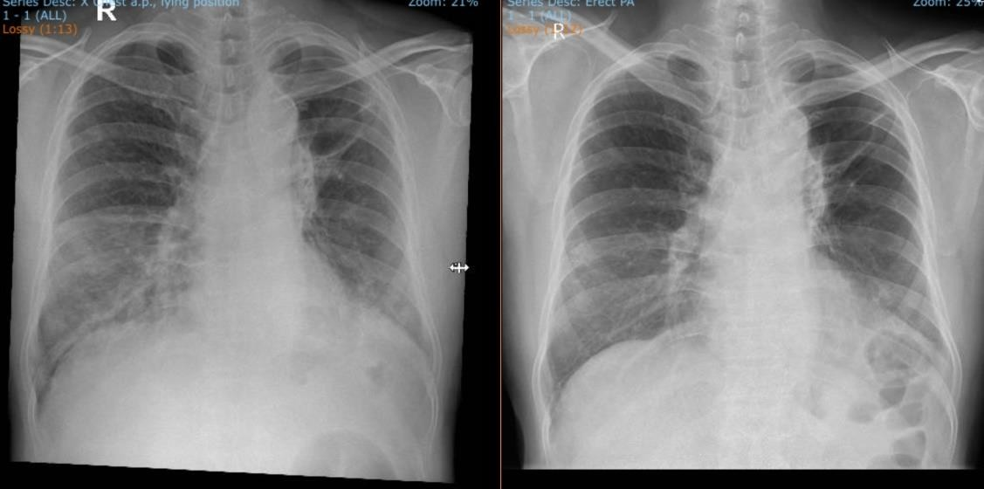
A.

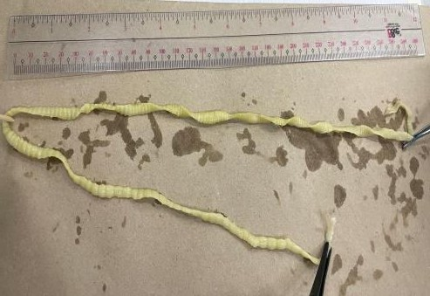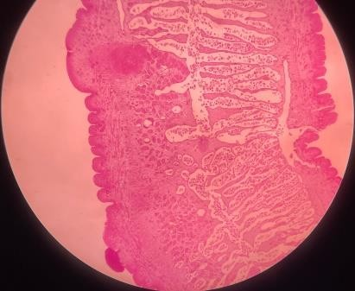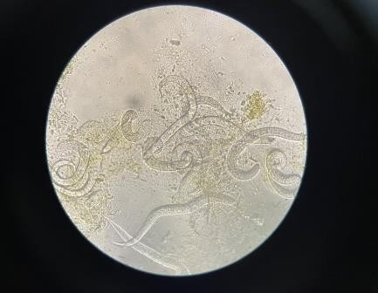
B.
C.
D.

A.Chest xray (PA view) of the patient: (left) taken upon admission, August 20, 2021 and upon discharge, September B. RIbbon-like proglottids that was passed out by the patient on the 2nd hospital day C. Microscopic examination on low power objective (LPO) of the proglottid stained with Hematoxylin & Eosin showing more than 15 lateral branches of uterus on each side which is consistent with Taenium saginata D. Microscopic examination of stool with direct mount using saline showing rhabditiform larvae of Strongyloides stercolaris.

