Multigenerational metastatic effects of perfluorooctanoic acid (PFOA) on Drosophila melanogaster with dysrhythmia and metabolic reprogramming
Fangnon Firmin Fangninou*

Tongji University, China

Abstract (300 word limit)
Statement of the Problem: Metastasis is one essential hallmark during the development of benign tumors to malignant ones. Moreover, it contributes to over 90% of cancer mortality. Therefore, metastasis by environmental pollutants can explain their carcinogenesis and mortality. However, the metastatic effects were seldom explored in long-term exposure over generations.
Methodology & Theoretical Orientation: In the present study, Drosophila melanogaster parents were exposed to perfluorooctanoic acid (PFOA) at 1.0 μg/L for three consecutive generations (i.e., F1 to F3), and their crossing resulted in offspring (i.e., T1 to T3) functioned as Rasv12 models to explore the multi-generational metastatic effects. Results showed that PFOA significantly promoted the metastasis with 1.07, 1.12 and 1.21 folds against the control in T1, T2 and T3 whose parents were normally eclosed in the morning (marked as AM offspring).
Findings: The results demonstrated a clear increasing trend over multi-generational exposure. Interestingly, PFOA provoked even stronger metastatic effects in T1 to T3 whose parents are abnormally eclosed in the afternoon (PM offspring) than the AM offspring. Correspondingly, PFOA reduced the circadian clock proteins (CLOCK, PER2 and CRY1) and increased BMAL1 in the PM offspring than in the AM one. Moreover, PFOA increased the expression or contents of glycolytic genes (Glut1 and Pdk1) and lipid metabolism enzymes (SREBP1 and FASN) in the PM offspring than the AM one. Taken together, PFOA at the environmentally realistic level provoked significant multigenerational metastasis with involvement of dysrhythmia and metabolic reprogramming.
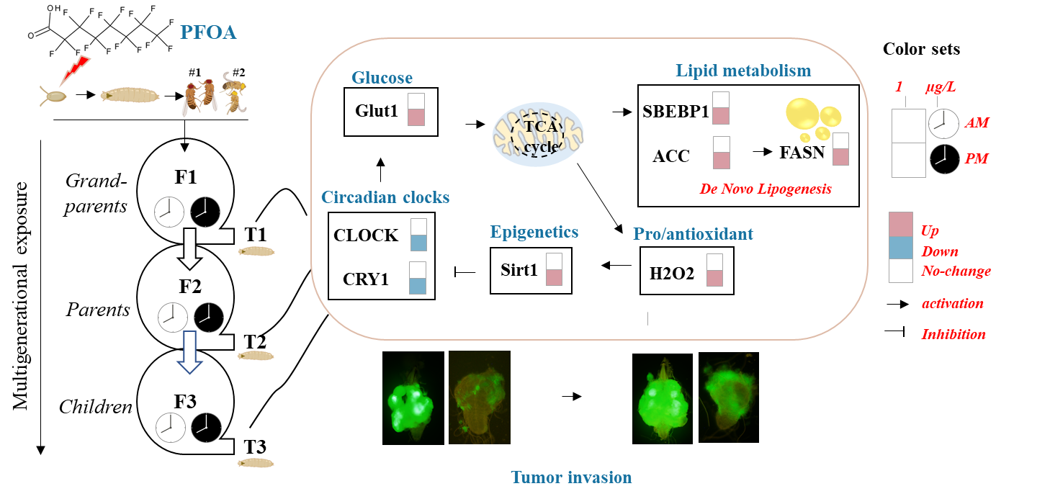
Figure 1. Effects of multigenerational PFOA exposure on tumor invasion, metabolic pathways and circadian rhythm clocks.
Biography
Firmin Fangninou is pursuing his PhD in environmental science and engineering at Tongji University, where he concentrates on investigating the multigenerational metastatic impact of carcinogens. Through his research, he employs Drosophila melanogaster to explore the potential mechanisms of action that carcinogens may have on cancer progression. Firmin has showcased his research at both national and international conferences. The outcomes of his current research hold noteworthy implications for environmental health and human public health, as they have the potential to uncover significant metabolic processes or pathways that are targeted by carcinogens.

