Effect of Human Umbilical Cord Matrix Stem Cell Conditioned Media in Cuprizone Mice Model of Multiple Sclerosis
Erfan H Goonaki, Medical Student, IRSHUMS, IRAN Erfan H Goonaki, Medical Student, IRSHUMS, IRAN

Abstract (300 word limit)

Human Umbilical Cord Matrix Stem Cells (h-UCMSCs) elicit neuroprotective effects, and their repair ability has been investigated in different experimental models. We aimed to investigate the effect of h-UCMSCs supernatant or conditioned media in the cuprizone mice model of multiple sclerosis. Materials and methods: Adult male C57BL/6 mice (n = 40) were fed a regular diet or a diet containing cuprizone (0.2% w/w) for six weeks. h-UCMSCs was cultured and supernatant was collected. h-UCMSCs supernatant was administered intraperitoneally for two consecutive weeks from the end of the fourth week of cuprizone administration. Animals (n = 12) were perfused with 10% paraformaldehyde at the end of sixth week of cuprizone administration. Animals (n = 12) were perfused with 10% paraformaldehyde at the end of sixth week.The brains were sectioned coronally in 6-8-μm thickness (-2.3 to 1.8 mm from bregma).The sections were stained by luxol fast blue-cresyl violet, and images were captured via a microscope. Demyelination ratio was estimated in corpus callosum in a blind manner, A quantitative real-time PCR was used to measure the myelin basic protein gene expression in sixth week. Also We used tunnel staining in corpus callosum to count apoptotic cells. Result: Histologically, cuprizone induced demyelination in the corpus callosum. Demyelinated area was diminished in the corpus callosum of h-DPSCs supernatant administered group. Conclusion: Our data indicated a remyelination potency of multiple i.p. h-UCMSCs supernatant in the cuprizone model of multiple sclerosis in mice.
Image
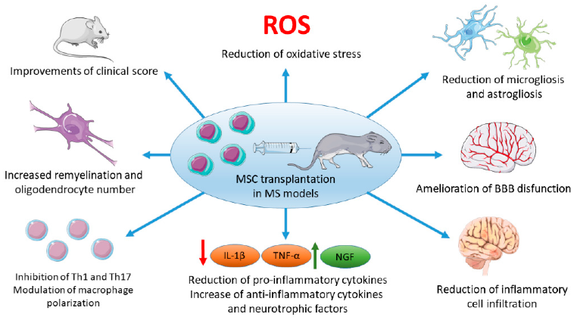
Recent Publications (minimum 5)
- De Miguel MP, Fuentes-Julián S, Blázquez-Martínez A (2018) Immunosuppressive properties of mesenchymal stem cells: advances and applications. Curr Mol Med. 2018 Jun;12(5):574-91.
- Zayed MA, Sultan S, Alsaab HO, Yousof SM (2022) Stem-Cell-Based Therapy: The Celestial Weapon against Neurological Disorders. Cells. 2022 Nov 2;11(21):3476.
- Riordan NH, Morales I, Fernández G, Allen N (2018) Clinical feasibility of umbilical cord tissue-derived mesenchymal stem cells in the treatment of multiple sclerosis. J Transl Med. 2018 Mar 9;16(1):57.
- Shen Z, Huang W, Liu J, Tian J (2021) Effects of Mesenchymal Stem Cell-Derived Exosomes on Autoimmune Diseases. Front Immunol. 2021 Sep 27;12:749192.
5. Donders R, Bogie JFJ, Ravanidis S, Gervois P (2018) Human Wharton's Jelly-Derived Stem Cells Display a Distinct Immunomodulatory and Proregenerative Transcriptional Signature Compared to Bone Marrow-Derived Stem Cells. Stem Cells Dev. 2018 Jan 15;27(2):65-84.

Biography (150 word limit)
ملشان

Erfan was born in 2000 and now is on his 4th year of medical college.his interest in neurology made him go fast in it and think differently and of course that was also because of his uni professor Dr Marzban who is an expert and huge fan of stem cells and their application in neurology specially neurodegenerative disorders. and everytime they get together, BOOM ! a new idea has come ! Erfan hopes everyone health and being safe from these disorders specially Multiple Sclerosis.
Email: erfan.hashemzahi79@gmail.com

Notes/Comments: Be free of MS !

Presenting author details
Full name: Erfan Hashemzahi Goonaki
Contact number:₊₉₈₉₁₅₇₈₅₈₆₁₂
Twitter account: ErfanHPZ
Linked In account: don’t have any
Session name/ number: neuro immunology
Category: Oral presentation

