‘Auspicious Liaisons’ The impact of a liaison geriatrician service

On older adults psychiatric wards

P. Swann, D. Zahedi, H. Wong, A. Tolley, T. Paschalis, V. Kirthisingha, E. Ruiz-Mendoza, J. Rubinsztein

Abstract (300 word limit)

Background

There is an unmet need for providing physical healthcare to older adults who are psychiatric inpatients, despite high levels of comorbidity and mortality. Although liaison services in acute hospitals are now the norm, the reverse is not usually available for patients in mental health trusts. Following the introduction of support from geriatricians to older people’s mental health inpatient wards, we wanted to see if this intervention was effective and acceptable.

Methods

We performed a retrospective cohort evaluation on the impact of a liaison geriatrician, using routinely collected data, and assessed acceptability among medical staff by semi-structured interview.

Intervention

Our service introduced regular sessions from consultant community geriatricians across older adults psychiatric wards including a mixture of video conference and face to face input.

Results

There was no significant decrease in emergency transfers but there was a significant reduction in length of stay with the introduction of a liaison geriatrician. There was a significant increase in geriatrician consultations and a decrease in specialty consultations to other specialists, however, there was no change in discharge prescriptions or destination. Geriatricians gave confidence to psychiatrists of all grades to treat physical health care issues, particularly chronic issues.

Conclusions

A liaison geriatrician service leads to a reduction in length of stay and an improved continuity of care, although it confers no impact on emergency transfers. The intervention brings extensive benefits to clinicians including confidence in managing complex cases and increased training.
Image
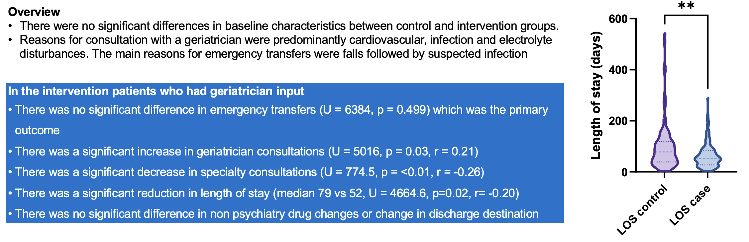
Recent Publications (minimum 5)
- Harper C (2009) The neuropathology of alcohol-related braindamage. Alcohol Alcohol 44:136-140.
- Heilig M, Egli M (2006) Pharmacological treatment of alcohol dependence: Target symptoms and target mechanisms. Pharmacology and therapeutics 111:855-876.
- LiX, SchwachaMG, ChaudryIH, ChoudhryMA (2008) Acutealcohol intoxication potentiates neutrophil-mediated intestinal tissue damage after burn injury. Shock 29:377.
- Room R, BaborT, Rehm J (2005) Alcohol and public health. Lancet
365: 519-530.
5. Sullivan EV, Zahr NM (2008) Neuroinflammation as a neurotoxic mechanism in alcoholism: Commentary on “Increased MCP- 1 and microglia in various regions of human alcoholic brain”. Experimental neurology 213:10-17.

 Biography

Daniel Zahedi is a junior doctor working in Addenbrookes Hospital Cambridge. He is currently studying to be an academic neuro-psychiatrist with an interest in the health needs of an ageing population.
Email: drz22@cam.ac.uk

Notes/Comments:

Presenting author details
Full name: Daniel Zahedi
Contact number: +447901714773:
Session name/ number:
Category: Poster presentation

