Prospective observational study on hyponatremia in Acute Encephalitis Syndrome (AES) in children: its occurrence and effect on outcome

Dr. Nikita Diwan*, Junior resident, Department of Paediatrics, King George’s Medical University, Lucknow
Dr. Chandrakanta, Professor, Department of Paediatrics, King George’s Medical University, Lucknow

Abstract
Statement of the problem: Hyponatremia has been reported in various central nervous system infections like tuberculous meningitis and found to be associated with poor outcome. So far, no study has been conducted on hyponatremia in acute encephalitis syndrome (AES) in children. This study was planned to study the proportion of hyponatremia in acute encephalitis syndrome (AES) in children, its association with clinical and lab parameters and effect on outcome.
This was a prospective observational study done at tertiary care teaching hospital. Institutional ethical clearance and informed consent from parents was taken. Patients between 6 months and 12yrs of age who presented with acute onset (7 days) of fever and neurological manifestation that included new onset seizures and/ or change in mental status (duration of altered sensorium >12 hrs) were included. A detailed history and examination was conducted, blood and CS Finest ligation serenest.
Methodology & theoretical orientation: 200 children were included in the study over 18 months duration. Hyponatremia (serum sodium of less than 135 mmol/L) was found in 24.5% cases. Mortality was significantly higher in children with hyponatremia (24.5%) in comparison to non hyponatremic patients (9.3%), p=0.02. No significant association with the occurrence of fever, seizures, focal deficits. Hepatomegaly was seen more (36.7%) in children with hyponatremia, p value- 0.012.
Findings: No significant association with other clinical findings. Hypocalcemia (p value- 0.002) and hypoalbuminemia (p value0.007) was seen more in children with hyponatremia. Uraemia ( p value- 0.03) was seen more in children without hyponatremia. Most common aetiology was scrub typhus. Past admission in hospital (OR- 0.423) and hepatomegaly (OR- 2.22) were predictors of hyponatremia. Severity of hyponatremia was associated with duration of seizures, hepatomegaly, deranged urea levels and transaminases
Hyponatremia was found in one fourth cases and was associated with significantly higher mortality in AES. Monitoring and timely correction of hyponatremia is prudent in AES.
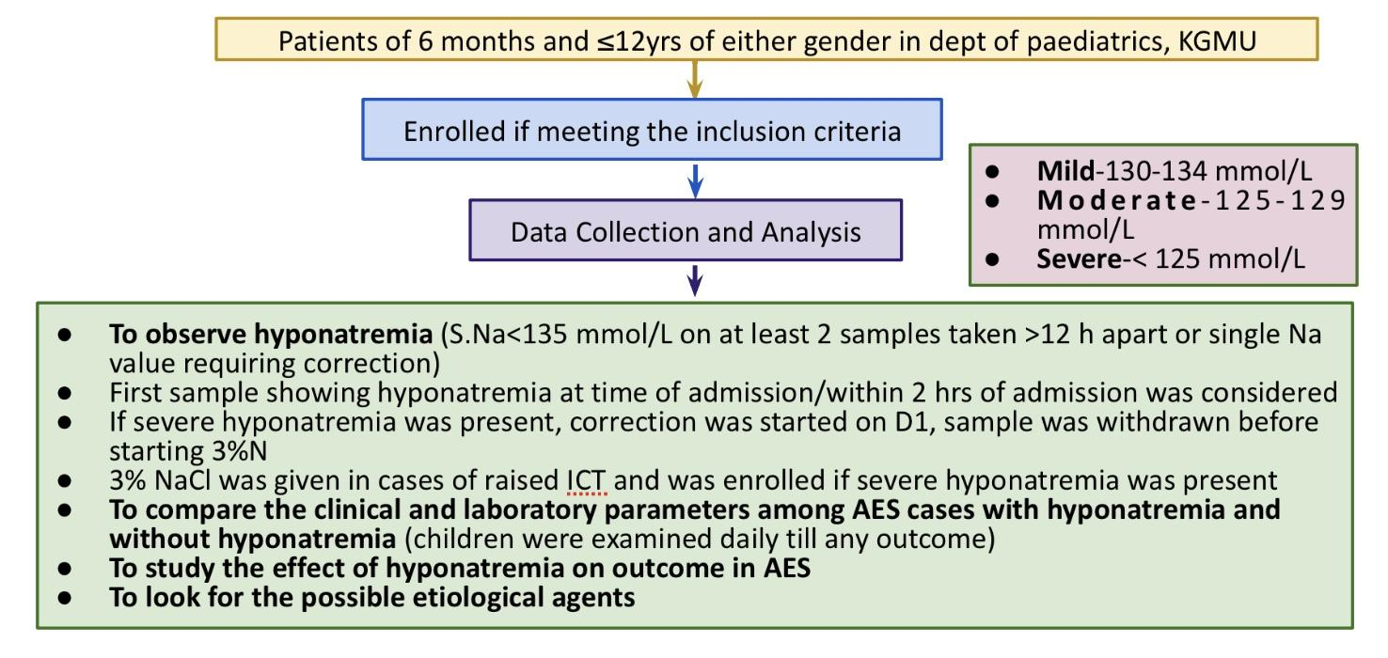
Publications-
Awaited

Bibliography-


Dr. Nikita Diwan is currently a third year post graduate junior resident in department of Paediatrics in King George’s Medical University, Lucknow who has an aptitude for research and a strong moral conscience to employ her research for the benefit of the needy. She has worked meticulously under the guidance of her chief supervisor, Dr. Chandrakanta, professor in department of Paediatrics in King George’s Medical University, a clinician with unmatchable proficiency in her subject of pediatric neurology and a researcher par excellence. This study was conducted to help in the management of children suffering from acute encephalitis syndrome which is an endemic disease in the state of Uttar Pradesh in India. It is first such study conducted in pediatric population in India with strict adherence to inclusion, exclusion criterias, vigilance regarding timing of drawing samples, a standardized protocol for treatment of hyponatremia and a scrupulous follow up.

E mail- angelsanddemon.nik@gmail.com

Presenting author details-
Full name- Dr. Nikita Diwan
Contact no- +919945734416
Session name/number- track 20
Category- Oral presentation

