CD99 – Negative paravertebral primitive Neuroectodermal tumor (PNET)/Ewing’s Sarcoma (ES) in a 39-Year-Old Male: A case report
Lee-Anne V. Sanglay, Felina R. Masadao –Adefuin
Notre Dame De Chartres Hospital, Philippines
Abstract
Background: Primitive Neuroectodermal Tumor (PNET)/Ewing’s Sarcoma (ES) is a small round cell tumor predominant in children and young adults. It frequently arises in bones and rarely occur in soft tissues. For a long time, the only positive marker of note for PNET/ES was vimentin but recent advancements revealed that CD99 is a specific and sensitive marker for the diagnosis of PNET/ES. We present a rare case of soft tissue CD-99 negative paravertebral PNET/ES in a 39-year-old adult male.
Case discussion: A 39-year old adult male presents with 2-month history of progressive back pain. There were no noted spinal deformities during physical examination at the time of admission. Patient suddenly developed signs and symptoms of spinal cord compression on the 1st hospital day. MRI of the spine revealed enhancing paravertebral soft tissue lesions surrounding the spinous process of T9-L1 with abnormal marrow signals also noted in the body of thoracic vertebrae indicating metastasis. CT scan of the chest and abdomen did not reveal any extraspinal sites suspicious for tumor growth. Decompressive laminectomy was done. Histopathology revealed malignant round cell tumor negative for Desmin and CD45/LCA, ruling out other round cell tumors such as rhabdomyosarcoma and lymphoma respectively. Vimentin, which is characteristic of PNET/ES, was positive but CD-99, unexpectedly, was negative. Unfortunately, molecular studies, such as FISH, were not available to confirm PNET/ES. Chemotherapy with Vincristine, Doxorubicin, Cyclophosphamide alternating with Ifosfamide and Etoposide was given. Patient developed progressive disease and succumbed to the disease after 5 months.
Conclusion: PNET/ES have an aggressive course with low survival rates, especially if the diagnosis is delayed. Early recognition of the disease and timely management are essential. In the absence of molecular studies, diagnosis should be based on clinical and radiographic review and on the histopathologic and immunohistochemistry patterns.
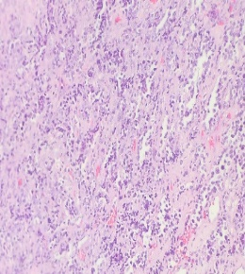
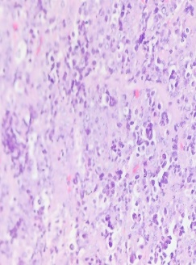
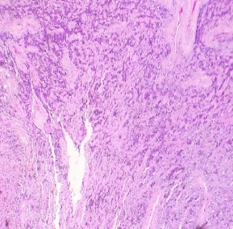
Figure 1. paravertebral soft tissue showing small round cells with increased nuclear-cytoplasmic ratio a. LPO, b. MPO, c. HPO
a
b
c

References:
1) Bethesda M. PDQ Ewing Sarcoma and Undifferentiated Small Round Cell Sarcomas of Bone and Soft Tissue Treatment. Natl Cancer Inst. Published online 2022. Accessed November 5, 2022.
2) De Alava E, Marcilla D, Biscuola M. Round cell tumors. In: Practical Soft Tissue Pathology: A Diagnostic Approach. Second. Elsevier; 2019:233-248
3) Sharma S, Kamala R, Nair D, et al. Round cell tumors: Classification and immunohistochemistry. Indian J Med Paediatr Oncol. 2017;38(3):349-353
4) Teo C, Chuah KL, Kaw G, Giron D. CD99 negative primary sciatic nerve Ewing family tumour in a middle‐aged woman: a rare clinical presentation. Pathology (Phila). 2007;39(5):528. doi:https://doi.org/10.1080/00313020701444580
5) Llombart-Bosch A, Machado I, Navarro S. Histological heterogeneity of Ewing’s sarcoma/PNET: an immunohistochemical analysis of 415 genetically confirmed cases with clinical support. Virchow Arch. 2009;455:397-411. doi:10.1007/s00428-009-0842-7
Biography
Lee-Anne V. Sanglay completed her MD at the age of 25 from Saint Louis University, Baguio city, Philippines last 2020. She passed the Philippine Licensure Exam last September 2021. She is currently undergoing Internal Medicine residency training at Notre Dame De Chartres Hospital, Baguio City, Philippines.

