Cornea melting Post Collagen cross linking keratoconus
Ferdouse Abusrewil , MD
Tripoli – Libya

Introduction :
What is the introduction of keratoconus
Keratoconus is a Greek word (kerato: Cornea; konos: Cone), meaning cone-shaped protrusion of the cornea. Keratoconus is a non-inflammatory, progressive thinning of the cornea that is usually bilateral and involves the central two-thirds of the cornea.
Signs & symptoms :
Glare and halos around lights.
Difficulty seeing at night.
Eye irritation or headaches associated with eye pain.
Increased sensitivity to bright light.
Sudden worsening or clouding of vision .
Treatment :Corneal Collagen Cross-linking (CXL),cross-linking has been performed successfully around the world for the past decade. ...
Corneal Transplantation. ...
Specialized Contact Lenses. ...
Intracorneal Ring Segments.
However there are cases in which unfavorable complication can occur .The purpose of this report is to highligh an unexplained transient complication post uneventful CXL complication.

Case Description :
A healthy 18 -year-old female presented c/o gradual decrease in vision. The patient had an uneventful medical history. Other than progressive bilateral keratoconus she had no other ophthalmological problems , Her VA: C.F2M OD , 0.4 OS .
Her auto-refraction was
OD : - 15.25 / -8.00 /11
OS : - 3.00 / -2.50 /20
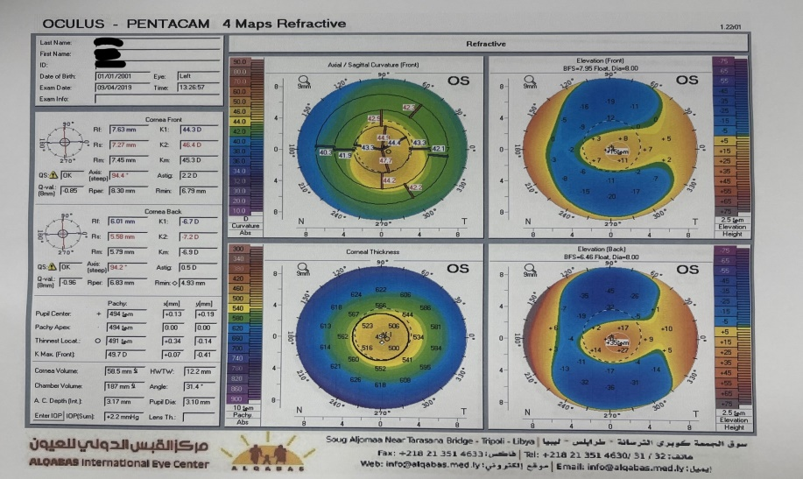
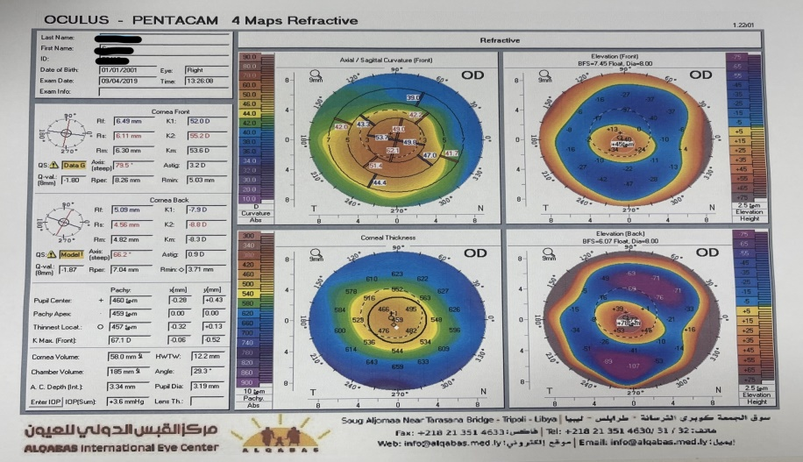

The patient with keratoconus cornea stage 3 to 4 underwent uneventful corneal collagen cross-linking treatment in the both eyes with Sheraz Daya Scraper,Standard CXL treatment was performed in the patient's Both eyes ( we started with Left eye then the Right eye, one month apart ) and patient was administered the following postoperative medications.
Standard CXL treatment was performed in the patient's Both eyes ( we started with Left eye then the Right eye, one month apart ) and patient was administered the following postoperative medications:
- - Vigamox Eye drop 1x 4
- - Maxidex eye drops 1 x6
- - hylocomod eye drop 1x6
- - Voltaren eye drop SOS

On Day 1 Post OP , the patient’s examination was unremarkable.
The left eye The Procedure went uneventful without any complications

On the 3rd day post OP. she had intense photophobia, watering and redness of the Right eye, and her visual acuity was markedly decreased .
Slit lamp bio-microscopy showed Revealed ciliary injection with sloughed epithelium and band corneal melting
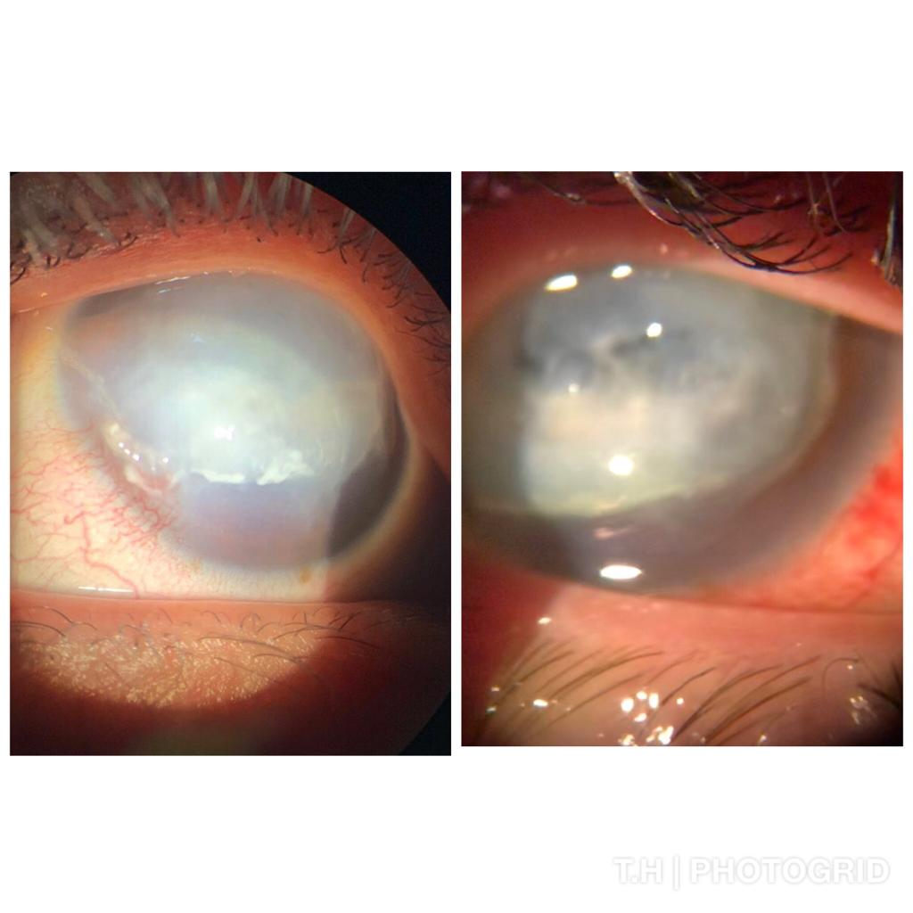
Our Patient should have underwent complete laboratory examination for autoimmune and infectious diseases, including markers for rheumatoid factor, immune complexes, C-reactive protein, anti-neutrophilic cytoplasmic antibodies and erythrocyte sedimentation rate, as well as polymerase chain reaction for herpes simplex virus DNA detection.
These were not ordered as we suspected a more critical post-operative severe infectious etiology for the inflammation and decided not to delay starting treatment.
The treatment change resulted in subjective improvement of ocular discomfort. However, the cornea presented extremely slow re-epithelialization and progressive thinning .
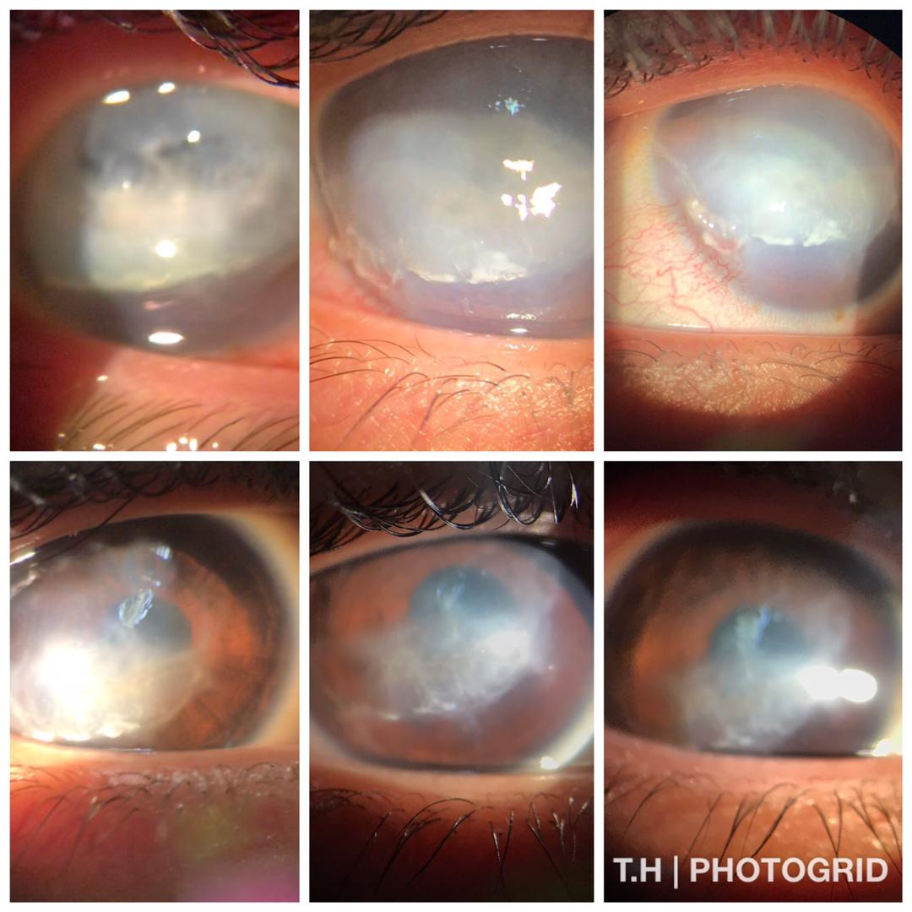
Conclusion :
The exact cause of corneal melting in our case remains unknown to us
Since all precautions for standard CXL treatment were met in our case, further research is necessary to address all safety issues associated with this procedure.

References
Millodot M, Ortenberg I, Lahav-Yacouel K, Behrman S. Effect of ageing on keratoconic corneas. J Optom. 2016;9:72–7.
Léoni-Mesplié S, Mortemousque B, Touboul D, Malet F, Praud D, Mesplié N, et al. Scalability and severity of keratoconus in children. Am J Ophthalmol. 2012;154:56–62.e1
Romano V, Vinciguerra R, Arbabi EM, Hicks N, Rosetta P, Vinciguerra P, et al. Progression of keratoconus in patients while awaiting corneal cross-linking: A prospective clinical study. J Refract Surg. 2018;34:177–80.
Belin MW, Villavicencio OF, Ambrósio RR Jr. Tomographic parameters for the detection of keratoconus: Suggestions for screening and treatment parameters. Eye Contact Lens. 2014;40:326–30.
O’Brart DP, Patel P, Lascaratos G, Wagh VK, Tam C, Lee J, et al. Corneal Cross-linking to halt the progression of keratoconus and corneal ectasia: Seven-year follow-up. Am J Ophthalmol. 2015;160:1154–63.


Ferdouse , I have been working in ophthalmology department since I was in my internship I was attending on my extra time in a private clinic because I have this passion for it , I love how it’s a combination of medicine and surgery with some optics , it gives me a lot of options to help the patients needs .
This case was followed up under the supervision of my consultant Dr. Khalifa ELbakkush ( FRCS – FRCOPTH ) - Khalifabakkush@yahoo.com, Tripoli -Libya

Full name : Ferdouse Abusrewil
No. :+218923456402
Email : ferdouseabusrewil@gmail.com
Category : Oral & Poster presentation .

