Thermal decomposition of cobalt(III), nickel(II), copper(II), palladium(II) and platinum(II) complexes of N-ethyl-N'-(4'-methylthiazol)-2ylthiourea
Suhair M. S. Jambi¹
University of Jeddah, College of Science, Department of Chemistry, Jeddah, Saudi Arabia

Abstract
Thermal decomposition of Co(III), Cu(II), Ni(II), Pd(II), and Pt(II) complexes of N-ethyl-N'-(4'-methylthiazol)-2ylthiourea (EthMeTzTu), HL, have been studied by TG, DTG, and DTA curves. The complexes have the molecular formulae as CoL₃, [CuLCl(H₂O)]and [CuL₂.2(H₂O)] a square for ML₂ (M = Ni(II), Pd(II) and Pt(II), and [Pd(HL)Cl₂]. The TG curves show that all complexes decompose in two stage to yield a free metal in CoCl₃ and PdL₂ complexes , while NiL₂, [CuL₂.2H₂O] and PtL₂ gave NiS, CuS and PtS respectively, [CuLCl(H₂O)] gave Cu(SCN)Cl, [Pd(HL)Cl₂].2HCl gave Pd(SCN)₂

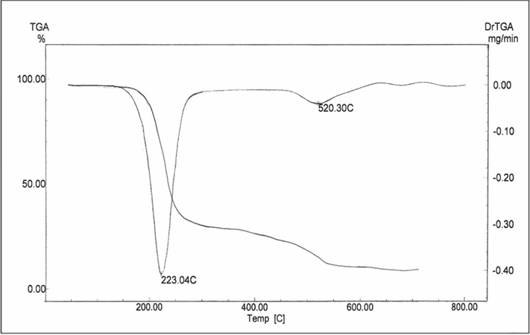
Fig:1 Two curves TG, DG for complex NiL₂

Reference:
[1] S.Tuncel, S. Gunal, M. Ekizoglu, N. Kelekci, S. Erdem, E. Bulak, W. Frey, I. Dogan, J.Molecular structure (2019) 1179, 49.
[2] A. Prasad, P. Mishra, Chemical Physics Letters (2017) 684,197.
[3] G. Zitouni, M. Altintop, A. Ozdemir, Z. Kaplancikli, G. Ciftci, H. Temel, European Journal of Medicinal Chemistry (2016) 107, 288.
[4] R. Kulkarni, G. Shivkumar, H. Rao, J. Med.Chem (20007) 42, 1272.
[5] A. Andreani, M.Granaiola, A. Leoni, A. Locatelli, R. Rambaldi, L J. Med. Chem (2005) 48, 5604.
[6] W. Henderson, R. D.W. Kemmitt, S. Mason, M.R. Moore, J. Fawcett, D.R. Russell J. Chem. Soc., Dalton Trans ( 1992) 2, 59.
[7] H. Arslan, N. Külcü, U. Flörke. Trans. Metal Chem (2003) 28, 816




Name: Suhair Mansour Jambi
Nationality: Saudi
Date of Birth: Oct. 26, 1965.
Current Work: Associate Professor, Faculty of Science for Girls
University of Jedahh
Doctorate: Ph. D. in Inorganic chemistry
University of Jeddah College of Science, Department of Chemistry
(2011)
Personal Email: smjambi@uj.edu.sa
Mobile Number
Postal Address Unit 5
3258 At Tawnir- Annuzhah, Jedah
23534-7929, Sadui Arabia

Some of the Publications
1- Suhair M.S. Jambi " Quantum, characterization and spectroscopic studies on Cu(II), Pd(II) and Pt(II) complexes of 1-(benzo[d]thiazol-2-yl)-3-phenylthiourea and its biological application as antimicrobial and antioxidant ", Journal of Molecular Structure, Vol. 1143, 2017, P 217-228
1- Suhair M.S. Jambi, " Crystal structure of bis(2-((allylcarbamothioyl)
imino)-4-methylthiazol-3-ido-κ2N,S)palladium(II), C₁₆H₂₀N₆PdS₄", Z. Kristallogr. NCS" , Vol. 233, 2018, P 73–74.
2-Suhair M.S. Jambi, "Cd(II), Hg(II) and Pt(II) complexes of 1-ethyl-3-(4-methylthiazol-2-yl) thiourea: Synthesis, X-ray crystal structure, DFT studies, antimicrobial and antioxidant applications", Journal of Molecular Liquids, Vol. 262 ,2018, P 237–247

