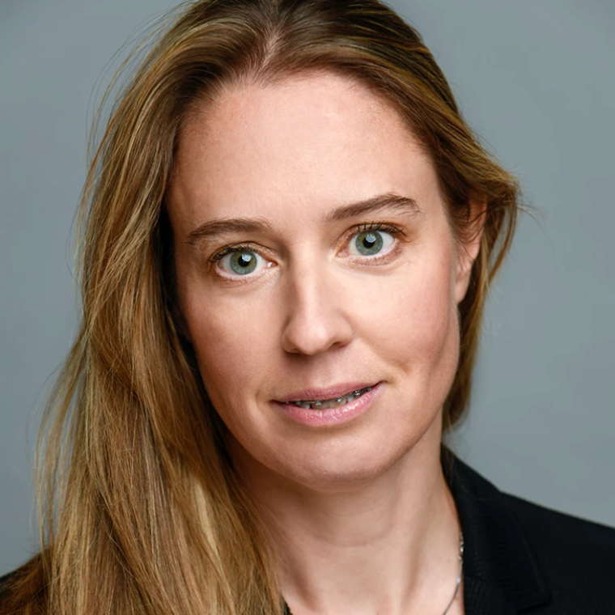
Title: Optimizing IVF Treatment with AI
Name: Urszula Sankowska
MIM Fertility, Warsaw, Poland

AI-powered applications have the potential to vastly improve medical care. The path to this revolution is still rather long and still has some obstacles. However, one of the areas of medicine that sees more and more progress with respect to application of AI is IVF. This follows as the IVF process offers unique, controllable and reputable conditions. These opportunities are further strengthened by the fact that over 10% of the human population will encounter reproduction problems, thus In Vitro Fertilization is becoming one of the fastest growing areas of healthcare. In this talk, I will present deep learning tools that support doctors in IVF treatment.
First, I will talk about how to automate ovarian ultrasound monitoring with deep learning computer vision algorithms. The calculating and measuring of follicles is of major importance for IVF, e.g., it helps estimate the ovarian reserve as well as the timing of the whole process.
Second, I will talk about an analytical and predictive system aiming for fully automated identification of the highest quality embryos based on a large collection of time-lapse images of human embryos.
Both AI-driven tools are designed for fertility clinics, diagnostic centers and hospitals and will respond to their well-identified needs. In this talk, I will describe the process of building these solutions and show the most important issues of applying deep learning in a medical context. Finally, I will talk about deployment of these tools in fertility clinics in Poland and worldwide.

Biography

Co-Founder and co-CEO at MIM Fertility, Polish best-in-class deeptech company specializing in AI solutions for IVF. Manager with over 15 years of experience in business and public sector. Economist, a graduate of the Warsaw School of Economics and University College Dublin. A scholarship holder of the Robert Bosch Foundation and the Irish Government. Winner of Businesswoman of the Year Award 2022. Awarded with Excellence in AI - Entrepreneur 2022. Under her leadership, MIM Fertility continues to deliver bespoke and innovative AI solutions crafted to different patients’ needs, and by collaborating closely with IVF clinics to standardize, optimize and automate clinical workflows.
Presenting author details
Full name: Ula Sankowska
Contact number: +48 606366958
Twitter account: -
Linked In account: https://www.linkedin.com/in/ula-sankowska/
Session name/ number:
Category: Oral presentation

