Poly(ionic liquid)s for Photocatalytic CO₂ Conversion

Chengcheng Liu, PhD, Institute of Frontier and Interdisciplinary Science, Shandong University, China

Abstract
Polyionic liquids (PILs) refer to polymers polymerized by ionic liquids (ILs) monomers. ILs and PILs have been widely used in CO₂ conversion. Their ionic microenvironment and special hydrogen bonds can enrich and activate CO₂ efficiently, thus facilitating the conversion of CO₂ under mild conditions. At present, the applications of PILs in CO₂ conversion mainly focus on thermal catalysis and electrocatalytic CO₂ conversion. Their applications in photocatalytic CO₂ conversion is rarely reported. Photocatalytic CO₂ conversion can convert CO₂ into high value-added fuel and store solar energy in the fuel, which is one of the important means to overcome the energy crisis and reduce environmental pollution. However, due to the high C=O dissociation energy of CO₂, photocatalytic CO₂ conversion still faces the problems of low conversion rate and serious hydrogen evolution side reactions. Due to its unique ion pair structure and strong structural designability, PILs have great potentials in photocatalytic CO₂ conversion. The main limiting factor for applications in photocatalysis is the poor photoexcitation ability of PILs. In the previous studies, the author found that the introduction of electron donor-acceptor structure into PILs can significantly improve the separation and migration rate of photogenerated carriers in the PILs structure. The synthesized PILs show high catalytic activity in both photocatalytic CO₂ reduction and photo-driven CO₂ cycloaddition reactions. Through the transient absorption and other spectral studies combined with the density functional theory (DFT) and time-dependent density functional theory (TD-DFT) calculations, it was found that there was a strong built-in electric field in the designed PILs molecules. The built-in electric field could provide a driving force for the separation and directional transmission of photo-carriers in PILs, thus promoting the photo-catalyzed/photo-induced CO₂ conversion.

Biograpy
Paste your Logo here
Dr. Chengcheng Liu is an associate researcher at the Institute of Frontier and Interdisciplinary Science, Shandong University. She received her PhD degree in materials science under the supervision of Prof. Buxing Han and Jianling Zhang from Institute of Chemistry, Chinese Academy of Sciences (ICCAS) in 2017. Then she worked as a postdoctoral researcher at the University of Manchester (2017-2019). Her research interest is developing functional porous materials toward their applications in energy fields.


Image
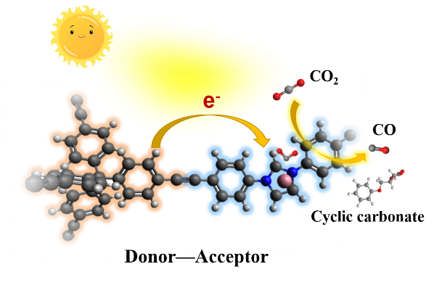
Figure 1: PILs with Donot-Acceptor structures for photocatalytic CO₂ conversion.
Recent Publications (minimum 5)
1. Fang X, Liu CC, Yang L, Yu T, Zhai D, Zhao WL, Deng WQ (2021) Bifunctional poly(ionic liquid) catalyst with dual-active-center for CO₂ conversion: Synergistic effect of triazine and imidazolium motifs. Journal of CO₂ Utilization 54: 101778.
2. Luo T, Li LL, Chen YL, An J, Liu CC, Yan Z, Carter JH, Han X, Sheveleva AM, Tuna F, Mclnnes EJL, Tang CC, Schroder M (2021) Construction of C-C bonds via photoreductive coupling of ketones and aldehydes in the metal-organic-framework MFM-300(Cr). Nature Communications 12: 3583.
3. Zhao WL, Sun L, Wang B, Yang L, Kang XC, Sun LJ, Ren G Q, Fang X, Bai TX, Deng WQ, Liu CC (2022) A multifunctional covalent organic framework with localized radicals for selective ion capture and photocatalysis. Materials Today Chemistry 26: 101225.
4. Zhao WL, Zhai D, Liu CC, Zheng DY, Wu H, Sun L, Li Z, Yu T, Zhou W, Fang X, Zhai SL, Han KL, He ZL, Deng WQ (2022) Unblocked intramolecular charge transfer for enhanced CO2 photoreduction enabled by an imidazolium-based ionic conjugated microporous polymer. Applied Catalysis B: Environmental 300: 120719.
5. Fang X, Yang L, Dai ZB, Cong D, Zheng DY, Yu T, Tu R, Zhai SL, Yang, JX, Song FL, Wu H, Deng WQ, Liu CC (2023) Poly(ionic liquid)s for Photo-Driven CO₂ Cycloaddition: Electron Donor–Acceptor Segments Matter. Advanced Science 10: 2206687.

