Role of Hepatitis C Virus (HCV) Core protein in virus mediated tumorigenesis by modulation of cellular metastasis suppressor Nm23-H1

Catherine Paul, PhD, and Rajeev Kaul, PhD
Department of Microbiology, Bhaskaracharya College of Applied Sciences, University of Delhi South Campus, India

Abstract
With an estimated 170 million infected individuals, hepatitis C virus (HCV) has a major impact on public health. The virus is difficult to clear even with the currently available drug therapy, thus resulting in persistent infection, increasing the risk of long-term liver disease and hepatocellular carcinoma (HCC). HCV is a leading cause of HCC, which is the most common of liver cancers around the world, including developed nations like U.S. and Japan. The incidence of metastasis is an important characteristic of HCV-related HCC, which makes the cancer treatment extremely difficult. Methodology & Theoretical Orientation: Firstly, we investigated the role of HCV- core protein on cancer cell phenotype, after which the interaction of HCV-core protein with different cellular proteins were studied by GST pull down and CO-IP procedures. To monitor the effect of viral proteins on cellular protein, translocalization, immunofluorescence assay was performed. HCV core was found to interact with cellular metastasis suppressor NM23-H1. The effect of this interaction was studied by protein stability assays. At last, RT- qPCR was performed to quantify the effect of HCV core protein on the transcript level of NM23-H. Conclusion & Significance: Our study now shows that HCV-Core expression as well as HCV infection is pro- metastatic which is co-incidental with Nm23-H1 transcriptional downregulation and protein degradation. Also, HCV-Core co-localizes with Nm23-H1 within the cytoplasm of the cells in both HCV-Core over- expressed as well as virus infected cells. Further, HCV-Core and Nm23- H1 are found to interact stably with each other. Further, HCV-Core and Nm23-H1 are found to interact stably with each other. The domains of Nm23-H1and HCV-Core essential for this interaction have been identified which were found to be amino acid region from 95-114 and 81-117 of Nm23-H1 and HCV-Core respectively. Core expression can also rescue the cells from metastasis suppression effect of Nm23-H1. Our study provides the role of HCV-Core in HCV mediated cancer metastasis (Figure 1).

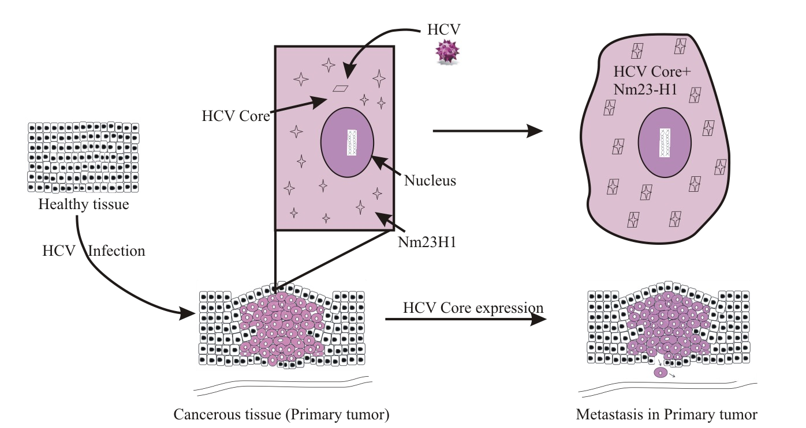

Figure 1. Schematic model showing role of HCV-Core in modulation of Nm23-H1 function

Recent Publications
- Roshika Tyagi, Catherine Paul, Juni Banerjee, Rajeev Kaul, Shuvomoy Banerjee. “Virus Association with Gastric Inflammation and Cancer: An Updated Overview”. JoMMID 2022; 10
- Snigdha Guha, Catherine Paul, Sophie Alvarez, Yoshinori Mine, and Kaustav Majumder. “Dietary γ-Glutamyl Valine Ameliorates TNF-α-Induced Vascular Inflammation via Endothelial Calcium- Sensing Receptors.” Journal of Agricultural and Food Chemistry 2020 68 (34), 9139-9149; DOI: 10.1021/acs.jafc.0c04526
- Jagrani Minj, Priyanka Chandra, Catherine Paul & Rakesh Kumar Sharma. “Bio-functional properties of probiotic Lactobacillus: current applications and research perspectives.” Critical Reviews in Food Science and Nutrition, 2020 DOI: 10.1080/10408398.2020.1774496
- Catherine Paul, Lohit Khera and Rajeev Kaul. “Hepatitis C Virus Core protein interacts with cellular metastasis suppressor Nm23-H1 and promotes cell migration and invasion.” Archives of Virology. 2019 Mar; 705: 1-15 doi.org/10.1007/s00705-019-04151-x
- Lohit Khera, Catherine Paul, Rajeev Kaul. "Hepatitis C Virus E1 protein promotes cell migration and invasion by modulating cellular metastasis suppressor Nm23(H1" Virology. 2017 Jun; 506: 110(20. doi: 10.1016/j.virol.2017.03.014

Biography

Catherine Paul has her expertise in Microbiology specifically in molecular virology and is passionate about the improving the health and wellbeing. Her study on Hepatitis C Virus core protein and its effect in modulation of metastasis suppressor protein creates new pathways for improving healthcare. Her study is an attempt to identify and investigate a relationship between HCV protein and Nm23H1 mediated metastasis in infected cells using human cancer cell lines as model system.

Notes/Comments:

Presenting author details

Full name: Catherine Paul
Contact number: +91-9899527220 Twitter account: @catherinespaul

Linked In account: https://www.linkedin.com/in/catherine-paul-96434030/ Session name/ number: Virology, Viral Pathogens and Associated
Diseases / 3

Category: Poster presentation

